Unit 2 HW Packet - Atomic Structure : Name:________________
HW#1
- State the subatomic particle that is described in each of the following statements.

___________+1 charge
___________ No Charge
___________-1 charge
___________found outside nucleus
___________found inside nucleus
___________least massive

What is an Atom?
- How many protons are found in ¹²C? __________ ¹³C? __________ ¹³C⁻ ? __________
- How many neutrons are founds in ¹²C? __________ ¹³C? __________ ¹³C⁻ ? __________
- How many electrons are found in ¹²C? __________ ¹³C? __________ ¹³C⁻ ? __________
- Based on the data presented above,
  - What do all carbon atoms (and ions) have in common?
  - What do all hydrogen atoms (and ions) have in common?
- What is the significance of the atomic number? Where will you find it on the periodic table?
- Look at a periodic table, what do all nickel (Ni) atoms have in common?
- How is the mass number determined?
- What structural feature is different in isotopes of a particular element?
- What feature distinguishes a neutral atom from an ion?
- Where is most of the mass of an atom, within the nucleus or outside of the nucleus? Explain your reasoning.
- Complete the chart below:
Isotope | Atomic Number (Z) | Mass Number (A) | Number of Electrons
³¹P | 15
¹⁸O |  |  | 8
 | 19 | 39 | 18
⁵⁸Ni²⁺ |  | 58

13. How many electrons, protons, and neutrons are found in each of the following?
Atom or ion | Electrons | Protons | Neutrons
²⁴Mg
²³Na⁺
³⁵Cl
³⁵Cl⁻
⁵⁶Fe³⁺
¹⁵N
¹⁶O²⁻
²⁷Al³⁺

14. Complete the chart below:
Isotope | Protons | Neutrons | Mass Number | Electrons | Nuclear Notation
K-40 | 19 | 21 | 40 | 19
Li-6
 | 2 | 1
 |  |  | 90 | 38

HW#2
Atomic Emission Spectrum of the Bohr Hydrogen Atom

- In which transition is the most energy released?
- n = 3 to n = 2
- n = 3 to n = 1
- n = 5 to n = 2
- n = 1 to n = 3

- Which transition required the largest quanta of energy input?
- n = 2 to n = 4
- n = 1 to n = 2
- n = 2 to n = 1
- n = 4 to n = 1

- a) What wavelength of light is produced during a transition from n = 5 to n = 2?
______________________ nm = ______________________ m
b) What color is the light that is released? Color = ______________________
- a) What wavelength of light is produced during a transition
from n = 3 to n = 2? ______________________ nm = ______________________ m
b) What color of light does this correspond to? Color = ______________________
- If violet light of wavelength 4.1 x 10⁻⁷ m is released, what transition did the electron make?
n = __________ to n = __________

- Put in order from lowest to highest frequency:
  - Radio waves, gamma rays, IR, X-rays, UV, Microwaves
  - Blue, Red, Violet, Orange

- Put in order from lowest energy to highest energy:
- Gamma Rays, IR, Radio Waves, UV, Red light, Violet Light

HW#3
Nuclear Chemistry Homework
Using your knowledge of nuclear chemistry, write the equations for the following processes:

1) The alpha decay of radon-219
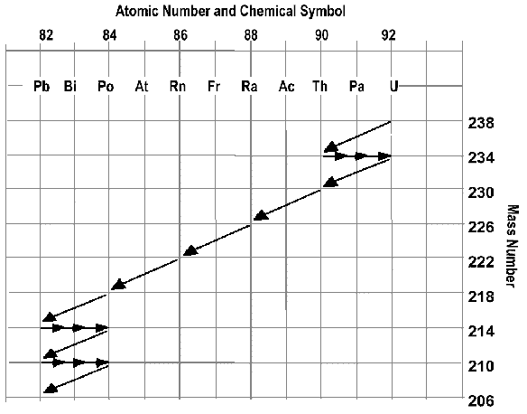
2) The beta decay of uranium-233

3) Use the disintegration series to write a decay equation for:
a) Ra-226
b) Pb-214

4) What is the difference between nuclear fusion and nuclear fission?
5) Name three uses for nuclear reactions.

Radioactivity and half-life questions
1. What is a radioactive isotope_____________________________________________________________
2. What is radioactive decay? ______________________________________________________________
3. What is half-life? ______________________________________________________________________
4. If we start with 400 atoms of a radioactive substance, how many would remain after one half life?_________
after two half-lives? _________ after three half-lives? _________ after four half lives? ________

5. If we start with 48 atoms of a radioactive substance, how many would remain after one half life?_________
after two half-lives? _________ after three half-lives? ___________ after four half lives?_______

6. If we start with 16 grams of a radioactive substance, how much will remain after three half-lives?________

7. If we start with 120 atoms of a radioactive substance, how many will remain after three half-lives?________
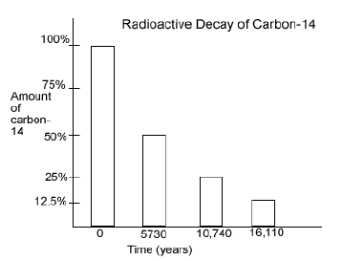

Use the following graph to answer questions 8-11…
8. How long is a half-life for C-14?____________

9. If only 25% of the carbon-14 remains, how old is the material containing the carbon-14? ________

10. If a sample originally had 120 atoms of C-14, how many atoms will remain after 16,110 years? _______
11. If a sample known to be about 10,740 years old has 400 carbon-14 atoms, how many atoms were in the sample when the organism died? _________
12. Which type of nuclear radiation (beta particles, gamma rays, or alpha particles) can be blocked by…
a) a piece of paper ____________ b) a sheet of aluminum ____________ c) a piece of lead ____________
Use the following chart to answer questions 13-16…
Radioactive Substance | Approximate half-life
Radon-222 | 4 days
Iodine-131 | 8 days
Radium-226 | 1600 years
Carbon-14 | 5730 years
Plutonium-239 | 24,120 years
Uranium-238 | 4,470,000,000

13. If we start with 8000 atoms of radium-226, how much would remain after 3,200 years? __________
14. If we start with 20 atoms of plutonium-239, how many would remain after 48,240 years? __________
15. If we start with 60 atoms of uranium-238, how many remain after 4,470,000,000 years? _________

16. If we start with 24 atoms of iodine-131, how many remain after 32 days? ___________

