Laboratory Safety Rules : Laboratory exercises are vital to learning in any science class. Since lab activities involve the use of potentially hazardous materials, students must practice professional standards of behavior. All students and visitors in the science lab must follow the safety procedures listed below:
- Horseplay and practical jokes are a serious hazard and are NOT PERMITTED.
- Never eat or drink in the lab or from lab equipment. Never taste chemicals.
- Do not perform unauthorized experiments with chemicals or hazardous materials. Never conduct an experiment alone.
- Be sure teacher is present in the room when performing a lab.
- Confine long hair and loose clothing. Wear an apron to protect clothing.
- Goggles must be worn during activities that may be dangerous to the eyes.
- All work surfaces must be cleaned after each use.
- Never allow the open end of a heated test tube to point towards anyone.
- Never touch heating equipment or heated glassware. Make certain all hot plates and open burners are off.
- Never pick up or use broken glassware. Notify the teacher immediately of any broken equipment or glassware.
- Use a wafting motion to note odors or fumes.
- Never force glassware into rubber stoppers.
- Always wash your hands after lab exercises.
- Point sharp objects or tools away from yourself and others. Do not use excess force when working with a sharp instrument.
- Use dissecting scissors instead of a scalpel whenever possible.
- Take note of fire extinguisher, eyewash, shower, and exit locations.
- REPORT ALL INJURIES TO THE TEACHER IMMEDIATELY.
- ALWAYS LISTEN FOR ADDITIONAL INSTRUCTIONS FROM YOUR TEACHER.
Husky Honor Code
In many organizations, honor is an empty word. We want our graduates to be marked by honor, and as such have developed the Husky Honor Code to address incidences of dishonesty.

Definition of Cheating: the act of gaining an unfair advantage, or misrepresenting one’s knowledge. It includes, but is not limited to:
  - Wrongfully using or taking the ideas or work of another.
  - Giving or receiving unauthorized aid from another person on assignments, papers, quizzes, tests, or examinations (sharing information, even copying answers to worksheets is considered cheating and therefore unacceptable)
  - Plagiarizing.
  - Getting advance information about quizzes, tests, or examinations.
  - Using or consulting unauthorized materials or using unauthorized devices on papers, quizzes, tests or examinations.
  - Using any portion of a paper or project to fulfill the requirements of more than one course, unless the student has received prior permission to do so.
  - Intentionally misrepresenting the need for extra time on any assignments, papers, quizzes, tests or examinations, in order to gain more information.
  - Choosing to be absent on the due date of a paper, project, quiz or test.
  - Lying about any of the above (Source: East-Chapel Hill High School)
Pledge: As members of the Heritage community, we commit ourselves to act honestly, responsibly, and above all, with honor and integrity in all areas of campus life. We are accountable for all that we say and write. We are responsible for the academic integrity of our work. We pledge that we will not cheat. I accept responsibility to maintain the Honor Code at all times. (Source: Wheaton College)
Translation Services:
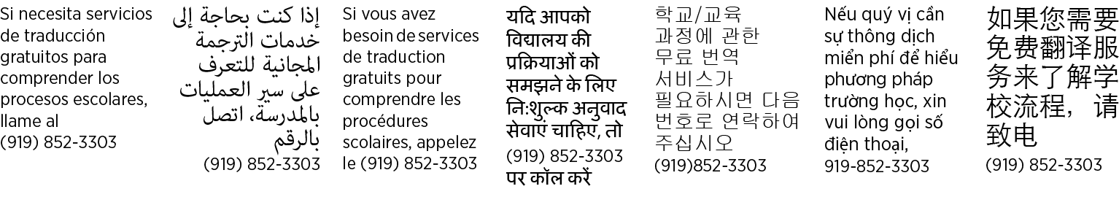
Student Name (printed)______________________________________________________________

- I have read the classroom syllabus and expectations for Mrs. Cowley’s classroom at Heritage High School. I understand that if I am using my phone in class without permission, Mrs. C will take my phone. I understand these expectations and agree to follow them while in science class. I understand the consequences should I choose not to follow these rules.

Signature ______________________________________ Date _________________

Parent Signature__________________________________ Date_________________

Parent Contact Information
Phone___________________________________________

Email____________________________________________

- I have read the classroom and laboratory safety rules for Biological/Life Science at Heritage High School. I understand these rules and agree to follow them while in science class. I understand the consequences should I choose not to follow these rules.

Student Signature ______________________________________ Date _________________

- As members of the Heritage community, we commit ourselves to act honestly, responsibly, and above all, with honor and integrity in all areas of campus life. We are accountable for all that we say and write. We are responsible for the academic integrity of our work. We pledge that we will not cheat.
I accept responsibility to maintain the Honor Code at all times. (Source: Wheaton College)

Student Signature:

I have read and reviewed the Heritage Husky Code with my child as it pertains to Science.
Parent Signature
Violations of Honor Code: As student has violated a trust, logical consequences are limiting the privileges which show we trust the student. One or several of the consequences will be assigned:
- Student will receive a zero on the assignment. They will receive an additional assignment which will be averaged with that zero.
- Loss of privilege to attend extra-curricular activities (dance, games, etc.)
- Loss of privilege to drive to school
- Loss of privilege to determine how you will spend Lunch
- Loss of leadership positions/removal from clubs and or sports
- Denial of future access to dual enrollment opportunities
- Detention>OSS on the discipline scale

