Sugar, Starch, Glycogen, Cellulose

Polysaccharides

Building Block: Monosaccharide
(ex. Glucose)

Short-term energy storage

Structural support for plants

bread, rice, potatoes, pasta, fruit, lettuce, cereal, beans

Insulin, Hemoglobin, Hormones, Enzymes
Building Block:
Amino Acid

Cell metabolism, immune system, organ structure, muscle contraction, oxygen transport

Eggs, beans, meat

The folding of the polymer is important to its proper functioning

Fats, oils, waxes, steroids, cholesterol

Building Blocks: 3 fatty acids attached to a glycerol molecule

Can be saturated (full of hydrogen, all single bonds) or unsaturated (less hydrogen, some double bonds)

Insoluble in water

Long-term energy storage, insulation, water-proofing, protective coverings for organs, making hormones, cell membranes
Meat, dairy, cooking oil, peanuts

DNA, RNA

Building Block: Nucleotide (contains a nitrogenous base, a simple sugar, and a phosphate group)

Contains info about heredity and protein synthesis

Forms a double or single helix

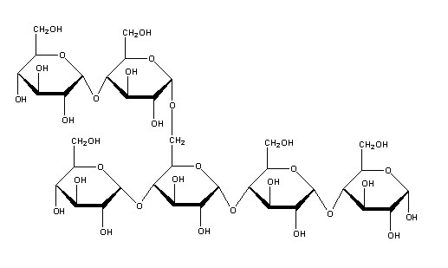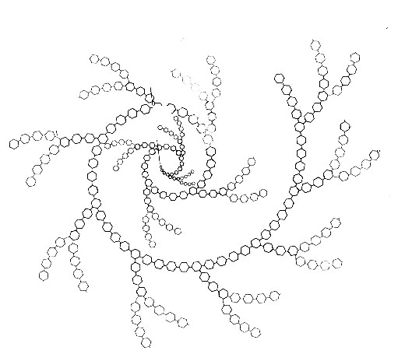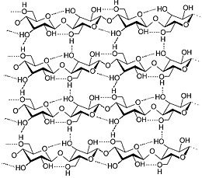

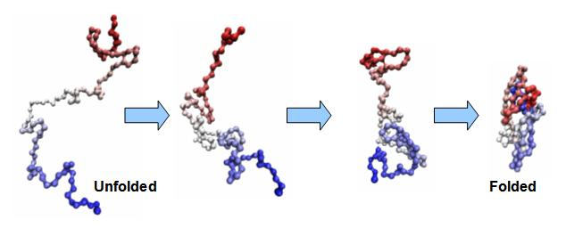

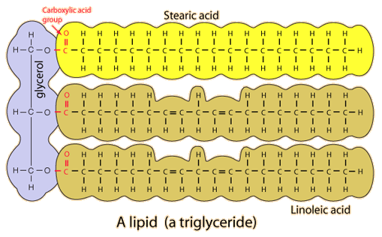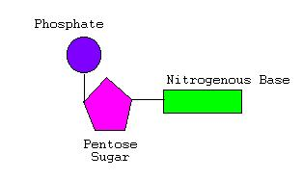

Carbohydrates

Lipids

Proteins

Nucleic Acids

Carbohydrates

Lipids

Proteins

Nucleic Acids

Carbohydrates

Lipids
Proteins

Nucleic Acids

Carbohydrates

Lipids

Proteins

Nucleic Acids

Carbohydrates

Lipids

Proteins

Nucleic Acids

