Cancer and the Cell Cycle
Using Fig. 3.21 pg. 66 in your textbook, answer the following
- The cell cycle is divided into four major phases: ______________________, _______________________, ____________________, and _________________________.
- Cell division occurs during ______________________________.
- DNA synthesis occurs during _______________________________.
- The purpose of cell division is for ___________________________ and ___________________.
- At the _______________________________, the cell decides whether it should divide. If so, _______________________ is replicated.
- Most cells don’t divide forever. Most types of cell divide _____ to _____ times. A cell “knows” when to stop dividing because of a built- in __________ on the chromosome tips called _____
Label and color the diagram below:
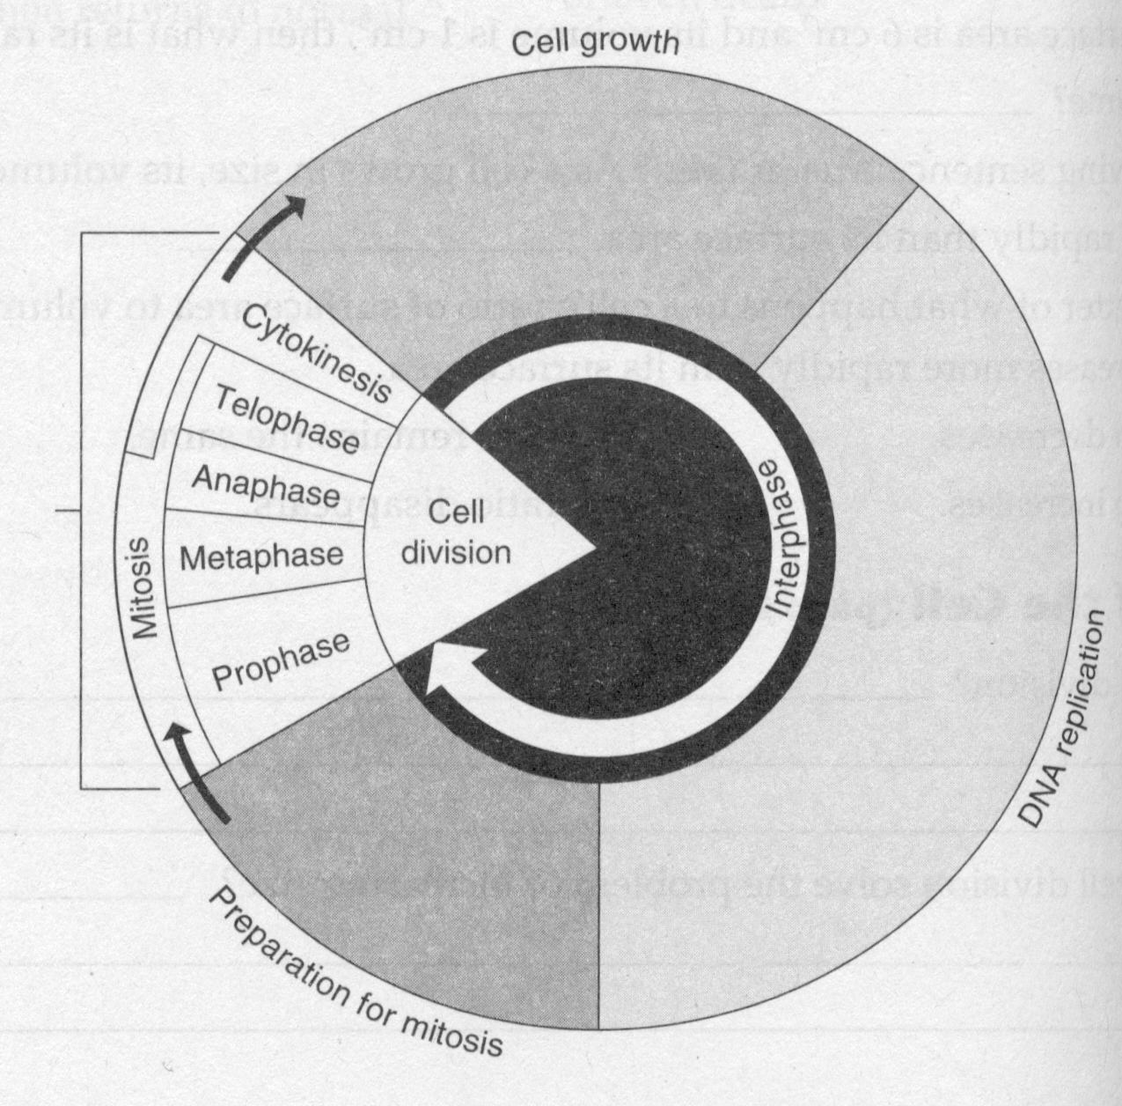
○ G₁ phase
○ G₂ phase
○ S phase
○ Mitosis

- List the phases of mitosis in order:

- Label the diagram below using the word bank:
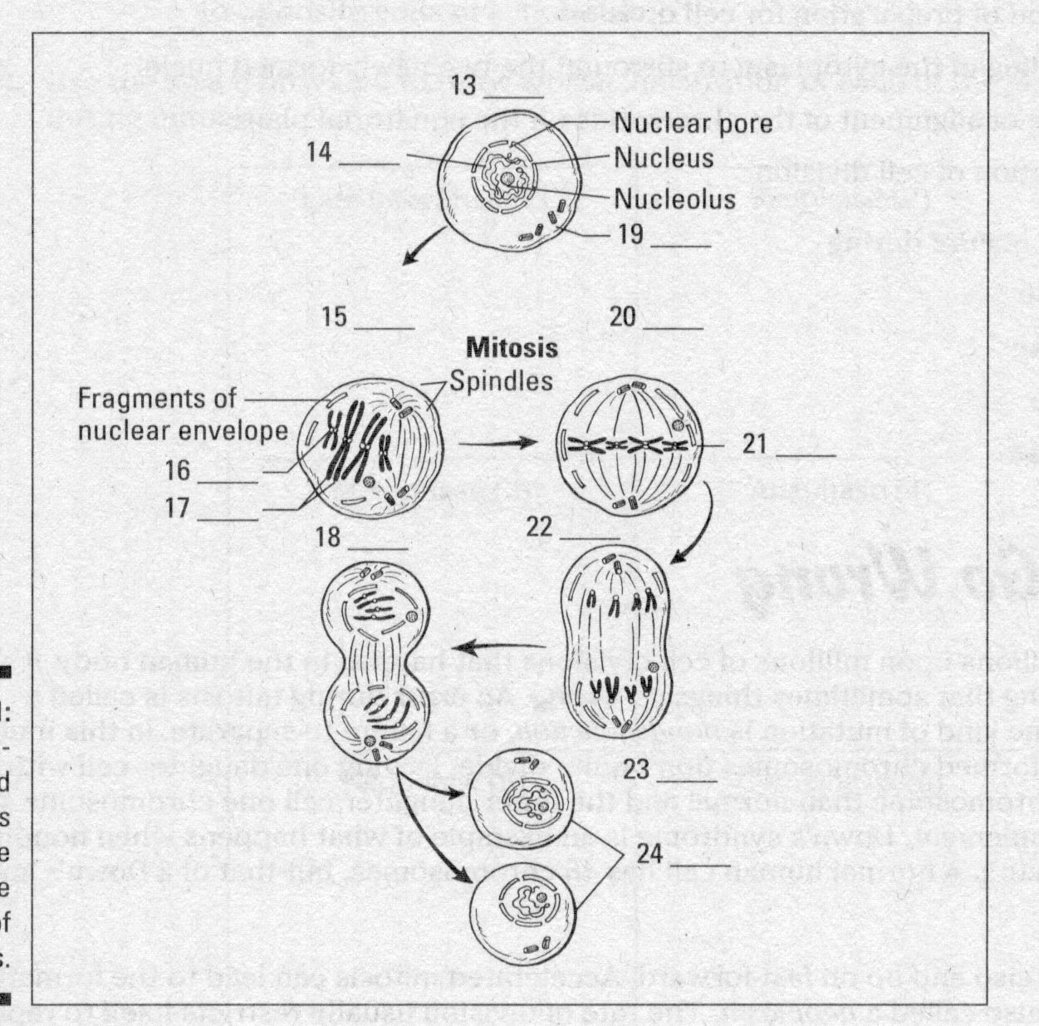

  - Anaphase
  - Centrioles
  - Centromere
  - Chromatids
  - Chromatin
  - Chromosomes lined up at equator
  - Cytokinesis
  - Daughter cells
  - Interphase
  - Metaphase
  - Prophase
  - Telophase

Visit the website: How Cancer Grows at http://www.pbs.org/wgbh/nova/body/how-cancer-grows.html If you are using an Apple device, you will have to choose Printable Version instead of interactive
Answer the following questions:
- All cancers begin with a __________________________________ within a body cell and advance when the ________________________________________________.
- Cancer found within epithelium, such as that found in the epidermis, breast, prostate and other organs is called _______________________________.
Click on How Cancer Grows and answer the following questions:
- Where are epithelial tissues found? ______________________________________
- A parent cell creates two daughter cells with ____________________________ DNA.
- What are two ways that DNA can suffer a mutation? __________________________________ and ______________________________
- How do body cells replicate periodically? _________________________
- Why do body cells replicate? _____________________________________
- How do these cells know that replication is required? ___________________________
- A mutation can cause a cell to _________________________ even though the tissue surrounding it does not need replacement cells.
- Over time, the altered cells can reproduce uncontrollably, _________________________ the healthy, unmutated cells.
- Normal cells have ____________________________________ that look for damage and for problems in their own systems.
- Mutations can occur in this area of the genome, causing a cell to not _______________________________.
- The tumor is still _____________________________ if it remains in the tissue in which it originated.
- If the mutated cells push through the ______________________________, the cells are no longer contained.
- __________________________________ is the recruitment of blood vessels into the tumor, accelerating the growth of the cancerous cells.
- Individual cells can now invade _________________________ and ______________________ vessels and spread to other areas of the body.
- When tumor cells move to other locations in the body, they have _________________________.
- How do these tumor cells form a new colony? _________________________________

Put the following pictures in the correct order, by indicating 1, 2, 3, 4, or 5.

Now, return to the How Cancer Grows homepage and choose Angiogenesis Explained. Again, choose printable version if you have an Apple device.
- Angiogenesis is the growth of blood vessels. When does this occur? _________________________, ________________________, and _______________
- Abnormal, uncontrolled angiogenesis spurs the ________________________________.
- What can determine the difference between a small, benign tumor and one that is able to spread? ________________________________________
- How do cancerous cells stimulate blood vessel growth? ____________________________________
- How does Avastin work to fight the growth of tumors? __________________________
- What cells form the initial scaffolding of new blood vessels? ______________________
- What type of molecules help the endothelial cells adhere to one another? __________________________
- What are two ways that the tumor is enabled by the new blood supply? ________________________________________________________________
- Why is cancer treatment that targets angiogenic growth so complex? ________________________________________________
- These anti-angiogenesis drugs are used in conjunction with what other forms of treatment? ________________________________

