Cells Part 2 Study Guide (Photosynthesis, Respiration, Mitosis, and Cell Specialization)
Chromosomes
- Contain all DNA
- Shaped like an X when all DNA has been copied (each half of the X is a chromatid and it is identical to the other half of the X)
Mitosis
- Once cell doubles everything inside, and then splits into two new cells (new cells = daughter cells)
- The daughter cells are identical to the original cell
- The daughter cells have identical DNA to each other and to the original cell
- Also called “asexual reproduction”
- Cancer results when cells divide rapidly and uncontrollably – known causes of cancer include smoking and genetic influences
- Phases of mitosis
  - Interphase (cell growth, repair, eliminate wastes)
  - Prophase – cell preparing for division
  - Metaphase (middle) – chromosomes line up in middle of cell
  - Anaphase (apart) – Chromosomes are pulled apart
  - Telophase (two) – cell splits into two new cells
    - Cytokinesis – vocab word for cell splitting in two (if cytokinesis did not occur, the original cell would have two nuclei!)
      - In plant cells – a cell plate forms to split cell in two
      - In animal cells – the cell membrane pinches closed
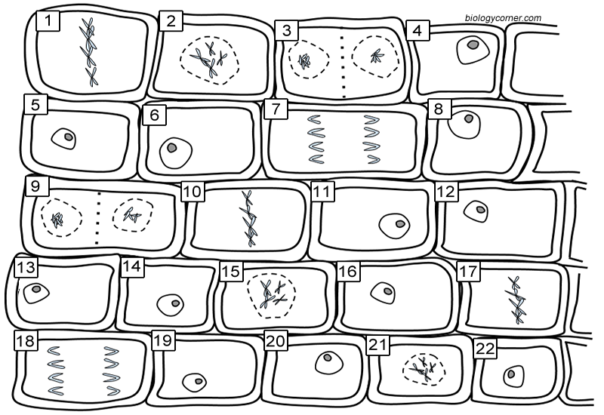
←Plant cells undergoing mitosis
4, 5, 6…Interphase
2 – Prophase
10 – Metaphase
18 – Anaphase
3 – Telophase

Cellular Respiration vs. Photosynthesis
- ALL CELLS (including autotrophs and heterotrophs) carry out cellular respiration.
- ONLY AUTOTROPHS carry out photosynthesis
Photosynthesis
- Chloroplasts are only found in plant cells because plant cells capture light energy from the sun to make their own food.
- Plant cells capture light with the chlorophyll inside the chloroplasts
- Plants take in carbon dioxide and let off oxygen (which can show up as bubbles on the leaves)
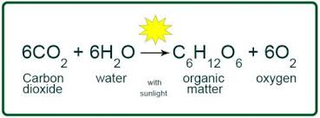
Reactants: carbon dioxide & water
Products: Glucose & oxygen

Cellular Respiration
- ATP is the source of energy for all cell activities in all cells
- Must have mitochondria to make energy (ATP) from glucose
- Aerobic vs. anaerobic respiration
- Aerobic – uses oxygen, makes lots of ATP (36) to use for energy
  - Most organisms perform aerobic than anaerobic because it makes more ATP!
  - Takes place in mitochondria of cells
- Anaerobic – does NOT use oxygen, only makes 2 ATP
  - Takes place in cytoplasm of cells
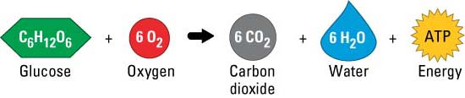

Cell specialization
- All cells from your body start from a single cell (fertilized egg) and then specialize into different types of cells
- Different cells all have the same DNA, but they can turn into different types of cells (liver, heart, brain) by turning off different genes in the DNA
- The original cells are stem cells, which can then develop into many different tissue types (and be used to treat diseases)
- Heart cells have more mitochondria than cells in other body parts because heart cells require a lot of energy to keep pumping.

General Information
- Ribosomes – make proteins by bonding amino acids together
- Active transport requires ATP, which is made in the mitochondria
- Homeostasis – when body organs work to keep every balanced in the body
- Prokaryotic cells – NO membrane bound organelles
- Cell membranes made primarily of lipids
- Plants are autotrophs (organisms that makes it own glucose)

