Viruses, phospholipid bilayers and such
We’ve discussed before that viruses, are not alive. They have some of the characteristics of living things, such as containing genetic material, but they don’t grow, they lack machinery for reproduction, lack homeostasis, and do not require energy. It’s best to think of viruses as nano-scale robots carrying out a genetic program to get inside of a host cell and force the host cell to make copies of the virus.
The simplest and most dangerous viruses, are simply made of genetic material coated in proteins. The proteins dock with host cell surface proteins, which trick the host cell into letting the virus or its genetic material inside.
Some viruses, however, are much more complex. By now, you’re probably familiar with this image of COVID 19:
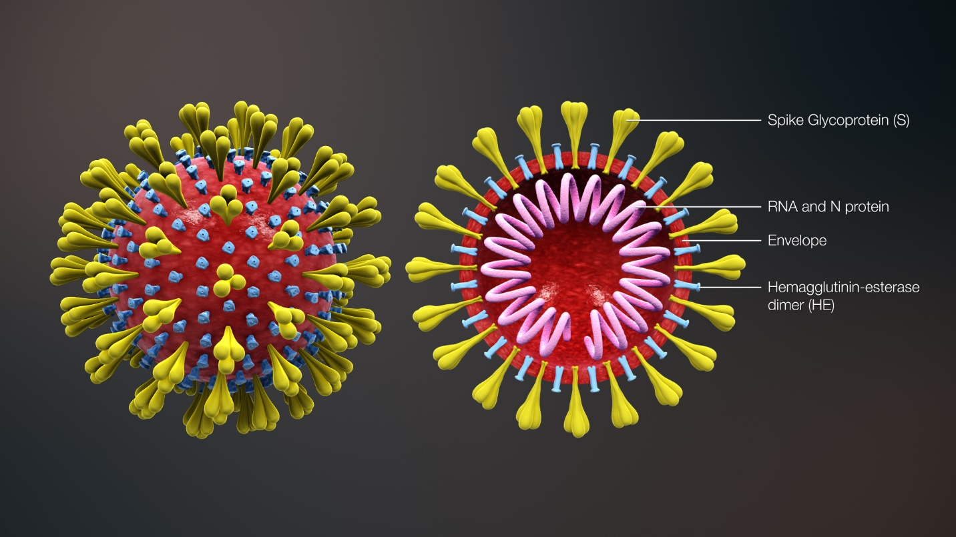
“3D Medical Animation Corona Virus.” Wikimedia Commons, Wikimedia Project, 27 Jan. 2020, commons.wikimedia.org/wiki/File:3D_medical_animation_corona_virus.jpg.
COVID 19’s genetic material is RNA. Like other viruses, it too contains surface proteins, as well as structure called an “envelope.” Not all viruses have envelopes, but when they do, they use phospholipids from their host cell’s membranes to construct the envelope. This means that the envelope is a phospholipid bilayer!
Structurally, corona viruses, like COVID 19, are similar to other viruses which have envelopes. Here’s a generalize image of influenza:
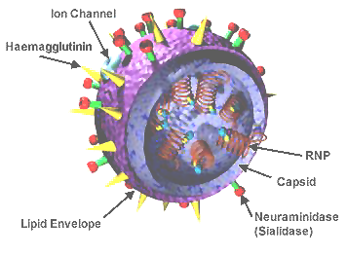
“3D Influenza Virus.” Wikimedia Commons, Wikimedia Project, 5 Apr. 2009, commons.wikimedia.org/wiki/File:3D_Influenza_virus.png.
Note, influenza also has a phospholipid envelope.
While the envelope offers protection to the virus’ genetic material, it’s also the key to its undoing. Remember, we said that soaps are also made of phospholipids. The article below explains how and why soaps work:
Using the two-column notes format (One column for what you read, one for what it means), take notes as you read the article at the following link:
https://www.wral.com/coronavirus/why-soap-sanitizer-and-warm-water-work-against-covid-19-and-other-viruses/19026202/
- Draw a picture of a soap phospholipid. Label its parts. Why does the article compare its structure to a sperm cell? Be sure to label which part is hydrophobic and which part is hydrophilic.
- Draw a soap molecule “attacking” a COVID 19 virus, as described in the article. Describe why the soap “attacks” in this fashion. Be sure to be clear about what part of the virus is the “skin” described in the article.
- Using what you know about the structures of the viruses and bacteria mentioned in the article, describe why soap is effective at preventing infections.
- Hand sanitizers are not made of phospholipids. Instead, they contain alcohol. Why are these effective at destroying viruses and killing bacteria? Be sure to describe what they do to the structures of the viruses and bacteria.
- Why is warm water better than cold? Relate this to lather and bubbles formed by soap.
- Why is a jail cell a good analogy for a soap bubble?
- If you don’t have a sink and soap available, is hand sanitizer just as good? Justify your answer with quotes from the article.

