Name _________________________

DNA, RNA and DNA Replication
A: Nucleic Acid Structure
1. Define the following terms in your own words
a. DNA
b. RNA
c. Nitrogenous Base
d. Double helix
e. Hydrogen bond
f. Phosphate
g. Pentose sugar
h. Nucleotide
2. Complete a Venn Diagram to compare and contrast DNA and RNA:
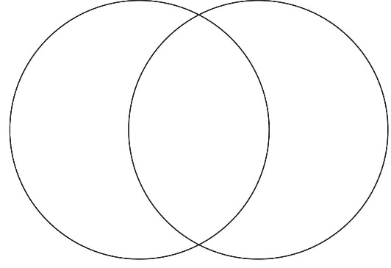
RNA
DNA
3. List the 4 Nitrogenous bases in DNA and state the complimentary base pairing rule:
a. __________________________ which is abbreviated __
b. __________________________ which is abbreviated __
c. __________________________ which is abbreviated __
d __________________________ which is abbreviated __
The complimentary base pairing rule states that ___ always bonds with ___ and ___ always bonds with ___ in DNA. It's the same with RNA except that the base __________ replaces ___________ so that ___ bonds with ___.
4. Which are stronger, hydrogen bonds or covalent bonds? ______________________________
5. Draw a DNA nucleotide and identify where covalent bonds are and where a hydrogen bond would form.

6. What is the structure of DNA called? ____________Is it single or Double standed?___________________
7. List the 3 parts of a DNA nucleotide: _________________________________________________________________
8. Which parts are on the outside of a DNA molecule? __________________________________________
9. Which parts are on the inside of a DNA molecule? ___________________________________________
10. What is the complimentary strand of DNA for ACCGTA? _____________________________
11. List the 3 parts of a RNA nucleotide: _________________________________________________________________
12. What types of bonds are between nitrogen bases in DNA? _________________________ Are these bonds weak or strong? _______Why is this important?______________
13. What types of bonds are between deoxyribose and phosphate molecules in DNA? ___________________________ Are these bonds weak or strong? ________________________

B: Replication
- In your own words using less than 5 words, define Replication.

- List the 3 steps of DNA replication.

3. Replication is a process that's not part of DNA's everyday function. Instead, it's only used in preparation for 1 important cell process that we've learned about. What is that process? ______ ________________
4. Play the simulations and animations on Replication at:
https://www.youtube.com/watch?v=dKubyIRiN84
http://highered.mheducation.com/sites/0072943696/student_view0/chapter3/animation__dna_replication__quiz_1_.html
Sketch and describe a replication fork. Why is "fork" an appropriate name?

5. What biochemicals (from the Biochemistry Unit) support the process of replication by doing things like untwisting/re-twisting DNA, positioning new nucleotides, proofreading the new strand, etc?
6. Replication is said to be a semi-conservative process. What does that mean? (Hint: think about what it means to conserve something. What's being conserved during replication?)
7. Once DNA is replicated, does it stay in the nucleus or leave? Why?

