CRIME SCENE INVESTIGATION

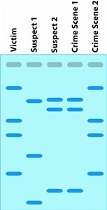
Home Burglary
- Crime Scene Sample #1 matches whose DNA? ________
- Crime Scene Sample #2 matches whose DNA? ________
- Who did the crime: Suspect 1 or Suspect 2? __________
- Who has the smallest fragment of DNA? _________
- Who has the largest fragment of DNA? _________
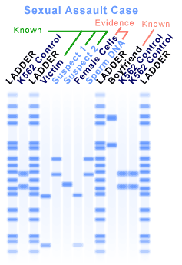
Murder Crime Scene
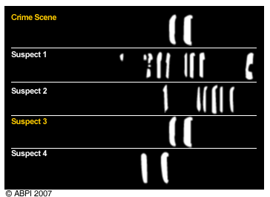

Sexual Assault Case Murder Crime Scene
6) Who did the crime? _____________ 7) Who did the crime? ______________
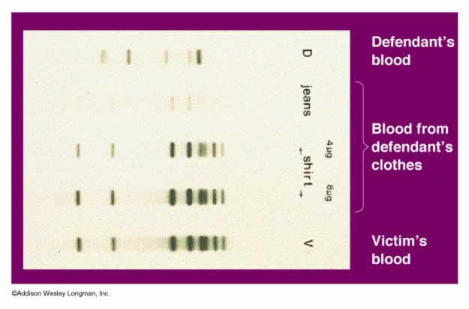

Assault with a Deadly Weapon

8) Is the defendant guilty? Circle One: YES / NO
9) How do you know?

WHO ARE THE PARENTS?

Is this the Real Father?
DNA Fingerprints (four DNA samples from the same people):
#1 #2 #3 #4
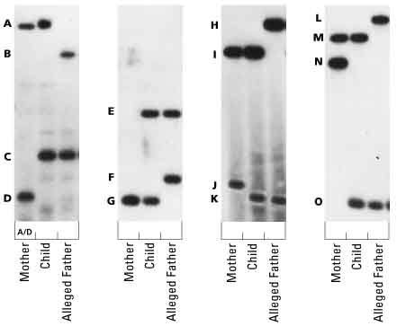
Example:
Fingerprint #1: Mother’s Genotype: AD, Child’s Genotype: AC, Alleged Father’s Genotype: BC
#2) Mother’s Genotype: ____, Child’s Genotype: ____, Alleged Father’s Genotype: ___
#3) Mother’s Genotype: ____, Child’s Genotype: ____, Alleged Father’s Genotype: ___
#4) Mother’s Genotype: ____, Child’s Genotype: ____, Alleged Father’s Genotype: ___

5) Is the alleged father the real father of the child? Circle: YES / NO

Identifying a Soldier’s Remains

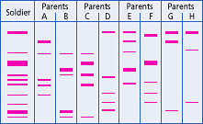

6) Who are the parents of the soldier? ____________

