DNA Structure (DNA = ________________________________________________)
- What type of organic molecule is DNA? _______________________
- Where does DNA replication occur? _____________________
- During which phase of the cell cycle does DNA replication occur? ___________________

- Building blocks of nucleic acids are ________________________________.
  - The three parts of a nucleotide are: ________________________, ________________________, and ___________________.

- The structure of DNA is a ___________________________ which looks like a coiled ladder.
  - The sides of the ladder alternate between a __________________________ and a _________________________, bound together by ____________________________ bonds. This is sometimes called the “backbone” of the DNA.
  - The steps of the ladder are ________________________ with ___________________________ bonds between them.
  - Who is credited with the discovery of the structure of DNA? _________________

- There are four types of nitrogen bases in DNA:
  - _________________________ bonds to _________________________
  - _________________________ bonds to _________________________

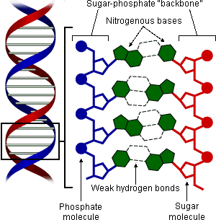
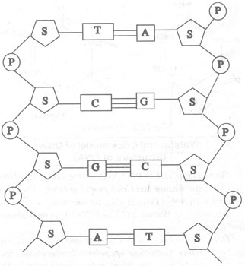
DNA Replication
- ________________________ unzips the double helix, breaking the __________________ bonds between nitrogen bases.
- ________________________ comes in and begins to add new nucleotides to the parent strand.
- When process is complete, two ________________________ strands of DNA are produced.

Unzip with helicase.
Add matching bases.
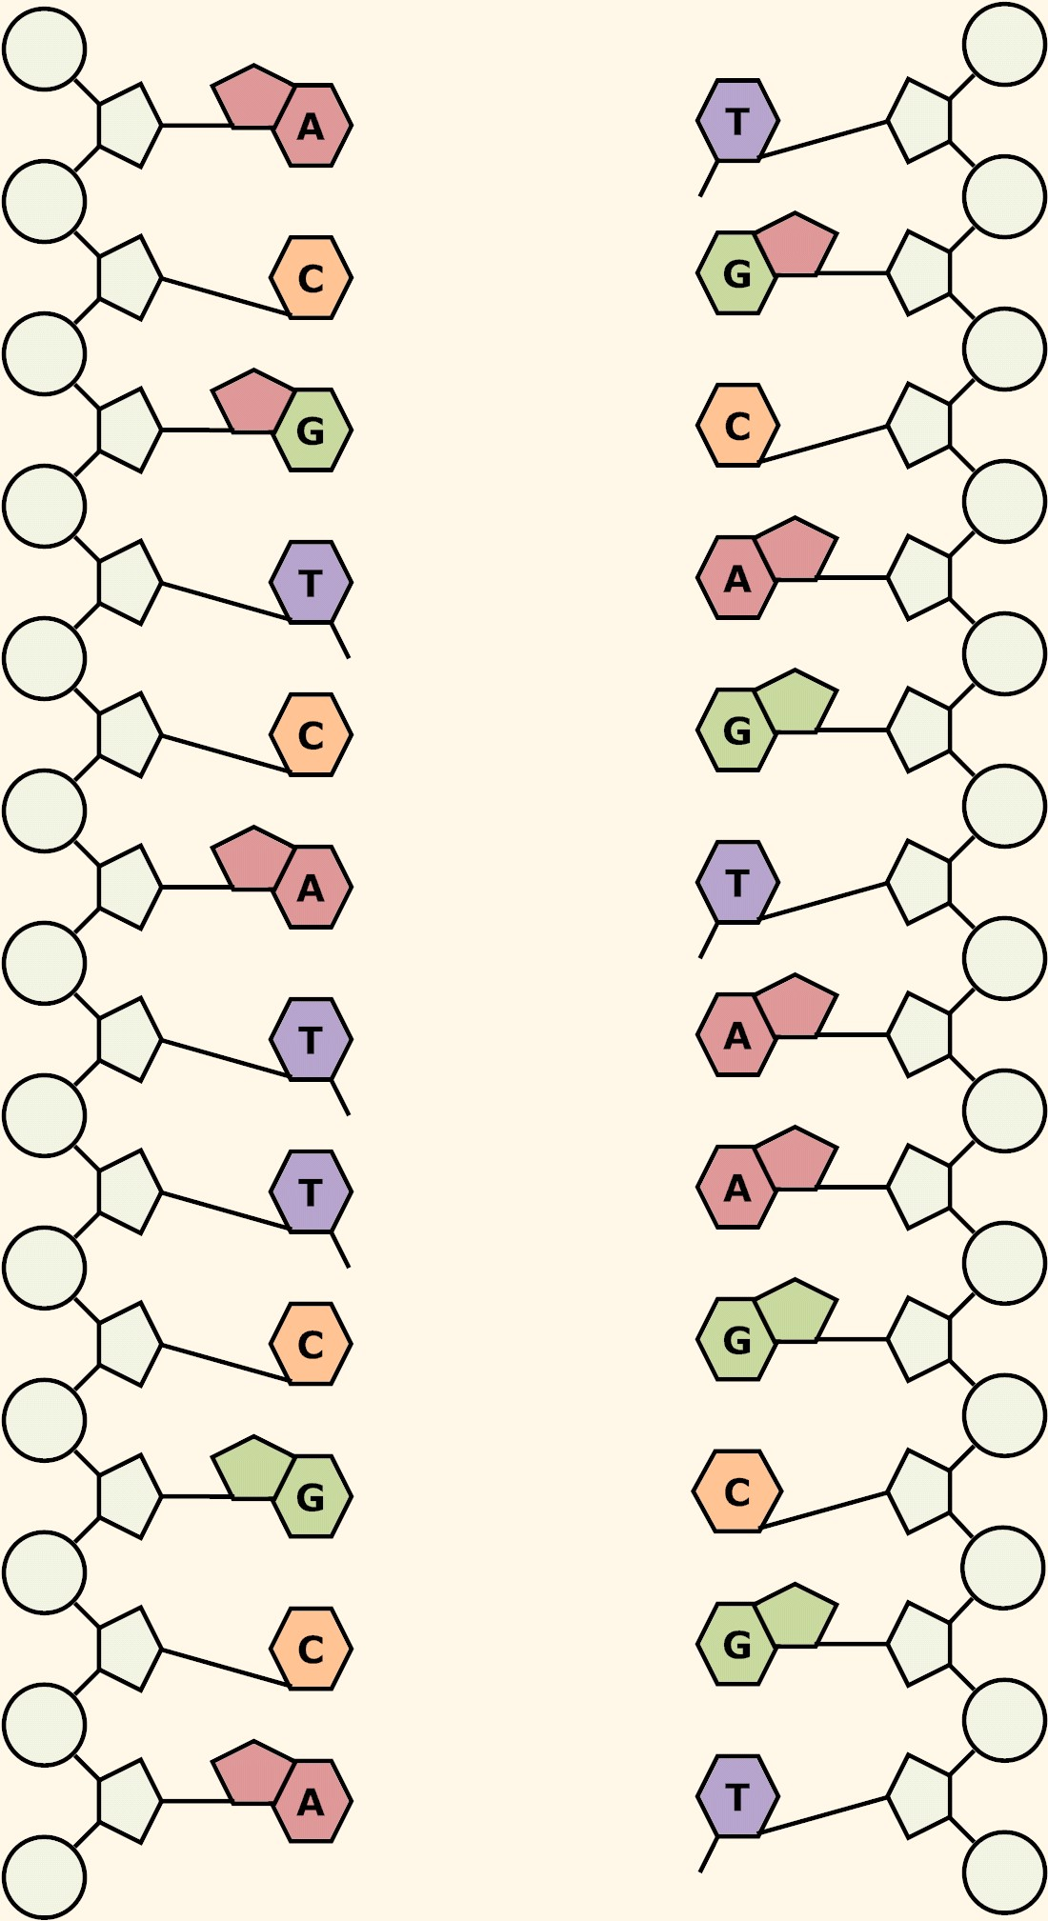
Draw helicase and DNA polymerase.
