Evolution and Behavior
References: Textbook Ch. 15 and Ch. 33
Test Date: _______________________
A: Evolution by Natural Selection
- Watch the following video clips. Write down two facts you learned and one question from each video:

- https://www.youtube.com/watch?v=1BLXV1qO03w
- https://www.youtube.com/watch?v=0SCjhI86grU
- https://www.youtube.com/watch?v=lIEoO5KdPvg

- Compare and contrast Lamarck and Darwin’s theories of evolution (how organisms change over time).

- Label the picture below:
Which side of the graphic describes Lamarck’s view of giraffe evolution?
Which side of the graphic describes Darwin’s view of giraffe evolution?
Which side of the graphic shows evolution by Natural Selection?
Which side of the graphic shows evolution by Acquired Traits?

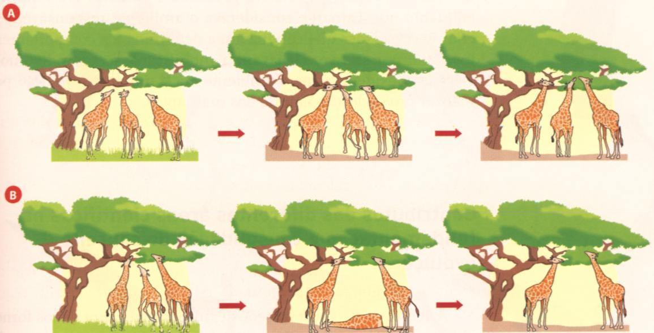

B: Evidence & Speciation
- What evidence did Darwin use to determine evolutionary relationships? Did Darwin use amino acid and DNA evidence to support his theory?

- Define homologous structures.

- What does this graphic tell us about a human, cat, whale and bat?
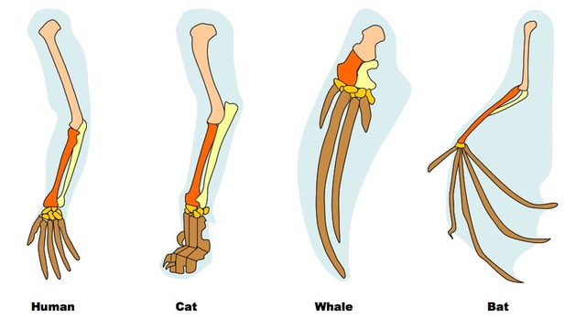

- Define the following terms. Each definition should be in your own words.
  - Natural Selection
  - Speciation
  - Geographic Isolation
  - Genetic Variation
  - Common Ancestor
  - Behavioral Isolation
  - Phylogenetic Tree
- Make a concept map that shows how natural selection leads to speciation. Include the following terms: evolution, natural selection, genetic variation, environment, speciation and divergence (make sure you indicate how these terms are related)

- Based on this graphic, which two species are the most closely related? Explain how you know.

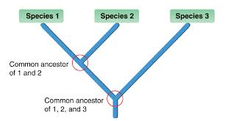

C: Immunity and Viruses
Use your book and the information at https://www.youtube.com/watch?v=CeVtPDjJBPU to answer the following:
- Why is your immune system necessary?
- Define and describe in your own words: Antigen, Pathogen, Innate immunity, Acquired Immunity
- What are the first line of defense of the immune system? What are they designed to do?
- If you get a cut and it gets red and swollen, what does that mean? What’s causing the redness and swelling?
- Why are allergies considered to be an immune system overreaction?
- Why is the acquired immune system like a filing system or database?
- Most of the immune system parts mark antigens and send out chemical signals. Why?
- How does an antibiotic work? Why are antibiotics only given for bacterial infections?
Use your book and the information at https://www.youtube.com/watch?v=PHp6iYDi9ko to answer the following:
- Some people compare viruses to robots. Describe why that’s an appropriate analogy
- True or false: Viruses are generalists that don’t specialize. Explain your answer.

D: Behavior

- Recreate the following chart and complete:
Term | Definition (your own words) | Example or Illustration
Innate
Learned Behavior
Foraging
Courtship
Imprinting
Habituation
Classical Conditioning
Territoriality
Reflex
Tropism

Answer the following as you view the video: Bozeman Behavior and Natural Selection
https://www.youtube.com/watch?v=vZNeRWchqRc

- Write a statement in your own words that explains the relationship between behavior and Natural Selection.
- What is phototropism and what mechanism allows plants to “move” toward sunlight? How does this an evolutionary advantage?
- Compare and Contrast phototropism and photoperiodism in plants.
- Why do female bowerbirds only mate with males who build the nicest bower? What is the evolutionary advantage?
- How is pollination related to co-evolution. Give Examples.

