THE EVOLUTION OF CANDY (H. chocolatius)

Problem:
How has the candy bar evolved from simple Hershey’s chocolate to the multitude of candy bars we have today? What are some derived characters (traits) that are found in the most evolved species of candy that the primitive ancestors of the chocolaty treats are missing? In this lab, you will attempt to create a diagram that will illustrate the evolution of candy, from simple beginnings to delicious results.
PROCEDURE
Identifying the Characteristics

- Using the chart below, make a list of the chocolate pieces from least highly evolved (the fewest ingredients) to most highly evolved (the most ingredients)
 | CHOCOLATE | PEANUTS | CARAMEL | NOUGAT
Milky Way | X |  | X | X
Hershey bar | X
Three Musketeers | X |  |  | X
Snickers | X | X | X | X

Creating the Cladogram

- Each time there is a new characteristic that shows up, your cladogram will have a new branch.
- Using the space below, construct your cladogram. When completed, your least highly evolved candy will be at the bottom, and your most highly evolved will be at the top.
- Label each branch of the cladogram with the characteristic that has evolved.

Cladogram of Candy

CONCLUSION QUESTIONS

- What could possibly be a common ancestor between your two least highly evolved chocolates?

- Where are the most highly evolved members of a species located on a cladogram?

- Where are the least highly evolved members?

- If a Hershey bar evolved into a 3 Musketeer’s bar, why are there still Hershey’s bars in existence (think about it!)?

- Create a cladogram with the groups of chordates provided. Draw the pictures on your cladogram. Label each branch in the cladogram with the trait that evolved between species.

Cladogram of Chordates
Chordates for Cladogram on Candy Lab

 | NERVOUS SYSTEM | RESPIRATORY SYSTEM | TEMPERATURE REGULATION | ABLE TO LIVE OUT OF WATER | TYPE OF  BIRTH | PICTURE
Mammals | DEVELOPED | LUNGS | ENDOTHERMIC | YES | LIVE | 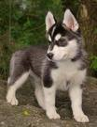
Amphibians | DEVELOPED | LUNGS | EXOTHERMIC | SOMETIMES | EGGS  (IN WATER) | 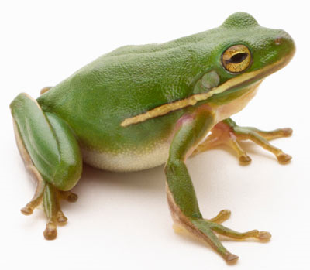
Reptiles | DEVELOPED | LUNGS | EXOTHERMIC | YES | EGGS  (ON LAND) | 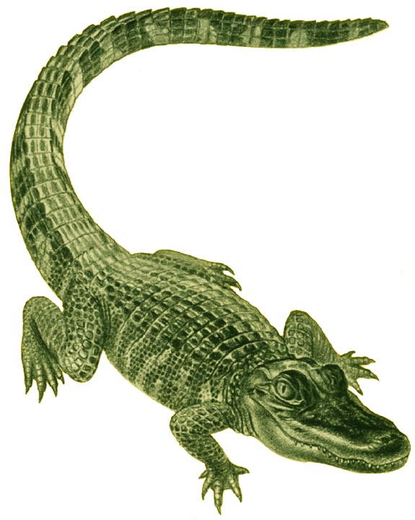
Birds | DEVELOPED | LUNGS | ENDOTHERMIC | YES | EGGS  (ON LAND) | 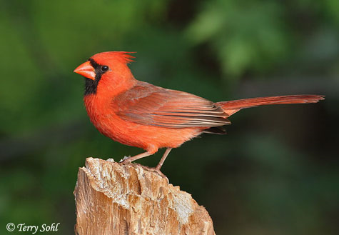
Fish | DEVELOPED | GILLS | EXOTHERMIC | NO | EGGS  (IN WATER) | 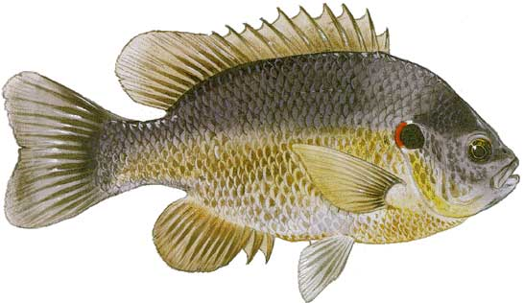
Tunicates | UNDER  DEVELOPED | GILLS | NO CIRCULATORY SYSTEM | NO | EGGS  (IN WATER) | 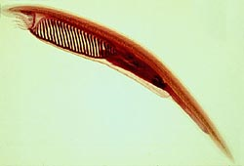

Making the Dichotomous Key

- Separate your seven pieces of candy into two groups. Identify your two groups and begin creating your dichotomous key. Remember, each step in your key should have two choices (example; chocolate/not chocolate). All of the candy should be identified in your key: Starburst, Skittles, Milky Way, Three Musketeers, Hershey Bar and Snickers.

Dichotomous Key of Candy

1 | a.
1 | b.
2 | a.
2 | b.
3 | a.
3 | b.
4 | a.
4 | b.
5 | a.
5 | b.

