Name______________________________________________________________________

Chemistry Study Guide for Final Exam –Fall 2016

Unit 1 Review

1. 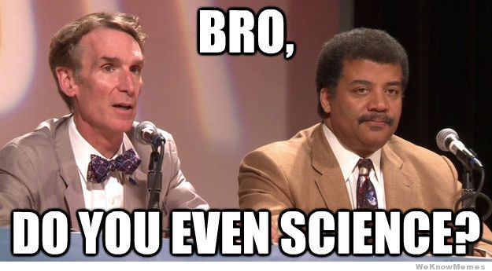 Conversions – convert the following:
2. 25 mL = _____________________ L
3. 729 m = _____________________cm
4. 545 m = ____________________ nm
5. 30,575 g = ___________________kg
6. .0034 L = ____________________mL
7. Density – calculate the following:

1. What is the identity of a metal with a density of 19.31 g/mL?

2. What is the identity of a metal with a mass of 5.3 grams and a volume of 1.18 mL?

1. Percent Error
2. In an experiment, the density of an alloy was found to be 5.49 g/mL. The actual density is 5.25g/mL. What was the percent error in the experiment?

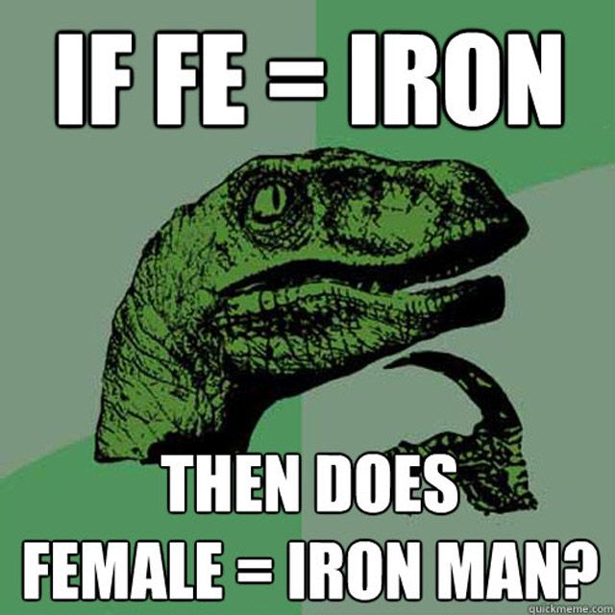

Unit 2 Review

1. Vocabulary – define the following terms:
2. Atomic Number:
3. Mass Number:
4. Isotope:
5. Ion:
6. Elements – fill in the chart below

|  |  |  |  |  |  |
| --- | --- | --- | --- | --- | --- |
| **Element** | **Atomic Number** | **Atomic Mass** | **# Protons** | **#Electrons** | **#Neutrons** |
| Oxygen |  | 12 |  |  |  |
|  | 20 |  |  |  | 20 |
|  |  | 75 | 33 |  |  |
| Br- |  | 80 |  |  |  |
|  |  | 88 | 38 | 36 |  |
| Chlorine - 37 |  |  |  |  |  |
| Chlorine - 35 |  |  |  |  |  |

1. **Light – Use the Bohr Hydrogen Model when answering the questions**
2. How are frequency and wavelength related?
3. When does emission of light from an atom occur?
4. a) What wavelength of light is produced during a transition   
   from n = 3 to n = 2? ______________________ nm = ______________________ m  
     
   b) What color of light does this correspond to? Color = ______________________
5. a) What wavelength of light is produced during a transition from n = 5 to n = 2?

______________________ nm = ______________________ m  
  
b) What color is the light that is released? Color = ______________________

1. **Nuclear**
2. Put the following particles in order of increasing mass:
   1. Neutron
   2. Alpha
   3. Beta
   4. Gamma Ray
3. Write an equation that shows Np-237 undergoing alpha decay.
4. Write an equation that shows Np-237 undergoing beta decay.
5. Identify the type of radiation: (alpha, beta, or gamma)

a. Uranium-234 To Thorium-230

b. Thorium-230 to Radium-226

c. Radium-226 to Radon-222

d. Radon-222 to Polonium-218

e. Polonium-218 to Polonium-218

**E. Half-lives**

1. If an element, Ah, has a half life of 25 years. What fraction would be left after 75 years?

2. Manganese-56 is a beta emitter with a half-life of 2.6hr. What is the mass of manganese-56 in a 1mg sample of the isotope after 10.4hr?

3. If a substance has a half life of 18.1 days how much of the substance will be left after 54.3 days?

**Unit 3 Review**

1. Periodic Table

1. What is the Octet Rule?

1. Fill in the chart below

|  |  |  |  |
| --- | --- | --- | --- |
| Element | Group # or Name | Period | Oxidation Number |
| Calcium |  |  |  |
| Nitrogen |  |  |  |
| Chlorine |  |  |  |
| Cesium |  |  |  |
| Boron |  |  |  |
| Helium |  |  |  |

1. How many energy levels are needed to hold the electrons of each of the following elements?
2. Ca - ______2. Al - ______3. He - ______4. I - _______
3. Trends on the Periodic Table
4. What element has the greatest electronegativity? ___________
5. What element has the greatest 1st ionization energy? ____________
6. What element is the largest? ____________
7. Describe the trend of electronegativity.
8. Describe the trend of ionization energy.
9. Describe the trend of size.
10. Where are the most reactive elements located on the periodic table? ____________________
11. Write the long hand electron configuration, short hand electron configuration, and the orbital diagram for the following elements.

|  |
| --- |
| Nitrogen |
| Strontium |
| Aluminum |
| Bromine |

**Unit 4 Review**

1. Name the following compounds (Determine if it is ionic (I) , covalent (C), or an acid (A)).
2. PBr3: ______________________
3. CuCl2: _____________________
4. Mg(NO3)2: __________________
5. CaSO4: _____________________
6. LiBr: ______________________
7. FeO: ______________________
8. NH4Cl: ____________________
9. CO: _______________________
10. Fe2O3: _____________________
11. N2O5: ______________________
12. AgCl: ______________________
13. ZnCl2: _____________________
14. SO3: _______________________
15. MgO: ______________________
16. H2O: _______________________
17. CCl4: ______________________
18. H2SO4: _____________________
19. HCl: _______________________
20. NaOH: _____________________
21. NH3: _______________________
22. Write the formula of each compound named below (Determine if it is ionic (I), covalent (C), or an acid (A)).
23. Calcium chloride: __________
24. Aluminum sulfate: __________
25. Lead (IV) chloride: __________
26. Lithium sulfide: __________
27. Ammonium phosphate: ________
28. Ammonium phosphide: ________
29. Diphosphorus pentoxide: _______
30. Aluminum oxide: __________
31. Sodium carbonate: __________
32. Aluminum sulfite: __________
33. Chromium (II) sulfide: ________
34. Potassium nitride: __________
35. Sulfur hexachloride: __________
36. Magnesium iodide: __________

15. Hydrobromic acid: ___________

16. Sulfuric acid: ______________

17. Calcium hydroxide: ____________

18. Nitrous acid: ______________

1. Ionic and Covalent Compounds: (Circle Correct Answer in Brackets)
2. Ionic compounds tend to have [higher / lower] melting points than covalent compounds.
3. Ionic compounds are generally [solids / liquids / gases] at room temperature.
4. Nonpolar covalent compounds are generally [solids / liquids / gases] at room temperature.
5. Which are more soluble in water (in general)? [ionic compounds / nonpolar covalent compounds]

5. Diatomic molecules are [covalent compounds/ionic compounds.] NAME the diatomic molecules.

**D. Shapes of Molecules:** Based on the vesper theory draw the molecular geometries of the following molecules:

a. H2O b. CO2 c. CH4  d. BH3

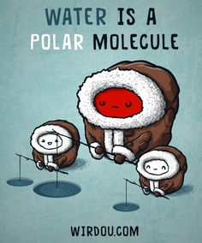

**Unit 5 Reivew**

1. Balance these equations! Identify the type of reaction
2. __FeCl3 + __NaOH 🡪 __Fe(OH)3 + __NaCl Classification: _________________
3. __C3H8 + __O2 🡪 __CO2 + __H2O Classification: _________________
4. __Ag2O 🡪 __Ag + __O2 Classification: _________________
5. __S8 + __O2 🡪 __SO3 Classification: _________________
6. __K + __MgBr2 🡪 __KBr + __Mg Classification: _________________
7. **__** C3H6O +___ O2 🡪____ CO2 + _____H2O Classification: _________________
8. ____P4 + ____ O2 🡪____ P2O3 Classification: _________________
9. ____ NO2 🡪 ____O2 + ____N2 Classification: _________________
10. **Predicting Products**
11. Circle which of the following will likely undergo a single replacement reaction.

Na and BaI2 / Zn and BaI2 / Ca and BaI2 / K and BaI2

1. Predict the products of the following equations:
   1. Na3PO4 + KOH 🡪
   2. Zn + Cu(NO3)2  🡪

**Unit 6 Review**

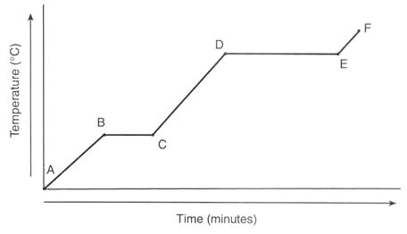A. Heat

1. Using the heating curve label:

a. Solid

b. Liquid

c. Gas

d. Melting

e. Boiling

1. How much heat is needed to increase the temperature of 4 grams of water from -25oC to -15oC?
2. How much heat is released when 30 g of liquid water changes into ice?
3. How much heat is released when 45 g of water at 30oC is placed in a freezer at -10oC?
4. The temperature of a sample of water increase from 20oC to 46.6oC as it absorbs 5650J of heat. What is the mass of the sample?
5. How much energy is required to raise the temperature of 50 g of water from – 10°C to 5°C?
6. What is the amount of heat required to raise the temperature of 500.0 g of aluminum by 15C? (specific heat of aluminum = 0.21 )



**B. Energy**

1. Identify what each line represents on the potential energy diagram to the right.

I._______________________________

II._______________________________

III.______________________________

IV.______________________________

V._______________________________

VI._______________________________

3. What phase of matter is this substance at each letter labeled on the graph “Phase Diagram”?

F.__________________

S.__________________

K.__________________

What is occurring at point H?_______________

What is occurring at point I? _______________

**Unit 7 Review**

1. Gas Laws
2. If the combined pressure of a mixture of two gases is 6 atm and one gas has a pressure of 2.5 atm . what is the pressure of the second gas?
3. The pressure of a sample of helium in a 1.0-L container is 0.988 atm. What is the new pressure if the sample is placed in a 2.0 L container?
4. The pressure in an automobile tire is 1.88 atm at 25oC. What will be the pressure if the temperature warms up to 37oC?

1. A sample of neon gas at 50oC and a volume of 2.5 liters is cooled to 25oC. What is the new volume?
2. At 0oC and 1.0 atm pressure, a sample of gas occupies 30 mL. If the temperature is increased to 30oC and the entire gas sample is transferred to a 20 mL container, what will be the gas pressure inside the container?
3. What volume will 5 moles of chlorine gas occupy at 100 torr and 25oC?
4. How many moles of Nitrogen gas occupies 2 L at STP?

**Unit 8 Review**

1. Empirical and Molecular Formulas

1. Determine the empirical and molecular formulas of each of the following compounds from the percent composition:

* 1. 7.8% carbon and 92.2% chlorine. The molecular mass = 153.8 g/mol
  2. 40.1% carbon, 6.7% hydrogen, 53.2% oxygen. The molecular mass = 180.1 g/mol

1. Determine the Percentage Composition (by mass) of each of the compounds below.
2. MgBr2  
   Mg:_____ Br: _________
3. (NH4)2S  
   N: _____ H: _________ S: ________
4. 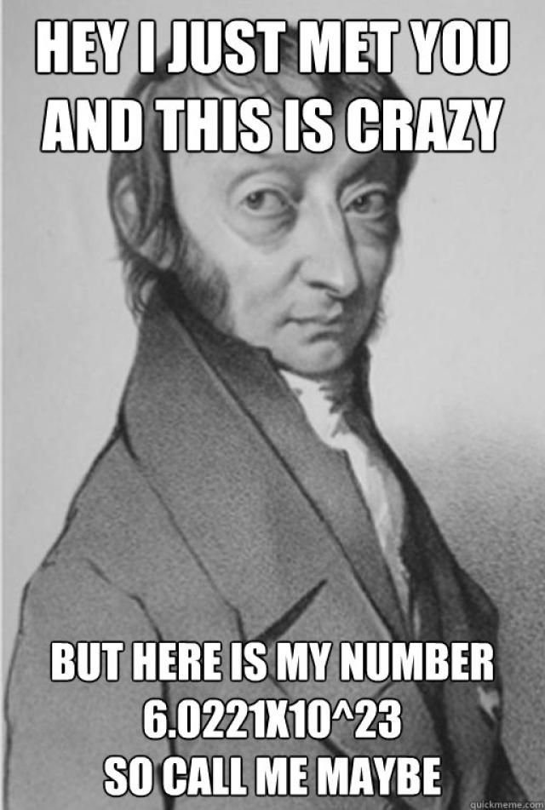 Stoichiometry
5. How many moles of silver are there in 6.9 x 10 28 silver atoms?
6. What is the molar ratio of P4 to O2 in the following reaction:

P4 + 3 O2 🡪 2 P2O3

1. How many liters of F2 do you have if you are given 100 grams of F2?
2. 5 moles of oxygen gas is equal to how many grams?
3. How many moles of product are formed from 50 grams of N2 and excess H2?  
   N2 (g) + 3H2 (g) 🡪 2NH3 (g)
4. How many liters of H2 are needed to react with 60 grams of N2?  
   N2 (g) + 3H2 (g) 🡪 2NH3 (g)
5. How many Liters of NH3 are formed if 2 moles of N2 reacts with excess H2?  
   N2 (g) + 3H2 (g) 🡪 2NH3 (g)
6. How many grams of aluminum are needed to produce 8 moles of aluminum oxide?

4Al + 3O2 🡪 2Al2O3

1. Considering this balanced chemical equation, how many grams of HgO will be produced when 54 g of Hg react with excess O2 ?

**Unit 9 Review**

**A. Molarity and Dilutions**

1. What is the molarity of .34 moles of CaCl2 dissolved in water to make 0.56 L of solution?

2. 25 mL of a .1 M NaOH solution is diluted to 100 mL. What is the new molarity?

3. A solution of 6 M HCl was diluted to 500 mL. The final solution had a concentration of 2 M. How much of the 6 M solution needed to be used for this dilution?

4. 0.123 moles of LiOH were used to make a .25 M solution. How many liters were able to be made?

**B. Solubility**

5. For each of the following, indicate whether they are soluble or insoluble in water. How do you determine solubility?

1. 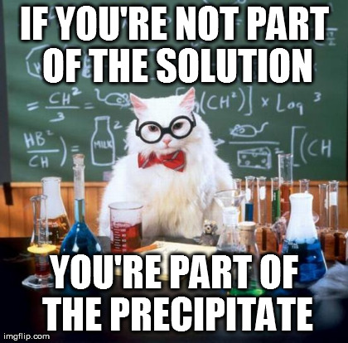Aluminum sulfide
2. Calcium carbonate
3. Iron(III) hydroxide
4. Potassium sulfate

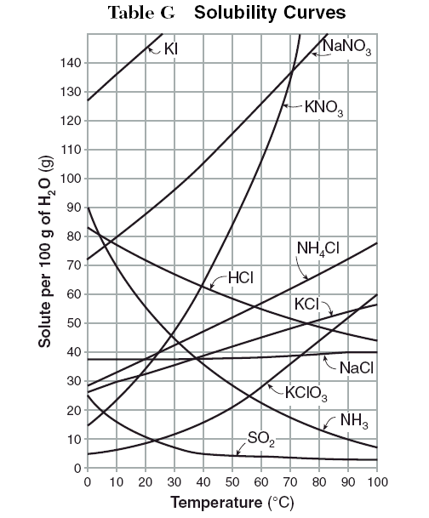Using the solubility graph provided, for the following questions.

1. How many grams of KNO3 can be dissolved in 100 g of water at 60oC? ______________
2. If 90 g of NH4Cl are dissolved into 100 g of water at 90oC, is the solution saturated, supersaturated, or unsaturated? (circle)
3. How many grams of KClO3 can be dissolved in 100 g of water at 50oC? __________________
4. If 100 g of NaNO3 are dissolved in 100 g of water at 20oC, is the solution saturated, supersaturated, or unsaturated? (circle)
5. Why does powdered sugar react faster than sugar cubes in a chemical reaction?

C. **Equilibrium**

1. Using the information below, determine which way equilibrium shifts using the following reaction: (Circle the correct answer)

180J + CH4(g) + 2H2S(g) ↔ CS2(g) + 4H2(g)

(a) Decrease the concentration of dihydrogen sulfide. (RIGHT / LEFT)

(b) Increase the pressure on the system. (RIGHT / LEFT)

(c) Increase the temperature of the system. (RIGHT / LEFT)

(d) Increase the concentration of carbon disulfide. (RIGHT / LEFT)

(e) Decrease the concentration of methane. (RIGHT / LEFT)

2. Using the information below, determine which way equilibrium shifts using the following reaction: (Circle the correct answer)

2SO3(g) ↔ 2SO2(g) + O2(g)

(a) Sulfur dioxide is added to the system.

(b) Sulfur trioxide is removed from the system.

(c) Oxygen is added to the system.

3. Write the equilibrium constant equation for the following reactions:

(a) 4NH3 (g) + 3O2 (g) ↔ 6H2O (g) + 2N2 (g)

(b) N2 (g) + 3 H2 (g) ↔ 2 NH3 (g)

**Unit 10 Review**

**A. Calculating pH, pOH, [H+], and [OH-]**

1. What is the pH if [H2SO4] = 2.5 x 10-4 M? _____________ Is it an acid or a base? _____________

2. What is the pH if [Ca(OH)2] = 0.090 M? _____________ Is this an acid or a base? _____________

3. Find the concentration of hydrogen ions if the pH is 3.2. _____________

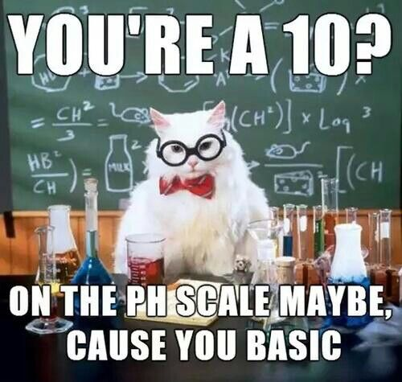4. Find the concentration of hydroxide ions if the pOH is 5.6. _____________

5. Find the [H3O+] in a solution if [OH-] = 3 x 10-6 M. _____________

6. Find the [OH-] in a solution if the [H+] = 9.4 x 10-2 M. ____________

7. What is the [ H+] of HCl if the pH measures 5? ________________

**B. Acids and Bases**

List 5 characteristics EACH of acids and bases.

**C. Neutralization Reactions**

1. Write the neutralization reaction for potassium hydroxide and Nitric Acid.

2. 20.0 mL of HCl reacts with 25.0 mL of NaOH . If the molarity of the NaOH is 0.50 *M*, what is the molarity of KOH?

**D. Acid/Base Theory**

Identify the Acid, Base, Conjugate acid, and Conjugate base in the following equations.

1. HCl + NaOH 🡪 H2O + NaCl

2. H2O + NH3 🡪 OH- + NH4+