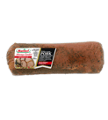

Original Tenderloin
Serving Size: 112g
Servings Per Containers: Varied
Per Serving:
Calories: 120
Calories from Fat: 35
Total Fat: 4g
Saturated Fat: 1.5g
Cholesterol: 50mg
Sodium: 400mg
Total Carbohydrate: 1g
Dietary Fiber: 0g
Sugars: 0g
Protein: 19g
Vitamin A: 0%
Vitamin C: 0%
Calcium: 0%
Iron: 2%

1. Does this food provide any carbohydrates for energy? ____________ How many? ____________

2. Does this food provide any carbohydrates for heart health (fiber/cellulose)? ________________

How much? ___________

3. Does this food provide any unhealthy (saturated) fats? ____________ How many? _____________

4. Does this food provide any protein? _______________ How many? _______________

5. What inorganic molecules are provided in this food? _______________________________________

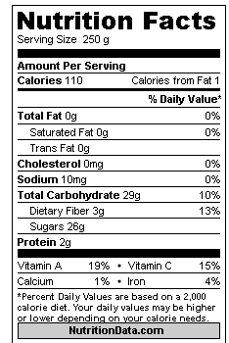
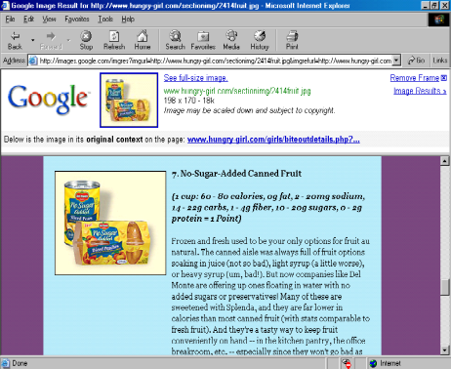

1. Does this food provide any carbohydrates for energy? ____________ How many? ____________

2. Does this food provide any carbohydrates for heart health (fiber/cellulose)? ________________

How much? ___________

3. Does this food provide any unhealthy (saturated) fats? ____________ How many? _____________

4. Does this food provide any protein? _______________ How many? _______________

5. What inorganic molecules are provided in this food? _______________________________________

Serving Size | 1 cup (87g)
Servings | about 5
Calories | 30
 |  | %DV
Total Fat | 0 g | 0%
Sat Fat | 0 g | 0%
Cholesterol | 0 mg | 0%
Sodium | 35 mg | 1%
Carbs | 6 g | 2%
Sugars | 3 g
Fiber | 2 g | 8%
Protein | 1 g
Vitamin A |  | 25 %
Vitamin C |  | 20 %
Calcium |  | 2 %
Iron |  | 2 %
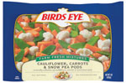

1. Does this food provide any carbohydrates for energy? ____________ How many? ____________

2. Does this food provide any carbohydrates for heart health (fiber/cellulose)? ________________
How much? ___________

3. Does this food provide any unhealthy (saturated) fats? ____________ How many? _____________

4. Does this food provide any protein? ____________
How many? _______________

5. What inorganic molecules are provided in this food?

_____________________________________________________________

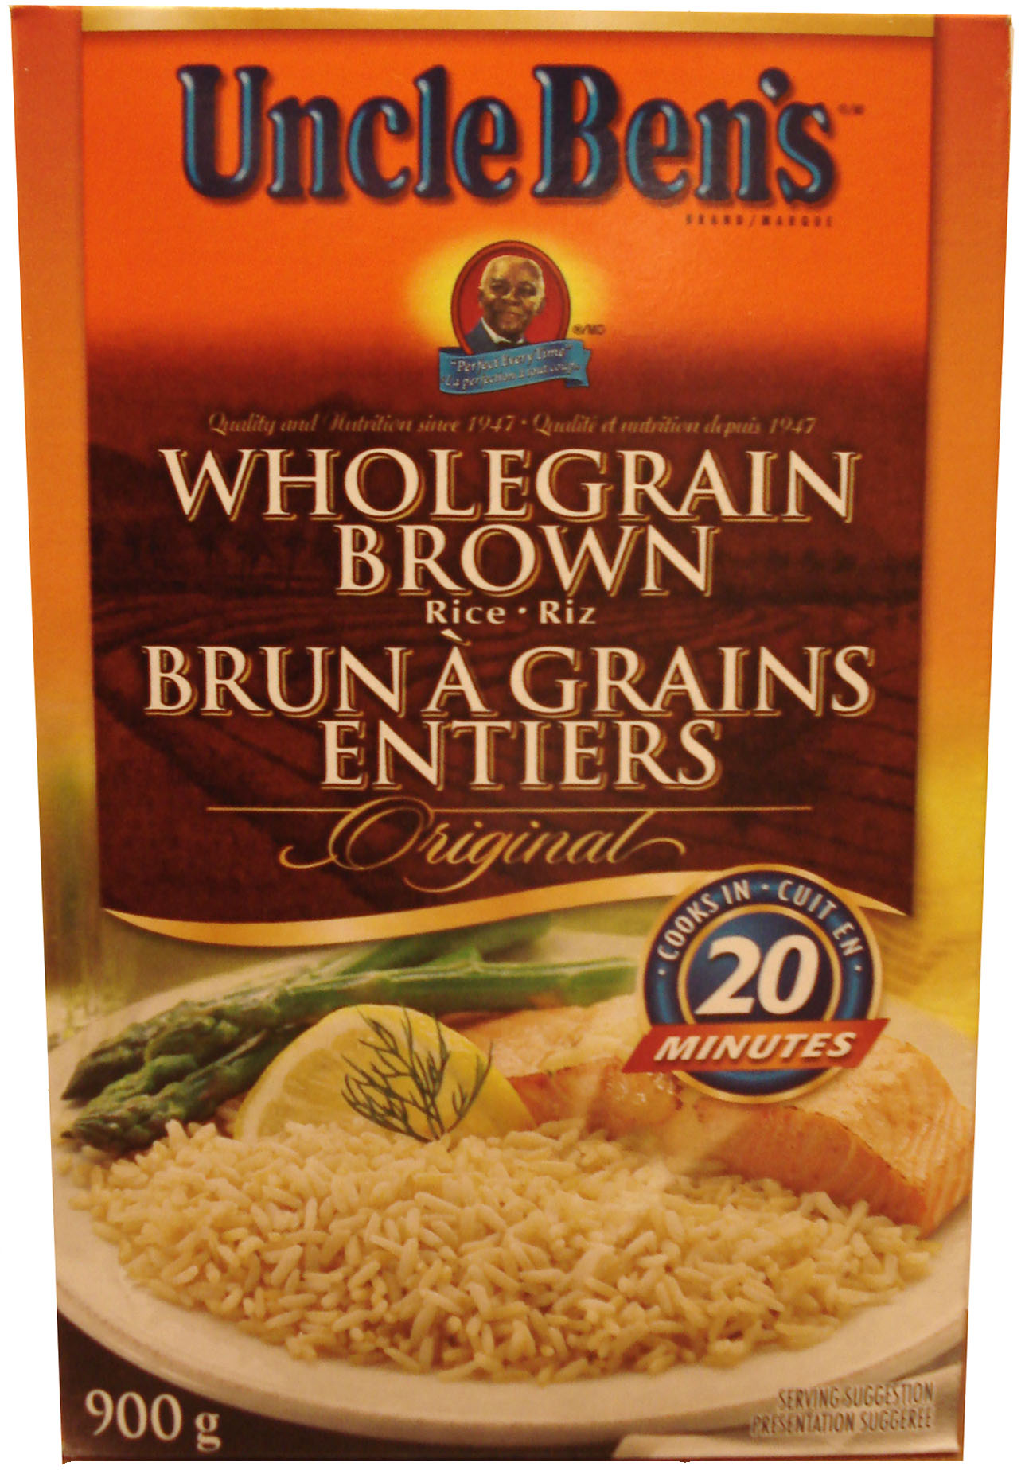
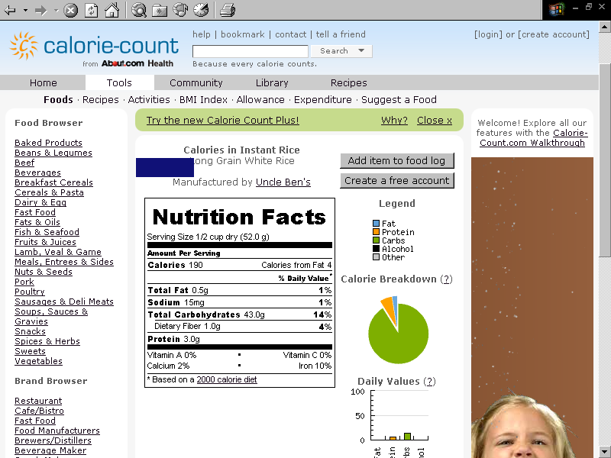

1. Does this food provide any carbohydrates for energy? ____________ How many? ____________

2. Does this food provide any carbohydrates for heart health (fiber/cellulose)? ________________

How much? ___________

3. Does this food provide any unhealthy (saturated) fats? ____________ How many? _____________

4. Does this food provide any protein? _______________ How many? _______________

5. What inorganic molecules are provided in this food? _______________________________________

