Genetics Review Sheet
You are employed by Genes R Us as a genetics lab technician to create a new breed of dog. You’re given the following information from previous research.
- Black coat (B) is dominant over brown coat (b)
- Spotted coat (T) is dominant over solid coat (t)
- Tall legs (L) and short legs (S) are examples of incomplete dominance
- Immunity to heart worms for dogs is sex linked (X^{h})
- Blood type is like that in humans: A type (I^{A} or I^{A}i), B type (I^{B} or I^{B}i), AB type (I^{A}I^{B}), and O type (ii): AB is the universal receiver (can receive blood from al other types) and O type is the universal donor (can give blood to all other types)

Using the information to the right, solve the following problems.

- Write the genotypes for the following:
  - Heterozygous black coat: Bb
  - Homozygous spotted coat: TT
  - Medium legs: TT’
  - Male with immunity to heart worms: X^{h}Y

- Draw a cross between two spotted puppies that would produce solid puppies: Tt x Tt

T t
TT | Tt
Tt | tt
T

t

- What is the phenotypic ratio (Spotted:solid) of a cross between a heterozygous black puppy and a brown puppy? Draw the Punnett square.

 | T | t
t | Tt | tt
t | Tt | tt

50% Spotted 50% brown

- A male with immunity to heart worms is mated with a female. They have only puppies (male and female) with immunity to heart worms. What must be the genotype of the female? Draw the Punnett square.

 | X^{h} | Y
X^{h} | X^{h}X^{h} | X^{h}Y
X^{h} | X^{h}X^{h} | X^{h}Y

X^{h}X^{h} Homozygous for Immunity

- What is the genotypic ratio (A:B:AB:O) of the cross between a homozygous B and heterozygous A blood types? Draw the Punnett square.

 | I^{B} | I^{B}
I^{A} | I^{A}I^{B} | I^{A}I^{B}
i | I^{B}i | I^{B}i

50% type AB and 50% heterozygous type B

- A puppy whose mother was O type was found to have B type blood. Which of the following male dogs could have been the puppy’s father?

SPOT | LASSIE | BUTCH | KILLER | TRAMP
O type | AB type | A type | B type | AB type

- Draw a punnett square for the cross of two heterozygous spotted puppies and list the phenotypic and genotypic ratios.

 | T | t
T | TT | Tt
t | Tt | tt
Phenotypic ratio 3:1 3 spotted and 1 brown
Genotypic Ratio 1:2:1 1 homozygous spotted 2 heterozygous spotted 1 homozygous brown

Genetic Diseases
- PKU | An individual cannot break down a particular amino acid
- Muscular dystrophy | Break down in muscle mass
10. huntington’s | Caused by a dominant allele
11.color blind/cystic fibrosis/ hemophilia/ muscular dystrophy | List 4 sex-linked diseases
12 Sickle cell anemia | Misshaped red blood cells; also resistant to malaria
13.Turner’s syndrome | Only X sex chromosome
14.Down’s syndrome | Trisomy 21
15.Kleinfelter’s syndrome | XXY sex chromosomes
Pedigrees
16.SQUARE | Shape for males
17.Circle | Shape for females
18. Have the trait/ disease | Shaded
19. not affected | Unshaded
20. Carrier | Half-shaded
Vocabulary
21. Polygenic | Type of inheritance found on multiple chromosomes (ex. Skin and hair color)
22.skin/ hair color | Example of a trait with multiple alleles
23. Dominant | Trait that is always seen and covers up the recessive allele
24. Recessive | Trait that can be hidden by a dominant allele
25. complete dominance | When only one trait (dominant) is seen in the heterozygote
26. Co-dominance | When both traits are seen in the heterozygote (black and white spotted)
27. Incomplete | When an intermediate of traits is seen (black and white make gray)
28. Male | An individual with XY
29. Female | An individual with XX
30. Karyotype | Picture of the chromosomes: 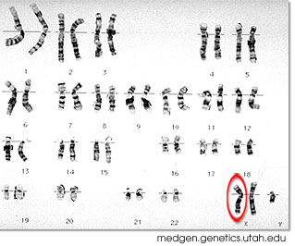
31. nondisjunction | Failure of chromosomes to separate during meiosis

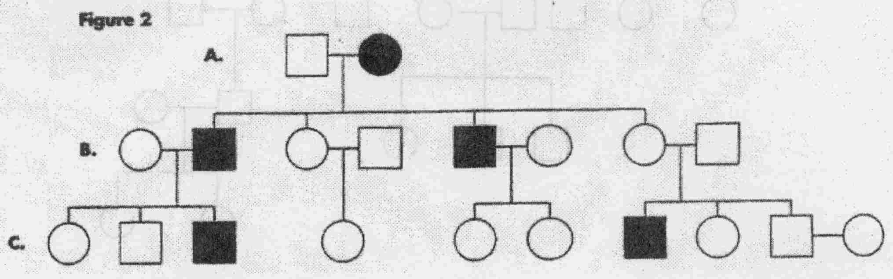
32. Label the genotypes in the following pedigree for muscular dystrophy (sex-linked):

