Heat Day Two

- Enthalpy (ΔH): __________________________________________________________________________
  - ΔH_{reaction} = H_{products} - H_{reactants}
  - ΔH_{reaction} is ______________ for exothermic reactions. Why?
  - ΔH_{reaction} is positive for _________________reactions. Why?
- Nature favors lower energy → ________________________
Law of Conservation of Energy: ____________________________________________________________________________________________________________________________________________________________________________________________________
Example: 2H₂ (g) + O₂ (g) → 2H₂O (l) ΔH = -572 kJ
2H₂O (l) → 2H₂ (g) + O₂ (g) ΔH = +572 kJ
Endothermic or Exothermic? Phase changes are physical changes (no new substance is formed)…
  - Melting
  - Freezing
  - Vaporization/Boiling
  - Condensation
Heating Curve
Label the curve….Energy changes also occur in physical processes. 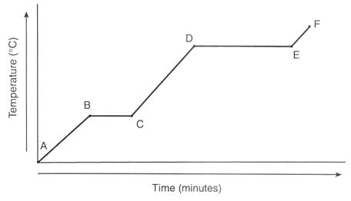Cooling Curve
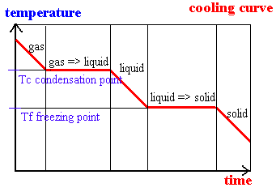

Applying Q when heating a substance across different phases: Label each below.
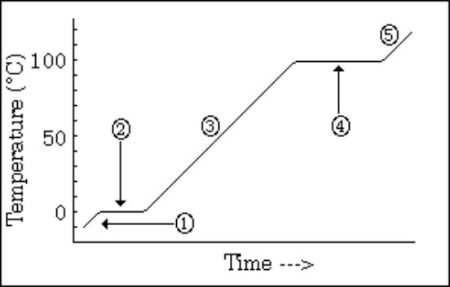
Specific Heat (C): _________________________________________________________________________________
Use the Reference Tables
q = mCΔT (+q = endothermic, -q = exothermic)
- q = heat (joules or calories)
- m = mass (grams)
- C = specific heat → Unit = _________________________
- ΔT = change in Temperature = T_{f} - T_{i} (ºC)
Remember!!!
- Temperature ______________________________________! (Energy goes into pulling molecules farther apart.)
- Therefore, we cannot use this equation for phase changes:
q = mCΔT
Latent Heats
- Heat of Vaporization (H_{v}):________________________________________________________________________________________ q = mH_{v}
- H_{v} = heat of vaporization ____________( unit)
- H_{v} of water = 2260 J/g
Heat of Fusion (H_{f}): __________________________________________________________________________________
  - (Or the heat released when 1 gram of liquid → solid.)
q = mH_{f}
- H_{f} = heat of fusion (J/g)
- H_{f} of water = 334 J/g
Example Problems – Level One
- How much heat is added if 100 grams of liquid water increases in temperature from 30ºC to 70ºC?

2. How much heat is absorbed if 200 g of ice increases in temperature from -15ºC to -5ºC?

- How much heat is released if 80 grams of water vapor is decreases in temperature from 150ºC to 125ºC?

4. How much heat is absorbed when 30 g of ice is changed into liquid water at 0ºC?
5. How much heat is released when 50 grams of water vapor is changed into liquid water at 100ºC?
Example Problems – Level Two
6. How much heat is absorbed if 30 grams of ice at -10ºC is converted into liquid water?
2 steps: (1) heat the ice and (2) melt ice → liquid
(1) q = mCΔT q = (30g)(2.05 J/gºC)(0º – ⁻10º)
q = 615J
(2) q = mH_{f} q = (30g)(334J/g)
q = 10,020J
7. How much heat is absorbed if 45 grams of water at 80ºC is converted into steam at 105ºC?
3 steps: (1) heat water, (2) water → steam, (3) heat steam

8. How much heat is released if 500 grams of vapor at 120ºC changes to liquid water 70ºC?
3 steps: cool the vapor, condensation, cool the liquid

Calorimetry: _______________________________________________________________________________________
1. How much heat is released by the reaction if 10 grams of water is heated from 20ºC to 60ºC.
q = mCΔT q = (10g)(4.18J/gºC)(60º – 20º) q = 1,672J → amount absorbed by water.
Therefore, -1,672J was released by the reaction.
2. What is the mass of the water if a release of 650 J of heat causes the water to increase in temperature by 15ºC?
(Water absorbed 650J of heat from the reaction.) 650J = m(4.18J/gºC)(15ºC) m = ________________
3. What is the final temperature of 15 g of water if the water starts at 20ºC and loses 300 J of heat?
**Losing heat means q is negative -300J = (15g)(4.18J/gºC)(Tf – 20º) T_{f} = ______ºC
4. Determine the substance if a sample of 20 grams increases in temperature from 10ºC to 28ºC when it absorbs 368.3 Joules of energy.
368.3J = 20g(C)(28º – 10º C = 1.023 J/gºC → _____________ (see ref.pack)

Entropy (S): a measure of the _______________ of the particles in a system.
  - Systems tend to become ____________________
Entropy increases when:
  - solid → liquid → gas (___________________)
  - # _____________________ in a reaction (1A + 2B → 3C + 3D)
  - Temperature _______________
Predicting Changes in Entropy
- Predict whether ΔS_{system} will be positive or negative:
1. H₂O (l) → H₂O (g)
2. CH₃OH (s) → CH₃OH (l)
3. Increase the temperature of a substance
4. Dissolving of a gas in a solvent
CO₂ (g) → CO₂ (aq)
5. What happens when the number of gaseous product particles is greater than the number of gaseous reactant particles?
2SO₃ (g) → 2SO₂ (g) + O₂ (g)
6. Generally, when a solid or liquid dissolves to form a solution?
NaCl (s) → Na⁺ (aq) + Cl⁻ (aq)
Spontaneous Reactions A reaction is spontaneous if:
  - ____________________ (energy is released = exothermic)
AND 2. Disorder ________________(positive entropy).
Ex. Wood burning

