**Heating and cooling curve graphs**

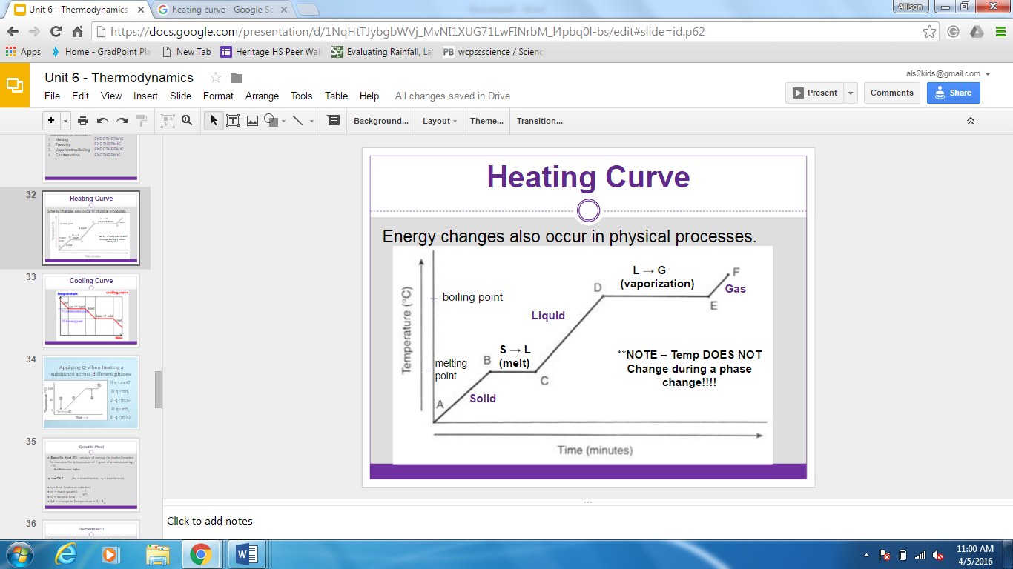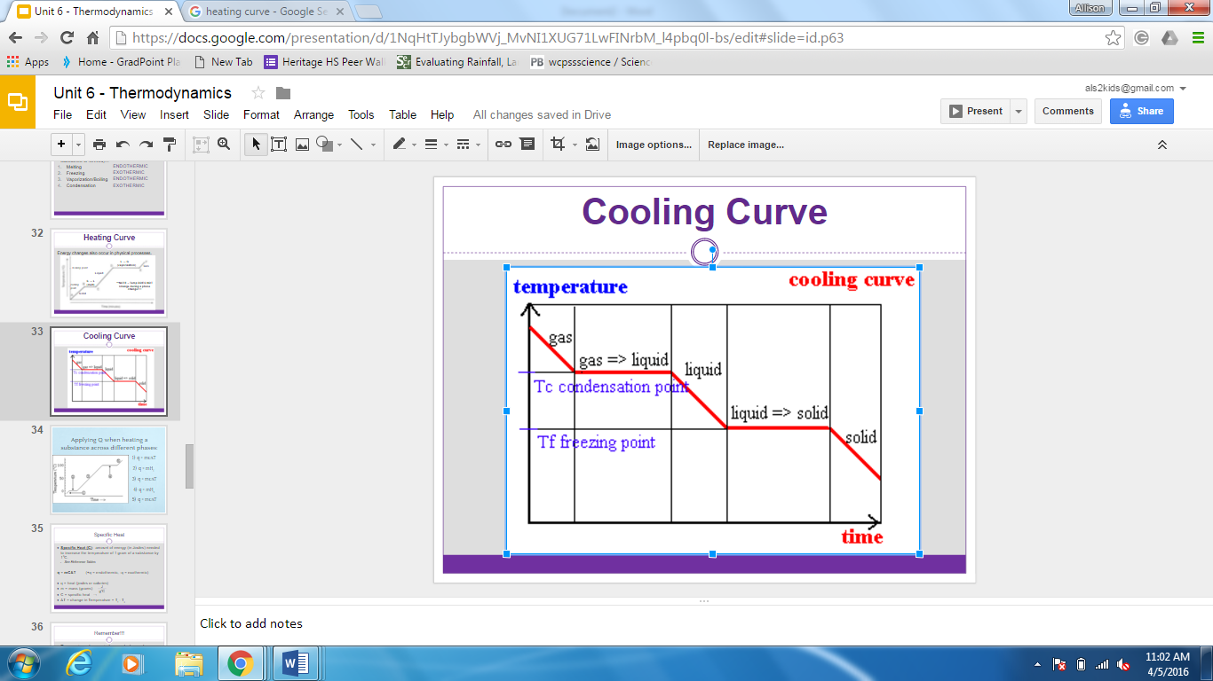**Heating curve**

**Label the following graph showing WHEN to use each of the heat equations.**

