Thermodynamics Homework
HW #1 Heating and Cooling Curve Questions

1. The solid and liquid phases of water can exist in a state of equilibrium at 1 atmosphere of pressure and a temperature of:

(1) 0ºC (2) 100ºC (3) 273ºC (4) 373ºC

2. In which process does a solid change directly into a vapor?

(1) condensation (2) sublimation (3) deposition (4) solidification

3. A sample of water is heated from a liquid at 40ºC to a gas at 110ºC.
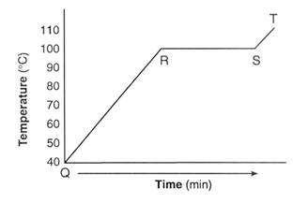
a) On the heating curve diagram provided above, label each of the following regions:

Liquid, only
Gas, only
Phase change

b) For section QR of the graph, state what is happening to the water molecules as heat is added.

c) For section RS of the graph, state what is happening to the water molecules as heat is added.

4. The graph below represents the heating curve of a substance that starts as a solid below its freezing point.

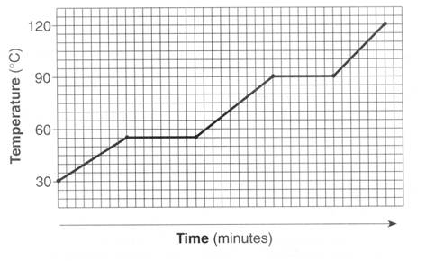
What is the melting point of this substance?

- 30ºC
- 55ºC
- 90ºC
- 120ºC

Base your answers to questions 5 and 6 on the information below.
Given the heating curve where substance X starts as a solid below its melting point and is heated uniformly:
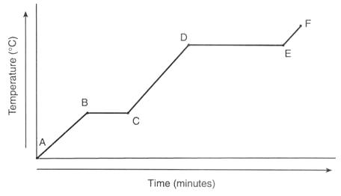

5. Identify the process that takes place during line segment DE of the heating curve.

6. Identify a line segment in which the average kinetic energy is increasing.

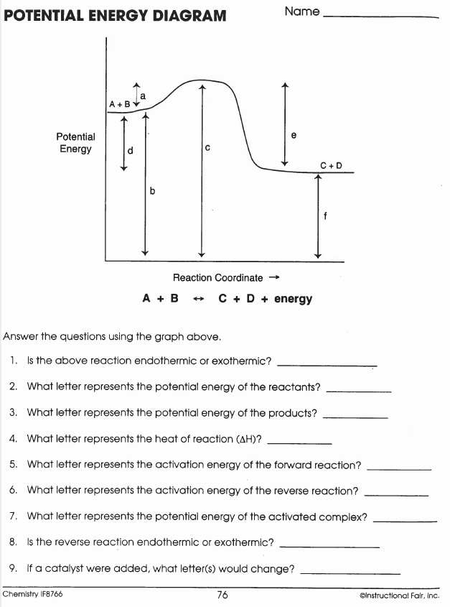
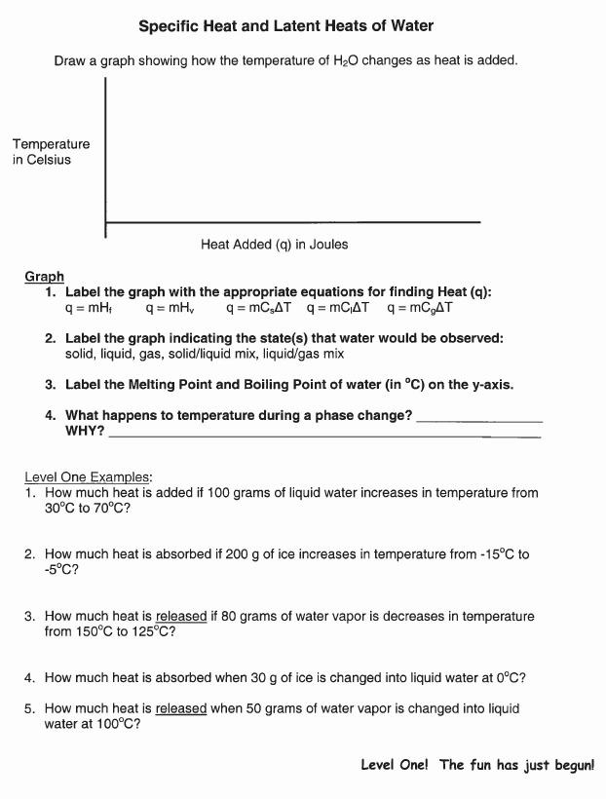

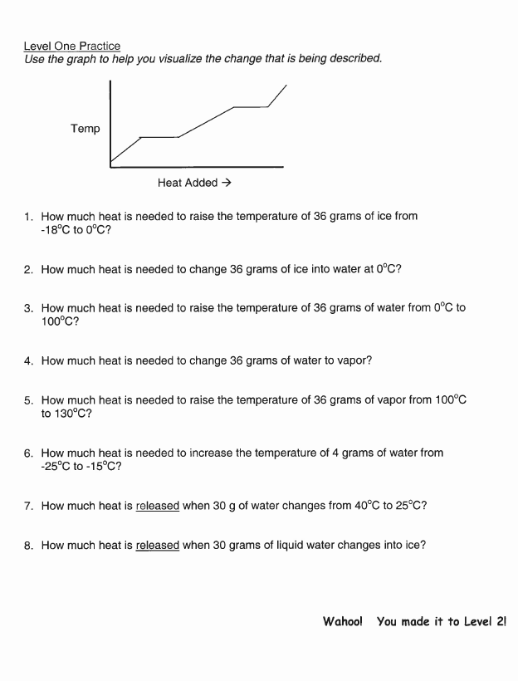

HW #2



