Cell Energy Modeling Assessment
Directions: We will spend this week modeling the various processes that the cell uses to obtain and use energy. You will watch online power points and videos and then utilize that information to create an INFOGRAPHIC using a webtool of your choice to show your comprehension of this week’s lessons. Begin by creating a rough draft of each part on white paper. Then, when you are finished, re-create it online and submit it. Be sure to go back and check off each step before you turn it in at the end of the week.
Part 1. Photosynthesis and leaf structure
- Display a leaf in the top left corner then zoom in on the leaf to show the cross-section like the one below.
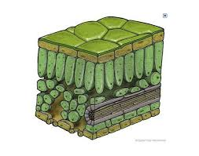
- Above that diagram, write “PHOTOSYNTHESIS”, and underneath that, write “WHO”?
- List which organisms preform photosynthesis next to “WHO?”
- Under the diagram, zoom in on a chloroplast and show the labelled thylakoids, grana, and stroma. State where the chlorophyll is found in the chloroplast under the labelled structure.
- Show the inputs to photosynthesis (reactants) entering the chloroplast, and the outputs (products) leaving the chloroplast. You may use pictures, words or formulas.
- Go back and label the function of each of the parts of the leaf. Your descriptions should focus on how the leaf is adapted to bring together all the necessary materials for photosynthesis.
Part 2. Transpiration and photosynthesis rate
- In the middle of the model, zoom in on the leaf guard cells, and paste an image of guard cells.
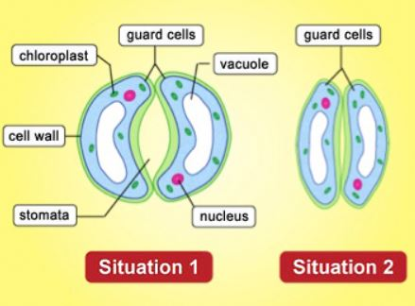
- Label which guard cells with the highest turgor pressure, and the ones with the lowest turgor pressure. Label the open and closed stomata.
- Show what enters and leaves the stomata during transpiration. Describe what this has to do with photosynthesis.
- List the factors that impact the rate of photosynthesis.

Part 3: ATP and the BIG Picture
- In the TOP, CENTER Position of your model, draw the reversible chemical reaction between ATP and ADP+P from your notes.
- Label the arrow that shows energy being stored and the arrow that shows energy being released. Draw the relationship between glucose and ATP on the model.
- Label the point at which cellular respiration occurs.
- Label the point at which photosynthesis occurs.
Part 4: Cellular respiration flow chart
- Insert an animal cell model to the far-right of your model near the top.
- Above the animal cell model, write “RESPIRATION”, and underneath that, write “WHO?” List which organisms perform Cellular respiration next to “WHO?”
- Next to the animal cell model, create a flow chart that starts with glucose at the top and includes the following terms: Oxygen present, oxygen not present, aerobic respiration, anaerobic respiration, fermentation, Lactic acid, ethyl alcohol, CO₂ (should be used more than once), Animals/Bacteria, and Plants/Yeasts, 36-38 ATP, 2 ATP
- Label the most efficient and least efficient process on your flow chart.
- Under the animal cell diagram, zoom in on a mitochondria and label the inner membrane, outer membrane, and matrix.
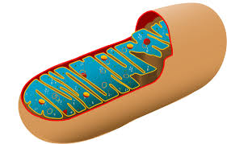

Part 5: Cellular respiration and comparing the processes
- On the right side of your model, show the inputs (reactants) of cellular respiration entering from the bottom of the mitochondria that you drew, and show the outputs (products) leaving the mitochondria out of the top.
- Underneath your mitochondria by the inputs/ reactants, label this as either aerobic or anaerobic cellular respiration.
- Draw arrows between your final photosynthesis and cellular respiration outputs showing the relationships between the two.
- In the center of the model, above your arrows, draw a graphic that shows the relationship between photosynthesis and cellular respiration.

