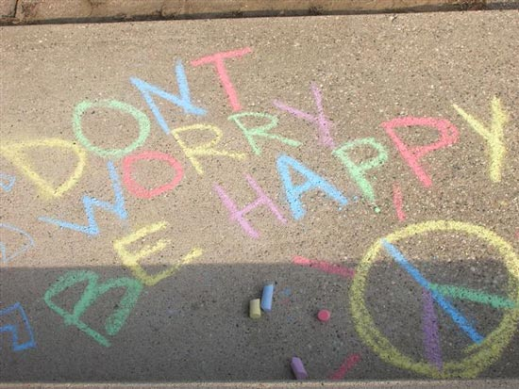
Molar Mass Chalk Lab
Purpose
• Visualize the concept of the mole
• Gain experience in calculating grams and moles
Materials

• A piece of chalk
• Electronic balance, if available
• Periodic Table
• A calculator

Instructions
1. Take a chunk of chalk and measure its mass on the balance: __________________________
2. Go outside and draw something on the sidewalk.
3. Weigh the unused chalk: ________________________________________________
4. Based on the initial mass of the chalk and the mass at the end, calculate how many grams of chalk you left
out on the sidewalk:_________________________________________________
5. Look up the molecular formula for chalk: __________________________________________
Calculate the following:
Chalk Molar Mass | Moles of chalk left on the sidewalk
Molecules of chalk left on the sidewalk | Atoms of Calcium left on the sidewalk
Atoms of Oxygen left on the sidewalk | Atoms of Carbon left on the sidewalk

