Nuclear Decay Notes
- Nuclear Decay - ______________________________________________________________________
_______________________________________________________________________________________
- All elements with atomic numbers greater than 84 are radioactive.
- Types of particles emitted: ____________________ ; _________________ ; __________________
- Alpha Decay - ________________________________________________________________________
____________________________________________________________________________________
  - Alpha particles can be stopped by: _________________________________________________
  - Transmutation - ________________________________________________________________
Alpha decay equation:

  - Alpha Decay examples and practice:

- Beta Decay - _________________________________________________________________________
____________________________________________________________________________________
  - Beta particles can be stopped by: __________________________________________________
  - Transmutation occurs in beta decay.
Beta decay equation:

- Beta Decay examples and practice:

- Gamma Decay - ____________________________________________________________________________________
____________________________________________________________________________________
  - Gamma Rays can be stopped by: ___________________________________________________
  - Nucleus goes from an excited state to a normal state.
  - Often occurs WITH alpha or beta decay.
  - NO transmutation because no new element is formed.
Gamma decay equation:

Nuclear Decay of a Uranium atom
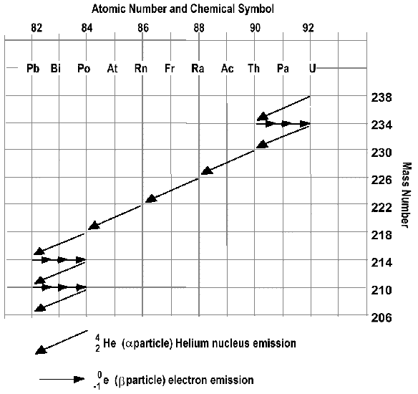

What happens when radiation
passes through an electric field
