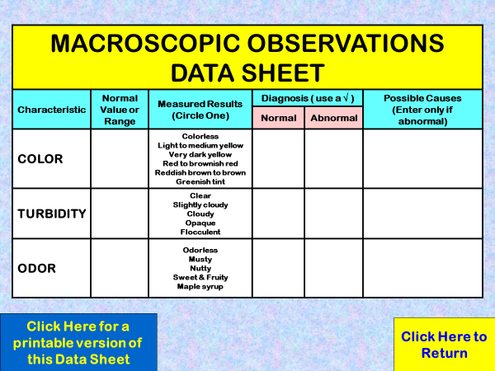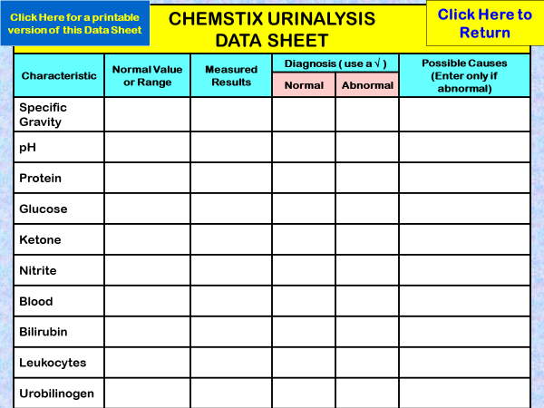

**Name _________________________________**

**Online Urinalysis Lab**

