Phase Diagrams
- Chemical change - ____________________________________________________________________________
- Physical change - _____________________________________________________________________________
  - Example - ____________________________________________________________________________
Phase changes (NEED TO KNOW!)
Solid Liquid
Liquid Solid
Liquid Gas
Gas Liquid
Solid Gas
Gas Solid

Phase Diagram
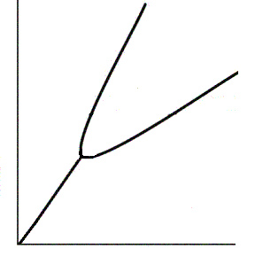
- Triple Point - ___________________________________________
______________________________________________________
_______________________________________________________
- Critical Point - ___________________________________________
_______________________________________________________
_______________________________________________________
- Lines - _________________________________________________
_______________________________________________________
_______________________________________________________
**A Phase Diagram is unique for each substance.

**Normal melting point and Normal boiling point occur at standard pressure. Standard pressure = 1 atm.

Phase Diagram Worksheet

Refer to the phase diagram below when answering the questions on this worksheet:

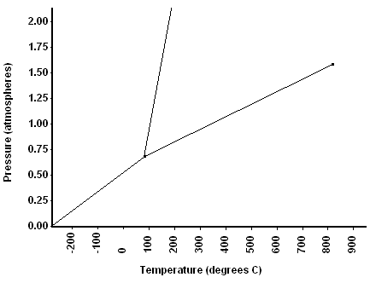

1) What is the normal melting point of this substance? ________

2) What is the normal boiling point of this substance? ________

3) What is the normal freezing point of this substance? ________

4) What is the pressure and temperature of the triple point?
Temp ________ Pres _______

5) What is the pressure and temperature of the critical point?
Temp ________ Pres _______

6) If I had a quantity of this substance at a pressure of 1.25 atm and a temperature of 300⁰ C and lowered the pressure to 0.25 atm, what phase transition(s) would occur?

7) Above what temperature is it impossible to compress a gas into a liquid?________________

8) If I had a quantity of this substance at a pressure of 0.75 atm and a temperature of -100⁰ C, what phase change(s) would occur if I increased the temperature to 600⁰ C? At what temperature(s) would they occur?

