**Protein Synthesis – Transcription & Translation**

**RNA (________________________)**

* ________-stranded (not double-stranded)
* Contains ____________ sugar (not deoxyribose)
* Contains ____________ (instead of Thymine)

**3 Types of RNA:**

1. **mRNA (_________________________)**
   * _____________ copy of DNA.
   * Moves from __________ to _________.
   * ___________: 3 nitrogenous bases (codes for an amino acid)
2. **tRNA (________________________)**
   * Transfers amino acid to ribosome.
   * Contains ______________ &   
     ___________: 3 bases (complement to mRNA codon)
3. **rRNA (_________________________)**

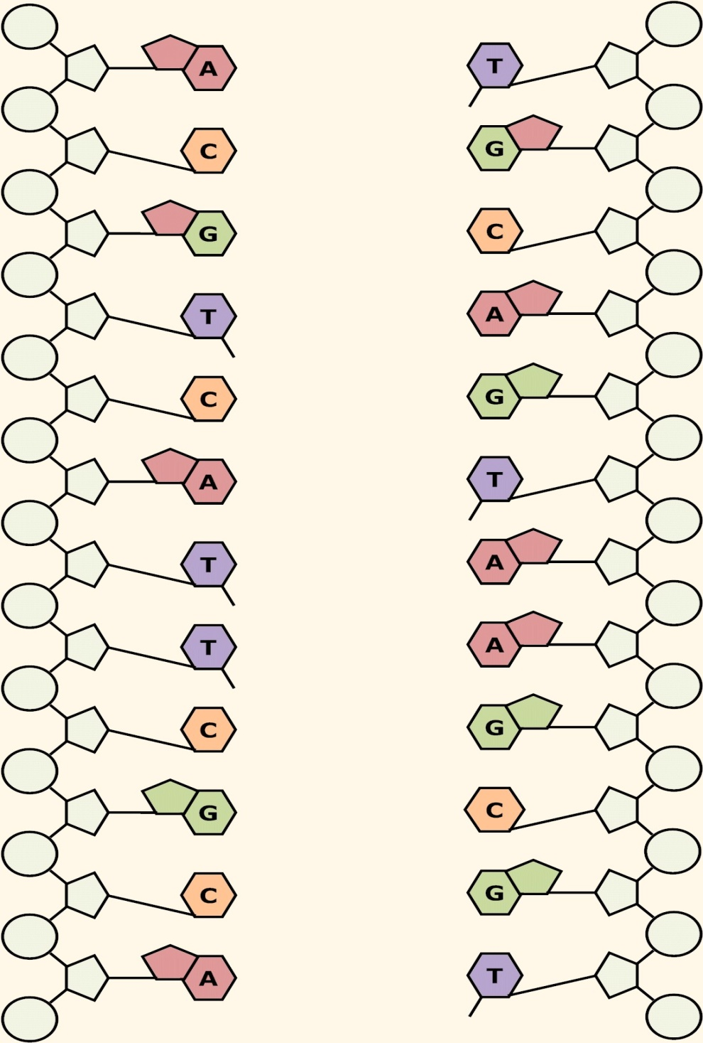

* + Makes up the ribosome.

**Ribosome**

* ______________ factory
* Contains _______ subunits.
* Made of ________ and __________.

**Transcription:** mRNA makes a copy of a DNA segment.

* + Location: ________________
  + *Don’t forget: U is used instead of T
  + Example

**Translation:** mRNA is used as a _______________ to create ________________.

* + mRNA travels from the nucleus to the ___________________.
  + The two _______________ subunits clamp onto the mRNA.
  + _____________ brings an amino acid to the ribosome.
  + tRNA’s anticodon bonds to its ______________ mRNA codon   
    (this is called ______________________).
  + Amino acids are attached together with __________ to form ___________ (_________)

**64 possible mRNA codons:**

* Different codons can code for the same amino acid
  + There are only ______ amino acids.
* Others code for instructions:
  + _______________: AUG (also codes for methionine)
  + _______________: UAA (does not code for an amino acid)

**Translation Example:**

mRNA strand: AUG CCC CUU AAA GAG UUU ACA UAU UGC UGG AGG CGU UAA

Protein: ______________________________________________________________________________

**Translation Practice:**

1. mRNA: AUGCUUUUAGCACGACAACAAUGUUGA  
   Protein: ___________________________________________________________________
2. mRNA: UAUCAAGAUGAUACAGUUUUUUAG  
   Protein: ___________________________________________________________________
3. DNA: TACGGTCATCGTGCA  
   mRNA: ________________________________________  
   Protein: _______________________________________________________________________
4. DNA: TACGGCAATATT  
   mRNA: ________________________________________

Protein: _______________________________________________________________________

