Male parts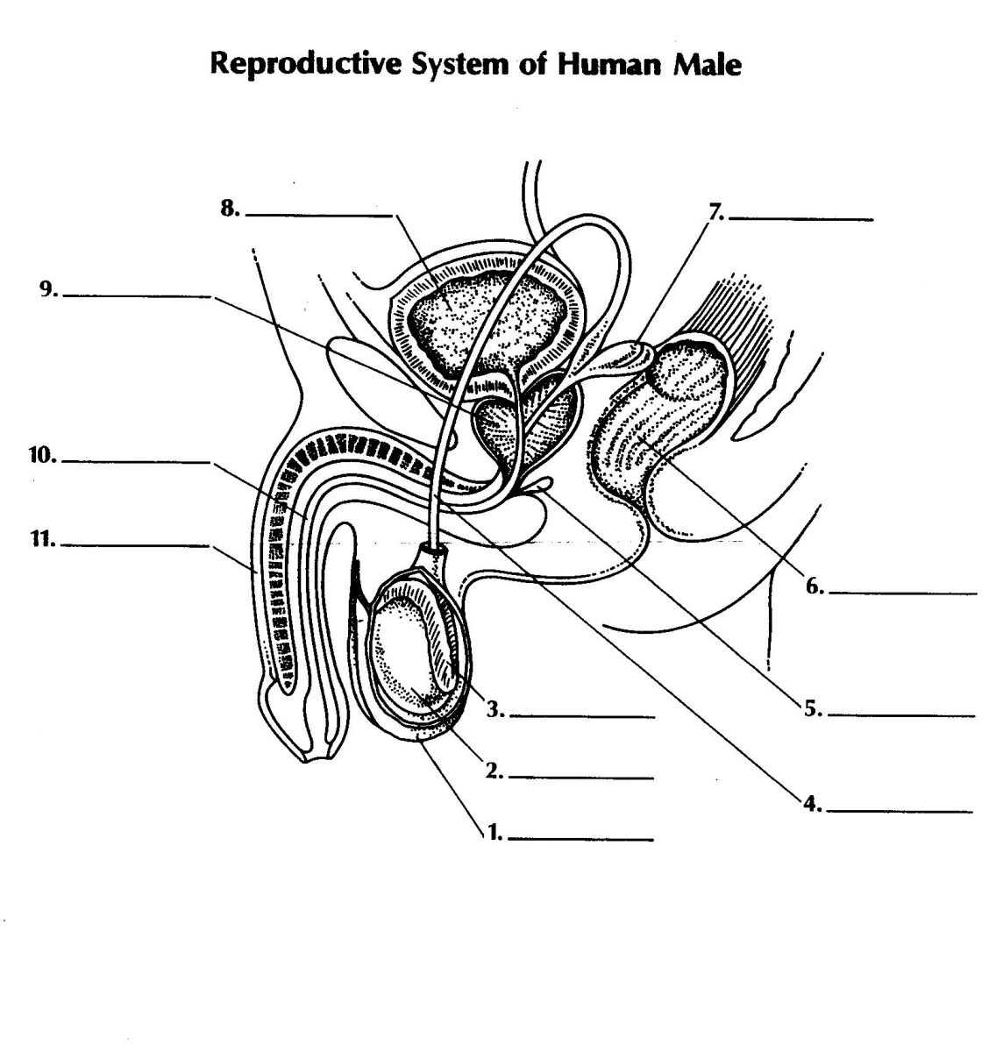
- Scrotum
- Testes
- Epididymis
- Vas deferens
- Bulburethral gland
- Rectum
- Seminal vesicle
- Bladder
- Prostate gland
- Urethra
- Penis
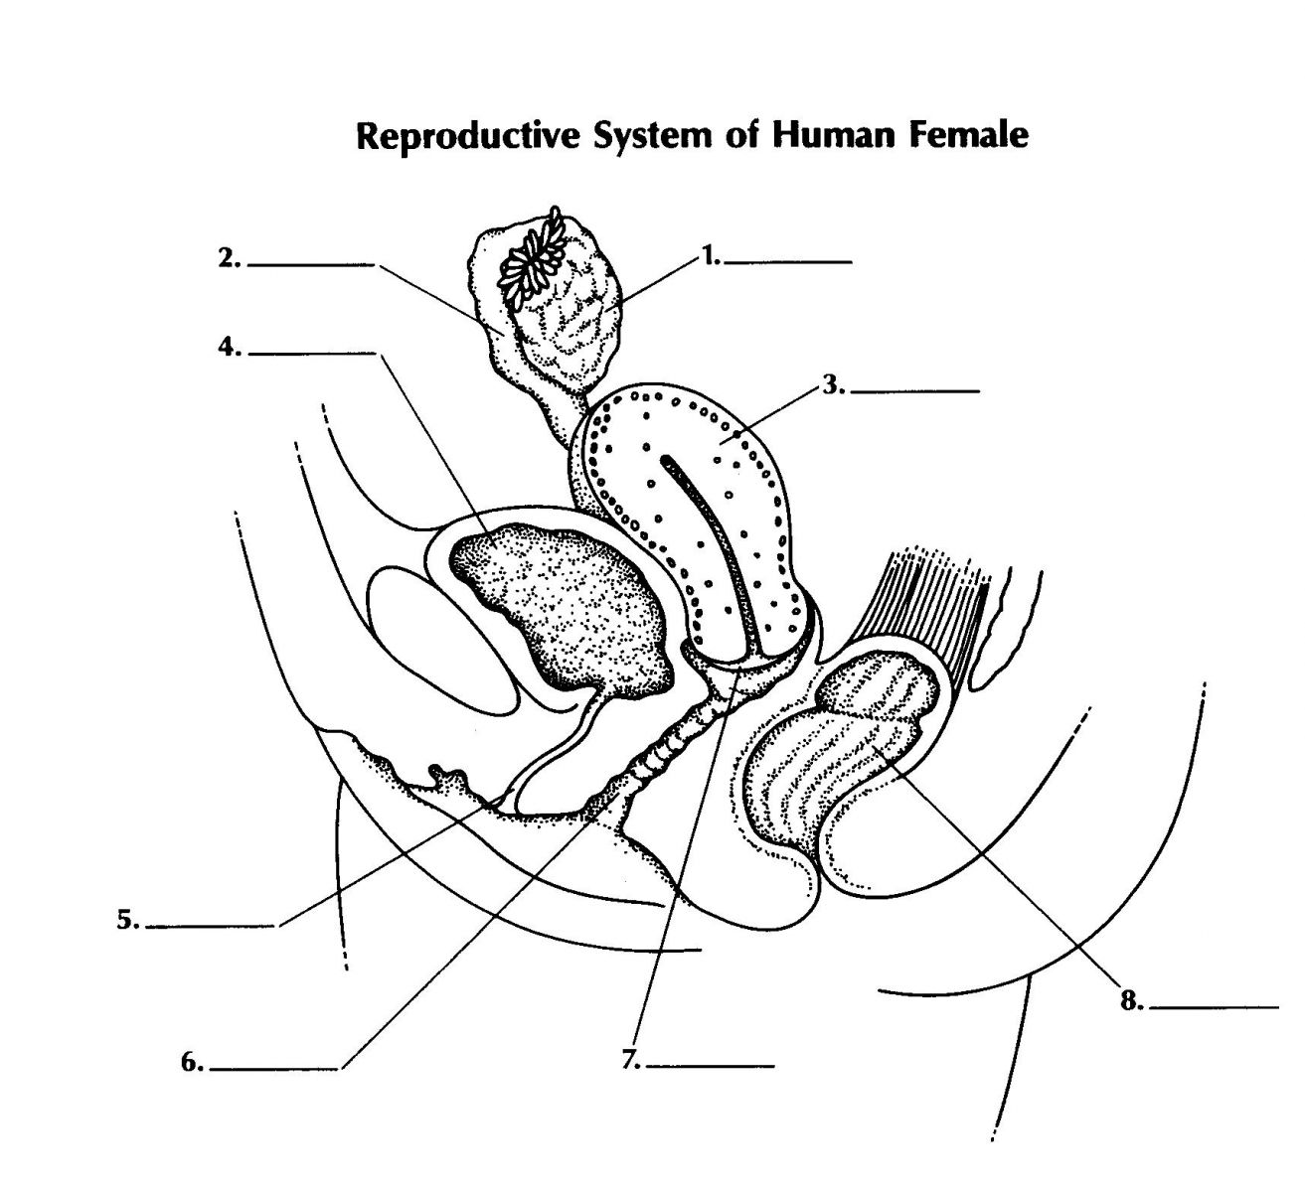

Female Parts
- Ovary
- Uterine tube (fallopian tube)
- Uterus
- Bladder
- Urethra
- Vagina
- Cervix
- Rectum

