Shark DNA could help cure cancer and age-related illnesses in humans
- 19 February 2019

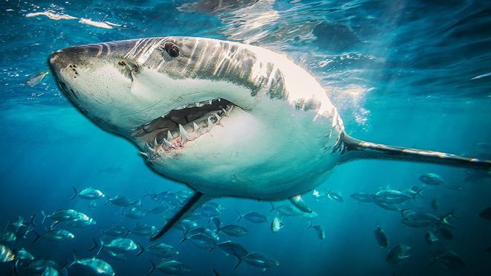TTY IMAGES
Great white sharks may hold the secrets to curing cancer and other age-related diseases, experts believe.
The first map of great white sharks' DNA has revealed "mutations" that protect the animals against cancer and other illnesses. Scientists hope more research could help apply the findings to treating age-related illnesses in humans. The great white's ability to repair its own DNA has evolved in ways ours hasn't. The research was carried out by a team of scientists at the Save Our Seas Foundation Shark Research Centre at Nova Southeastern University in Florida.

What are sharks packing in those genes?
Unstable genes in humans are what make us vulnerable to aged-related diseases such as cancer. Because sharks have been around and at the top of their game for so long, they have evolved so their DNA can repair itself and is more tolerant to damage." Genome instability is a very important issue in many serious human diseases," says study co-leader Dr Mahmood Shivji."Now we find that nature has developed clever strategies to maintain the stability of genomes in these large-bodied, long-lived sharks. "There's still tons to be learned from these evolutionary marvels, including information that will potentially be useful to fight cancer and age-related diseases, and improve wound-healing treatments in humans, as we uncover how these animals do it."
Great white sharks have been patrolling the seas for at least 16 million years and at their biggest, can grow up up to 20 feet long and weigh as much as three tons

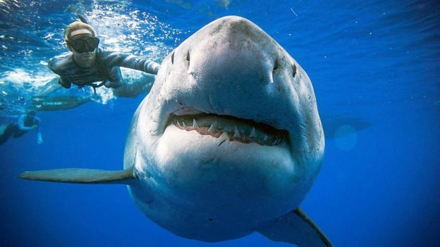 teeth, the most striking thing about sharks may be the secrets they hold in their DNA
Shark DNA is one-and-a-half times bigger than human DNA, meaning there are things coded into the animals that, at the moment, humans can't do. And scientists hope to unlock those secrets and use them to treat the problems that DNA is already solving in sharks. They believe sharks could also help wound-healing and blood-clotting, because of their ability to recover quickly from serious injuries.

Sharks: More than just Jaws
This research could be a step towards a more positive reputation for one of the most feared animals in nature. Photographer Kimberly Jeffries recently told Radio 1 Newsbeat she felt "no danger whatsoever" when she swam with one of the biggest great whites in the world, who's named Deep Blue. "It's an incredibly humbling experience," she said. Although she wasn't recommending that anyone hop in the water with some sharks."These are apex predators so they are to be respected," Kimberly said.

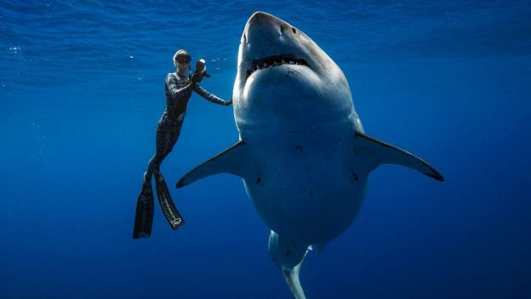s already play an important role in the ecosystem of our oceans
And through hunting fish and other animals in the sea, they can also help their prey flourish by targeting slower and weaker creatures. Studies also show that sharks are even important in the fight against global warming, as their hunting keeps the numbers of smaller creatures, who produce more carbon dioxide, in check.

