Name Skin Test Fall 2019

1. Which gland does not have a bad smell and become active at puberty?
- Eccrine glands
- Pituitary glands
- Adrenal glands
- Apocrine glands

2. What does the connective membrane encapsulate?
- Bone
- Skin
- Organs and movable joints
- Foot

3. What is the oily matter that the sebaceous glands produce called?
- Adipose
- Sebum
- Mucus
- Synovial fluid

4. What substance do Mucous Membranes secrete?
- Sebum
- Serous Fluid
- Mucus
- Salvia

5. What fluid do both eccrine and apocrine glands release?
- Sweat
- Water
- Blood
- None of the above

6. What is the infection that causes the skin to form scaly, dry, and itchy patches?
  - Impetigo
  - Burn
  - Cold Sore
  - Psoriasis

7. What is the difference between boils and athlete's foot?
a. Prevention of Boils is washing your hands and of Athlete’s Foot is to not use damp and
warm shoes and socks.

b. Boils are caused by the bacteria Staphylococcus and Athlete’s Foot is a fungus called
Tinea pedis.
c. Boils affect cuts and Athlete's Foot start in between toes.
d. All of the Above.

- Based on the Rule of 9, what part of the body has the least amount of Total Body Surface Area?
  - Pubic
  - Arms
  - Head
  - Legs

- What is damaged in a third degree burn?
  - Dermis
  - Epidermis
  - Accessory Skin Surfaces
  - All of the Above

- What are the symptoms of Dermatitis?
- Bumps, dryness, fissures.
- Rashes, redness, and peeling
- Burning sensation
- A and B

- What is the function of your skin?
- Protects the body from microbes and the elements
- regulate body temperature
- permits the sensations of touch
- All of the above

- Which layer of skin is the thickest?
- Epidermis
- Dermis
- Subcutaneous
- None of the above

- What is the main function of the epidermis?
- The outermost layer of the skin.
- To protect the Dermis.
- To protect, absorb nutrients, and homeostasis.
- To protect, provide nutrients, and homeostasis.

- What is also known as the hypodermis or subcutis?
- Submarine
- Subcutaneous
- Subconscious
- Sub-skin disease

- What type of melanin can be found in the hair, skin, and, and dark areas around the nipples?
- Pheomelanin
- Neuromelanin
- Eumelanin
- All of the above

- The arrector pili muscle connects which two parts of the epidermis?
  - Skin and hair follicle
  - Veins and hair follicle
  - Hair follicle and connective tissue
  - Connective tissue and hair

- What is the second fastest growing tissue on the human body?
  - Bone marrow
  - Hair follicle
  - Epithelial tissue
  - Nails

- What is the difference between the shaft and root of a hair follicle?
  - The shaft and root are different colors
  - The shaft is below the surface of the skin and the root is above it.
  - The shaft is anchored to the hair bulb and the root is not.
  - The root is anchored to the hair bulb and the shaft is not.

- What part of the nail has the only living tissue
  - The matrix
  - The nail bed
  - The cuticle
  - The lunula

- What is porosity as it pertains to hair?
  - the ability of hair to absorb liquid and depends on the condition of the cuticle
  - Density of the hair follicle
  - The ability to absorb heat
  - The overall health of the hair follicle
- What are new skin cells called?
  - Epidermis
  - Keratinocytes
  - Dermis
  - Skin cell Renewal
- Whiteheads are known as ___________.
  - Closed plugged pores
  - Open plugged pores
  - Small, red tender bumps
  - Pustules
- The most deadly or severe form of skin cancer is
  - Leukemia
  - Basal Cell Cancer
  - Melanoma
  - Vitiligo
- Millia occurs when?
- Hormones are passed to the baby
- Keratin gets trapped under skin
- Oil builds up
- Dirt in pores
25. Skin cancer rule is known as
- Abcde rule
- Xyz rule
- Lmnop rule
- Cancer rule

Label the Cross-Section of the Skin below using the word bank given.
Epidermis Subcutaneous Arrector pili
Sebaceous Gland Sweat gland
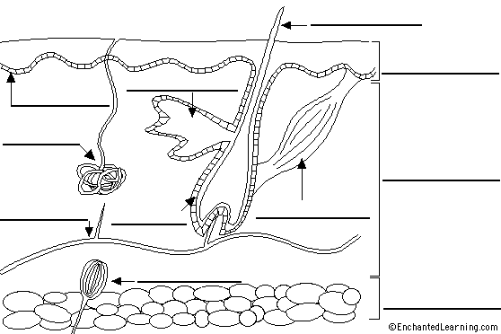
Answer Key
- D
- C
- B
- C
- A
- D
- D
- C
- D
- D
- D
- B
- C
- B
- C
- C
- B
- D
- C
- A

