Solubility Curves Practice
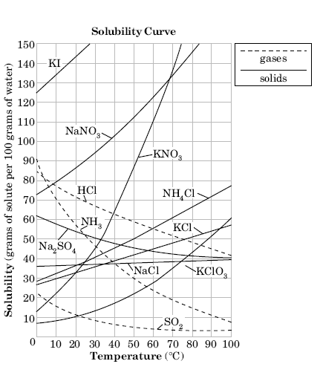

Solubility - the amount that can be dissolved.
Salt - Ionic Compound

- For the salts (solids), the overall trend is that as temperature
increases, solubility [increases or decreases?] ___________________.
- For the gases, the overall trend is that as temperature increases,
solubility [increases or decreases?] ________________.
- Which salt (solid) is the most soluble at 10ºC? ________
- Which salt (solid) is the least soluble at 50ºC? ________
- Which salt shows the least increase in solubility as temperature
increases? ________________
- Which salt shows the greatest increase in solubility as
temperature increases? ______________
- How much KNO₃ can be dissolved in 100 grams of water at
60ºC? ______________
- How much potassium chloride can be dissolved in 100 g of
water at 30ºC? _______________
- How much NH₄Cl can be dissolved into 200 g of water at
70ºC? ______________
- How much NaCl can be dissolved into 200 g of water at
90ºC? ___________________
- How much potassium iodide can be dissolved in 300 g of water
at OºC? _________________
- Is the solution saturated, unsaturated, or supersaturated?
  - 85 g of KNO₃ at 55ºC? ____________________________________
  - 100 g of NaNO₃ at 30ºC? _________________________________
  - 110 g of KNO₃ at 60ºC? ___________________________________
  - 10 g of SO₂ at 40ºC? ______________________________________
  - 62 g of NH₃ at 10ºC? ______________________________________

