Solutions and Equilibrium Remediation

Molarity and dilution questions

Solve the following molarity/dilution problems. Show all work and include correct units!
- Find the molarity of a solution in which .58 moles of NaCl are dissolved in 2.5 L of solution.

- What is the original molarity of .50 L of a KMnO₄ solution that is diluted to 2.00 L of a 0.500M solution?

- What volume of 0.25M solution can be made from .125 mol of KCl?

- Find the molarity of a 450 mL solution containing 13.7 g of ZnSO₄.
- How many L of a .25 M CuCl₂ solution can be made from 0.30 L of a 6 M CuCl₂ solution?

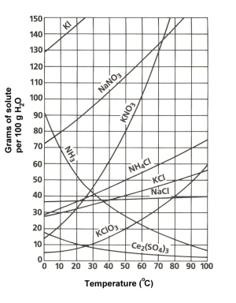
Use the solubility Curve to answer the following questions:
1. a. At 90°C, you dissolved 10 g of KCl in 100. g of water. Is this solution saturated or unsaturated?
b. How do you know?
2. A mass of 100 g of NaNO₃ is dissolved in 100 g of water at 80ºC.
a) Is the solution saturated or unsaturated?
3. What mass of solute will dissolve in 100 g of water at the following temperatures?
  - KNO₃ at 70°C ____________
  - NaCl at 100°C ____________
  - NH₄Cl at 90°C ____________
Equilibrium Practice:
Write an equilibrium expression for each of the following reactions.
1) 3O₂ ⇌ 2O₃
What happens to the equilibrium of this reaction if pressure is increased?
2) N₂ + 3H₂ ⇌ 2NH₃
What happens to the equilibrium of this reaction if more nitrogen is added?
3) H₂ + I₂ ⇌ 2HI
What happens to the equilibrium of this reaction if Iodine is taken away?
4) PCl₅ ⇌ PCl₃ + Cl₂

