Solutions Guided Notes
- Vocabulary:
Solution

Solute

Solvent

Aqueous Solution

- Solution examples - ___________________________________________________________________
____________________________________________________________________________________
Solution | Solute | Solvent
2 g of sugar dissolved into 100mL water
Gold for jewelry has added Silver, Nickel, and Zinc to make it more durable
Jell-O consists of solid particles that were dissolved and then left suspended in water
NaCl (aq)

- To create a solution ___________________________________________________________________
- What is meant by the phrase “likes dissolve likes”? __________________________________________
________________________________________________________________________________________________________________________________________________________________________
- Example 1: Lava lamps - what is the polarity of the two substances in the lamp?

- Example 2: Oil and water. Do they mix?
- What happens when food coloring is dropped on top of oil and water?
- Alcohols - ___________________________________________________________________________

Dissolving Ionic Compounds | Dissolving Covalent Compounds
Electrolytes

- Unsaturated solution - ____________________________________________________________________
_______________________________________________________________________________________
- Saturated solution - ______________________________________________________________________
_______________________________________________________________________________________
- Supersaturated solution - __________________________________________________________________
_______________________________________________________________________________________
Solubility | Temperature
Pressure | Stirring  Solute Size/Surface Area
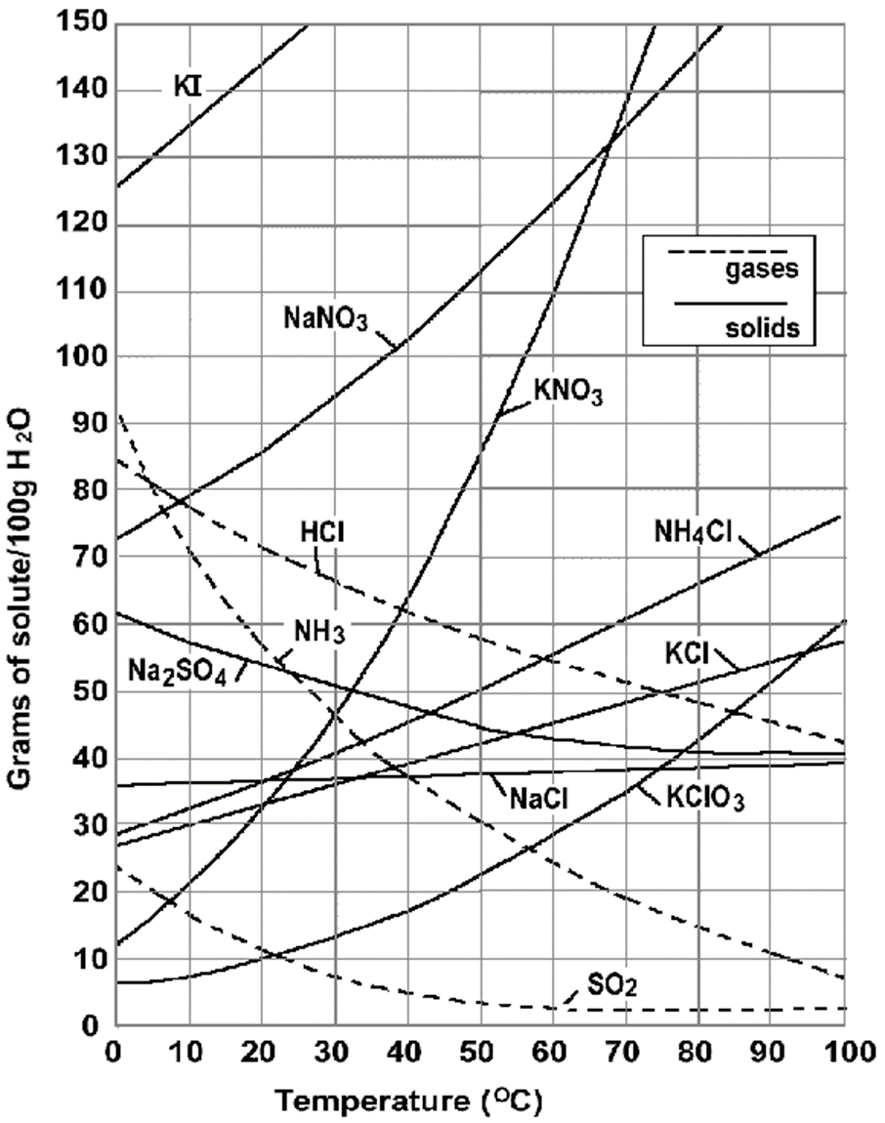
Solubility Curve
Saturated | Unsaturated | Supersaturated

- A solution has 130 g of NaNO₃
in 100 g of water at 75ºC. Is the solution saturated, unsaturated, or supersaturated?

What about 95 g of KNO₃ in 100g water at 50ºC?

- How many grams of KCl would dissolve in 100g of water at 90ºC?

- How many grams will dissolve in 200g of water?
- Molarity
  - To calculate the concentration of a solution:

- What is the molarity of a solution in which 67 g of NaCl are dissolved in 1 L of solution?

- How many grams of KNO₃ should be used to prepare 2 L of a 1 M solution?

- How do you dilute a solution?______________________________________________________________
_______________________________________________________________________________________

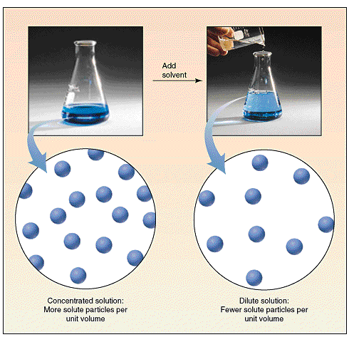
- Equation for dilutions:

- A chemist starts with 50.0 mL of a 0.40 M NaCl solution and dilutes it to 1000. mL. What is the concentration of NaCl in the new solution?

- If you dilute 175 mL of a 1.6 M solution of LiCl to 1.0 L, determine the new concentration of the solution.

- A chemist wants to make 500. mL of 0.050 M HCl by diluting a 6.0 M HCl solution. How much of that solution should be used?

