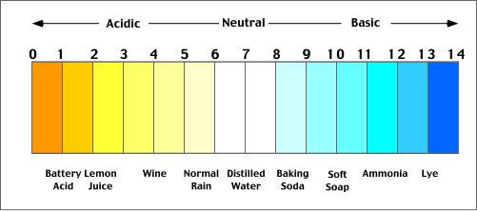
Study Guide – Unit 2
Acids/Bases
- pH scale 0-14
  - Acids – pH 0-6.9
  - Neutral – pH 7
  - Bases – pH 7.1-14
Organic macromolecules
- 4 kinds - Carbohydrates, Proteins, Lipids, Nucleic Acids
- All organic molecules contain carbon

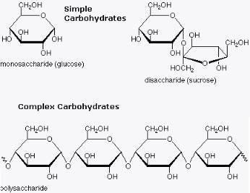
Carbohydrates
- Provide organisms with energy
- Monomer (building block) = sugar (a.k.a. monosaccharide)
- Polymer (many subunits together) = polysaccharide
- Examples of simple carbohydrates – glucose, sucrose
- Animals store extra glucose as glycogen in the liver, plants store extra glucose as starch
- Shape is a hexagon (like a stop sign)

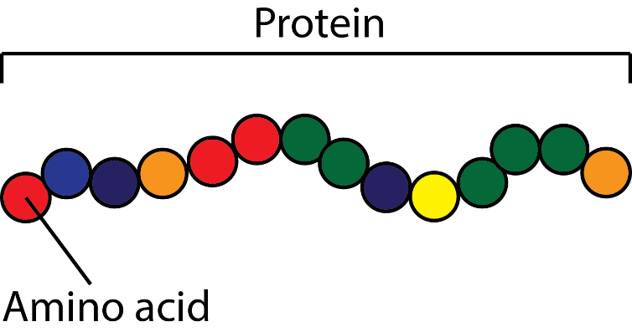
Proteins
- Subunits are amino acids
- Found in meat, cheese, eggs
- Include enzymes (enzymes are a type of protein)

Lipids
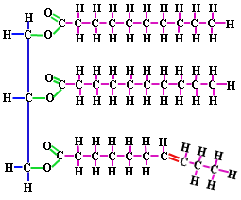
- Monomer (building block) = glycerol and fatty acids
- Examples:
  - Saturated fat (saturated fats are solid at room temperature, ex. butter)
  - Unsaturated fat (liquid at room temperature, ex. oil, healthier for you)
  - Cholesterol
- Uses: long-term energy storage
- Shape is a capital E (glycerol on the side with three fatty acids)
Nucleic Acids
- Two types of nucleic acids = DNA (stores hereditary information) and RNA
- Building blocks of nucleic acids = nucleotides
  - Nucleotides include A, T, C, G, U
- Adenine bonds with Thymine (or Uracil), Guanine bonds with Cytosine

Enzymes (type of protein)
- What are enzymes?
  - Biological catalysts (catalysts speed up reactions by lowering the activation energy)
- Not used up by reaction – can use them over and over again
- Cells contain thousands of them – each one speeds up different types of chemical reactions
- Parts of enzymes:
  - Substrates – molecules on which enzymes act
  - Active site – place on enzyme where enzyme bonds to substrate
- Function of enzymes are impacted by pH, temperature (heat), and amount of enzyme present
- Example of an enzyme
  - Amylase – digestive enzyme that breaks down starch into simple sugars
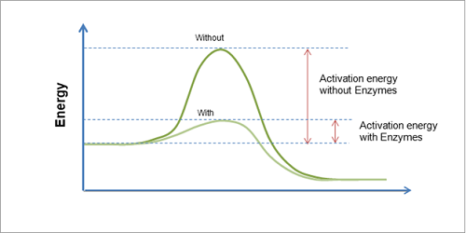
- Enzymes in the stomach work best at low pHs (acid pHs)
In graph – note that amount of energy needed is less when have more enzymes!

Review from Unit 1
- First organisms on earth were most likely bacteria
- Homeostasis – process by which organisms keep their internal conditions in equilibrium
- Autotrophs- make own food (glucose), heterotrophs = do not make their own food
- Domain, Kingdom, Phylum, Class, Order, Family, Genus, Species
- Independent (variable that is changed) vs. dependent (variable that is measured)
- Experiment is a series of steps to test a hypothesis
- Prokaryotic cells = no nucleus

