Biology - Unit 3 Cells, Part 1 Study Guide
Microscopes
- Calculate total magnification by multiplying eyepiece power times the objective lens power
Cell Theory
- All cells come from cells
- All organisms (living things) are made of cells
- Cells are the basic unit of structure and function in living things
Level of organization
- Least complex to most complex: organelles → cells → tissues → organs → systems
- Organelles are cell components that perform specific functions
ALL CELLS (PLANT AND ANIMAL) HAVE…
Plasma Membrane
- Made of phospholipids
  - Phosphate head is hydrophilic (loves water) and polar (positive and negative charges)
  - Lipid tails are hydrophobic (scared of water) and non-polar (no charges)
  - Phosphate heads are on outside of membrane, so the outside is hydrophilic
- Phospholipid bilayer, has proteins embedded in it
- Controls what enters/leaves cell – only allows some substances to enter
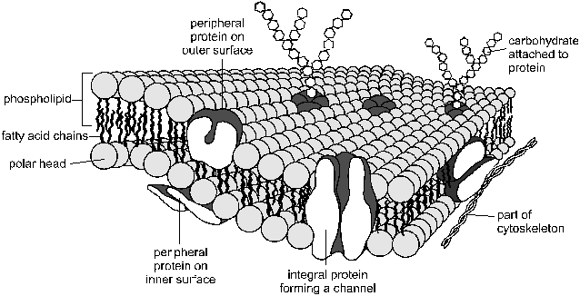
- Proteins – transport large molecules into and out of cell

Nucleus
- Contains genetic information (DNA) for cell
Ribosomes
- Small dots in cell that make proteins (remember that proteins include enzymes)
- Making proteins involves bonding amino acids together
ONLY FOUND IN PLANT CELLS
Cell walls
- Only found in plant cells
- Necessary to provide structure and support for plants
- Composed of cellulose
Central vacuole
- Only found in plant cells, visible with microscope
- Maintains internal water pressure (keeps cells from collapsing)
Chloroplasts
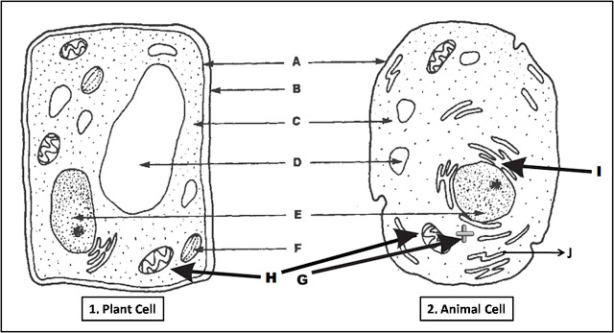
- Organelles that transform light energy into food (glucose)

Eukaryotes vs. Prokaryotes
- Eukaryotes are bigger than prokaryotes
- Prokaryotes = bacteria, no membrane-bound organelles, no nucleus (so DNA just floats around in cell) – so all cells do NOT have a nucleus!
  - Bacterial cells are prokaryotes so they do NOT have a nucleus
- Eukaryotes have membrane-bound organelles

Cell Transport
- Semi-permeable membrane – lets some things across, but not others
  - Passive Transport – requires a concentration gradient (more of substance on one side than the other)
    - Diffusion – molecules spread out or move across a plasma membrane (move from high concentration to low concentration)
      - Facilitated Diffusion – large molecules need to move through a protein channel to enter/leave a cell (such as glucose)
      - Diffusion – small molecules can move through plasma membrane without any help
    - Osmosis – water moving across a semi-permeable membrane
  - Active Transport – requires energy (ATP) to move molecules across the plasma membrane
- Equilibrium - when there is the same concentration of a particle on both sides of the plasma membrane (molecules keep moving across, but move at same rate on both sides)
- When put cells in salt-water – they shrink because water moved out of cell into the salt water where there are more particles
- When put cells in distilled water (no salt) – they swell because water moves into cells where there are more particles

