Thermodynamics Remediation
- During a phase change, the temperature of a substance ____.
- Refer to graph A. During which line segment does the substance change from a solid to a liquid?
- Refer to graph A. During which portion of the graph is the temperature of liquid water increasing?
- What happens to the energy and temperature during a phase change?
- Refer to graph B. What is the temperature and pressure at which this substance can be found at all three states of matter?
Graph A
- Refer to graph B. If you are 1.50 atm and 400 ºC and decrease the pressure to 0.25 atm, what kind of phase change is occurring?
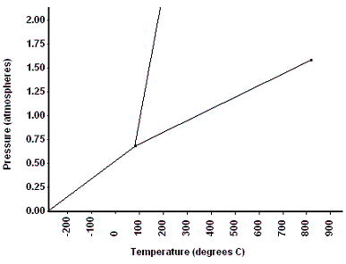
- On a phase diagram, what does the critical point represent? Circle the critical point on graph B.
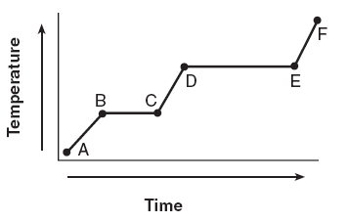

Graph A
Graph B

- What is the difference between an endothermic and exothermic reaction. ___________________________________________________________________
- While melting, entropy __________________ .
- An Endothermic reaction would feel _______to the touch.
Calculate the answer to the following problems
- How much heat is required to vaporize 541 g of liquid water at 100ºC?

- How much energy is absorbed when 25 g of ice melts at 0 ºC?

- During a laboratory experiment, 25 grams of water at 100ºC is transformed into steam at 102ºC. How much heat energy is needed to completely change the state of the water?

- How much energy is absorbed when 8 g of ice at -10ºC is heated and changes to water at 50 ºC?

- What is the amount of heat required to raise the temperature of 100.0 g of zinc from 5 ⁰C to 20 ⁰C? (specific heat of zinc = 0.388 )

- What is the substance if 1347.5 J are required to raise the temperature of a 350-g sample by 10 ⁰C?

- When 50 g of an alloy, at 20 ⁰C, are dropped into 100.0 g of water, the alloy absorbs 1050 J of heat. If the final temperature of the alloy is 38 ⁰C, what is its specific heat?

- What is the amount of heat required to raise the temperature of 100.0 g of aluminum from 5 ⁰C to 80 ⁰C? (specific heat of aluminum = 0.21 )

