Unit 1 Scientific Method and Taxonomy Review Day Stations

Station 1: Taxonomy

Interpreting Graphics Worksheet (Use this address if the link doesn’t work: https://www.biologycorner.com/worksheets/taxonomy_interpret.html)

Station 2: Six Kingdoms ( online computer animated activity)

Online review of Six Kingdoms (Use this address if the link doesn’t work: http://www.glencoe.com/sites/common_assets/science/virtual_labs/E07/E07.swf)

Station 3: Characteristics of Life

Go to this link on your device. Use this address if the link doesn’t work: http://www.ck12.org/biology/Characteristics-of-Life/

Scroll down to find Mind Map. Explore the Mind Map links to videos, sites and animations to review Characteristics of Life. Draw the mind map on your review paper.

Once you have reviewed. Take the 11 question quiz at the station. Write answers on your review sheet. When everyone has finished the quiz. Ask the teacher for a key.

Station 4: Cladogram worksheet

Cladogram Worksheet Name: ________________________
Period: _______________

- Fill in the following table. Mark an “X” if an organism has the trait.

 | cells | legs | 6 legs | wings
Worm
Spider
Carpenter Ant (black)
Fly

2. Add each of these organisms to the cladogram below: worm, spider, ant, fly

3. USING complete sentences, explain why you put each organism where you did on the cladogram.

4. On the cladogram above, add traits that make the organisms different from each other.

5. According to your cladogram, which two species are more closely related: worms and spiders or worms and ants? How do you know?

6. According to your cladogram, what species are flies most closely related to? How do you know?
7. Fill in the following table. Mark an “X” if an organism has the trait.

 | hair | legs | opposable thumbs | eyes
Human
Snake
Monkey
Lizard

8. Add each of these organisms to the cladogram below: human, snake, monkey, lizard

9. USING complete sentences, explain why you put each organism where you did on the cladogram.

10. On the cladogram above, add traits that make the organisms different from each other.

11. According to your cladogram, which two species are more closely related: humans or snakes or humans or monkeys? How do you know?

14. According to your cladogram, what species are humans most closely related to? How do you know?

Station 5: Dichotomous Keys

Honors: Students will create a dichotomous key using the items left by the discretion of the teacher… ideas are… old shoes, writing utensils, science lab materials, candy etc.

Academic: Students will complete the worksheet using the Dichotomous Key given.

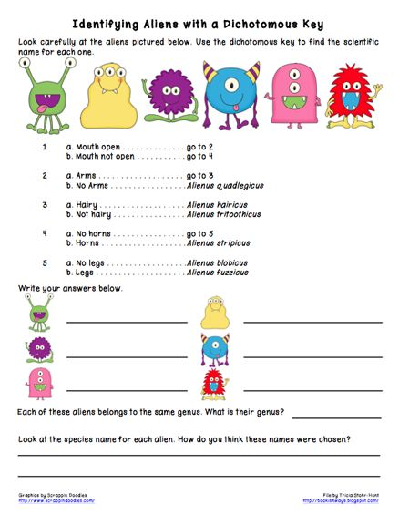

Station 6: THROW BACK STATION: Scientific Method

Academic: Read and Identify IV, DV, constants and controls

Use PDF I shared with you…. PAGE 3 only for Academic students

Honors: Create Hypothesis’ and create controlled experiments.

Experimental Design Honors Name ______________________________
Scientific Method Block ___________ Date______________

**Practice: Write a hypothesis for each of the statements and identify the variables, control group, and experimental group.

1. Cigarette smoking increases the risk of lung cancer.

Hypothesis: If __________________________, then _________________________________________

Independent Variable: __________________ Dependent Variable: ________________________

Control Group: _______________________ Experimental Group: ________________________

2. Eating breakfast increases performance in school.

Hypothesis: If ________________________, then _________________________________________

Independent Variable: ___________________ Dependent Variable: ________________________

Control Group: ______________________ Experimental Group: ________________________

3. Hummingbirds are attracted to the color red.

Hypothesis: If _______________________, then _________________________________________

Independent Variable: __________________ Dependent Variable: ________________________

Control Group: ________________________ Experimental Group: ________________________

Situations: Read the situation below and design an experiment.

John Smith has been hired by the city of Virginia Beach to investigate the recent shark attacks off the resort’s coast. He has a budget of $40,000, a 25 foot boat, and three graduate student assistants to help him. A helicopter has also been donated by a local television station, should he need one.
* * *
1. List 2 hypotheses John and his crew may have come up with for the recent shark attacks.
a. If_______________________________, then ______________________________________

b. If______________________________, then ______________________________________

2. What materials will John need to perform this experiment (How will they spend the $40,000?). _______________________________________________________________________________________
_______________________________________________________________________________________

3. Where should they perform the experiment (Hint: Where do sharks like to live)?___________

4. Pick one of the two hypotheses and determine the following:
a. Control Group: _______________________________________________________________

b. Experimental Group: __________________________________________________________

c. Dependent Variable: ___________________________________________________________

d. Independent Variable: ________________________________________________________

5. What type of data do you think John will collect (What will be the results of the experiment?)?
________________________________________________________________________________________
6. What conclusions will John be able to make from the results of the experiment? _________________________________________________________________________________________
Read the following situation and answer the following questions.

Suzie Q wants to know the effect of different colors of light on the growth of plants. She believes that plants can survive best in white light. She buys 5 ferns of the same species, which are all approximately the same age and height. She places one in white light, one in blue light, one in green light, one in red light and one in the closet. All of the ferns are planted in Miracle-Grow and given 20 mL of water once a day for 2 weeks. After the two weeks, Suzie observes the plants and makes measurements.

Hypothesis: If___________________________, then ______________________________________

Independent Variable: ____________________ Dependent Variable: ________________________

Control Group: _________________________ Experimental Group: ________________________

Constants:____________________________________________________________________________

What types of measurements can Suzie make on the plants to determine how they did in different types of light?________________________________________________________________________

