Unit 1 Remediation: Classification and Characteristics of Life
- List the Characteristics of Life.

Complete the Chart:
 | Living or Non-Living | Biotic or Abiotic | If non-living, list the characteristic(s) of life that is NOT met.
Fire
Seed
Tree
Mold

What Kingdom of Life is described below? Use the word list:
EUBACTERIA, FUNGI, PLANTAE, ANIMALIA, PROTISTA, ARCHAEBACTERIA
- ________________ Multicellular, cell wall, and no chloroplast
- ________________ Multicellular, and heterotrophic
- ________________ Multicellular, cell wall, chloroplasts and autotrophic
- ________________ True bacteria, most common form of bacteria, prokaryotic, cause diseases
- ________________ Strange bacteria, live in wild or extreme environments
- ________________ Mostly unicellular, have a nucleus, live in moist environments, autotrophic & heterotrophic

Use Table 1 to help answer the following questions# 8-11
Table 1: Classification of common animals
Common name | House cat | Red fox | Dog | Wolf
Kingdom | Animalia | Animalia | Animalia | Animalia
Phylum | Chordata | Chordata | Chordata | Chordata
Class | Mammalia | Mammalia | Mammalia | Mammalia
Order | Carnivora | Carnivora | Carnivora | Carnivora
Family | Felidae | Canidae | Canidae | Canidae
Genus | Felis | Vulpes | Canis | Canis
Species | domesticus | fulva | familiaris | lupus
- What is the largest taxon that ALL of the organisms have in common? What domain do all of these organisms belong to?

- What is the smallest taxon that ALL of the organisms have in common?

- Explain why the Dog and the Wolf are the most similar.

- What is the scientific name of a Red Fox?

Look at the cladogram and animal characteristic data below to answer the following questions.
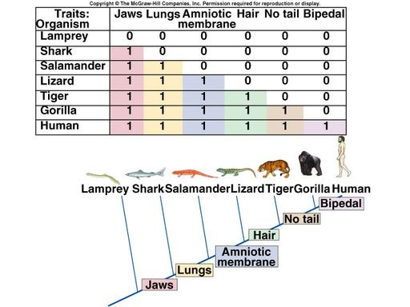
- What group of animals has the most characteristics according to the data table? Where is that organism located on the cladogram?

- What two organisms are the most similar according to the data and cladogram? Explain your answer.

- Name all of the organisms according to the cladogram who use lungs to breathe.

- Use the dichotomous key to identify BIRD W:________________ BIRD X:______________________
