Unit 1 Test Study Guide
Organism – living thing
Autotroph – Produces its own energy; Heterotroph – consumes other organisms to obtain energy
6 characteristics of living things
- Made of cells
- Obtain and use energy (also called metabolism; energy comes from food)
- Grow and develop
- Reproduce
- Respond to environment
- Adapt to environment
*note that some living things DO NOT move!
Levels of organization in living things – Cells → Tissues → Organ → Organ system
*Cells are smallest level of organization, organ systems are largest level of organization
Homeostasis – process by with organisms keep their internal conditions in equilibrium
Classification – each level of classification is based on shared characteristics
*As you move down the list and get more specific, organisms look more similar to each other and have more similar DNA
- Domain (largest)
- Kingdom
- Phylum
- Class
- Order
- Family
- Genus
- Species (smallest) – Species are groups of genetically similar organisms that can produce fertile offspring
Scientific names – include genus and species (ex. Homo sapiens – Homo is the genus, sapiens is the species)
- This means that Homo sapiens and Homo habilis are the same genus but DIFFERENT species
- This naming system (also called binomial nomenclature) was developed by Linnaeus
- Scientists use scientific names instead of common names (meaning scientists use Homo sapiens NOT just the word humans) because common names can be misleading, they are not the name in all languages, and organisms may have more than one common name
6 Kingdoms
- Archaebacteria
*Bacteria were most likely first organisms on earth (prokaryotes)
*Protists, Fungi, Plants, Animals – more advanced with complex cells (eukaryotes)

- Eubacteria
- Protists
- Fungi
- Plants
- Animals
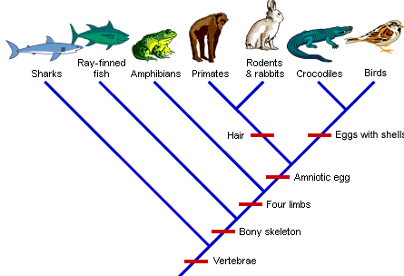
Cladogram – picture that shows evolutionary relationships among organisms
The organisms that are closer together are more closely related and share more traits
In the cladogram to the right, sharks and ray-finned fish are more similar than sharks and birds

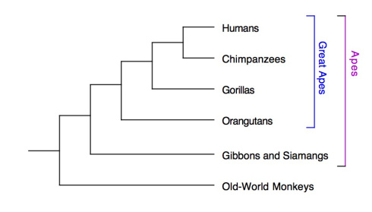

In the cladogram to the right, the species with the longest lines evolved first
-Ex. Orangutans appeared before humans

Organisms that share similar DNA and proteins are more closely related
In the table to the right, humans and chimpanzees are most closely related because they have the same amino acids

Dichotomous Keys – used to identify organisms based on their physical traits
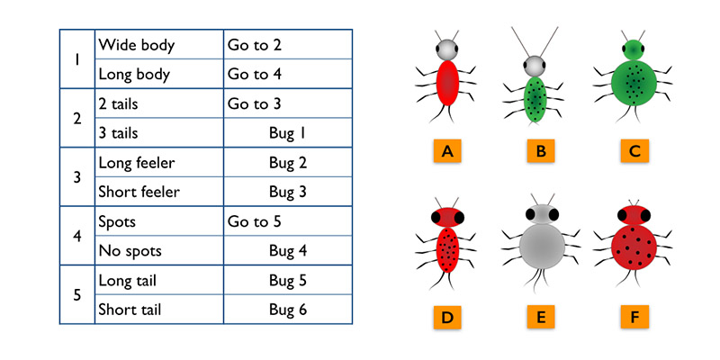
*In the dichotomous key above, Insect “E” would be “Bug 1” because it has a wide body and 3 tails

Scientific Method
- Hypothesis – must be testable by a controlled experiment
- Experiment – a test of a hypothesis
- Independent variables – things changed by the experimenter
  - Ex. amount of light and temperature in a plant growth experiment
- Dependent variables – variable that is measured in an experiment
  - Ex. Height of plant (after changing the amount of light and the temperature)
- Experiments must be repeatable and NOT open to judgement
- QuaNtitative data – data in Numbers (such as graphs or charts)
- Qualitative data – date in words (descriptions)
- Scientific theory – may be revised as new evidence is presented
Example of an experiment using the scientific method…
Hypothesis – Raspberry plants that receive more water will produce bigger berries
Experiment - Raspberry plants are placed in moderately lit areas all receiving the same amount of light each day. Each plant will receive different amount of water (INDEPENDENT VARIABLE). The size of the berries (DEPENDENT VARIABLE) will be measured daily once the plants begin to produce berries.
Results - The raspberry plants receiving 1 cup of water daily grew to 0.5 inches in diameter and those receiving two cups of water grew to 0.75 inches in diameter.
Conclusion - The raspberry plants receiving the most water grew the biggest, so the hypothesis was correct.

