Unit 2 HW Packet - Atomic Structure
HW#1
- State the subatomic particle that is described in each of the following statements.

__PROTON__+1 charge
__NEUTRON_ No Charge
__ELECTRON_-1 charge
_ELECTRON__found outside nucleus
PROTON & NEUTRON__found inside nucleus
ELECTRON__least massive

What is an Atom?
- How many protons are found in ¹²C? ___6_______ ¹³C? ____6______ ¹³C⁻ ? _____6_____
- How many neutrons are founds in ¹²C? ____6______ ¹³C? _____7_____ ¹³C⁻ ? _____7_____
- How many electrons are found in ¹²C? _____6_____ ¹³C? ____6______ ¹³C⁻ ? _____7_____
- Based on the data presented above,
  - What do all carbon atoms (and ions) have in common? All have 6 protons
  - What do all hydrogen atoms (and ions) have in common? All have 1 proton
- What is the significance of the atomic number? Where will you find it on the periodic table? Atomic number signifies the number of protons. Top number in the symbol’s box.
- Look at a periodic table, what do all nickel (Ni) atoms have in common? All Ni atoms have 28 protons
- How is the mass number determined? Number of protons + neutrons
- What structural feature is different in isotopes of a particular element? Different # of neutrons
- What feature distinguishes a neutral atom from an ion? Ions have a charge. Neutral = no charge
- Where is most of the mass of an atom, within the nucleus or outside of the nucleus? Explain your reasoning. INSIDE the nucleus. Protons and neutrons are heavier than electrons.
- Complete the chart below:
Isotope | Atomic Number (Z) | Mass Number (A) | Number of Electrons
³¹P | 15 | 31 | 15
¹⁸O | 8 | 18 | 8
³⁹K | 19 | 39 | 18
⁵⁸Ni²⁺ | 28 | 58 | 26

13. How many electrons, protons, and neutrons are found in each of the following?
Atom or ion | Electrons | Protons | Neutrons
²⁴Mg | 12 | 12 | 12
²³Na⁺ | 10 | 11 | 12
³⁵Cl | 17 | 17 | 17
³⁵Cl⁻ | 18 | 17 | 17
⁵⁶Fe³⁺ | 23 | 26 | 30
¹⁵N | 7 | 7 | 8
¹⁶O²⁻ | 10 | 8 | 8
²⁷Al³⁺ | 10 | 13 | 14

14. Complete the chart below:
Isotope | Protons | Neutrons | Mass Number | Electrons | Nuclear Notation
K-40 | 19 | 21 | 40 | 19
Li-6 | 3 | 3 | 6 | 3
He-3 | 2 | 1 | 3 | 2 | 3  2  He
I-131 | 53 | 78 | 131 | 53
Sr-90 | 38 | 52 | 90 | 38 | Sr  90  38

HW#2
Atomic Emission Spectrum of the Bohr Hydrogen Atom

- In which transition is the most energy released?
- n = 3 to n = 2
- n = 3 to n = 1
- n = 5 to n = 2
- n = 1 to n = 3

- Which transition required the largest quanta of energy input?
- n = 2 to n = 4
- n = 1 to n = 2
- n = 2 to n = 1
- n = 4 to n = 1

- a) What wavelength of light is produced during a transition from n = 5 to n = 2?
________434______________ nm = ________4.34 x 10⁻⁷______________ m
b) What color is the light that is released? Color = _______BLUE_______________
- a) What wavelength of light is produced during a transition
from n = 3 to n = 2? ____656__________________ nm = ______6.56 x 10⁻⁷________________ m
b) What color of light does this correspond to? Color = _____RED_________________
- If violet light of wavelength 4.1 x 10⁻⁷ m is released, what transition did the electron make?
n = _____6_____ to n = ____2______

- Put in order from lowest to highest frequency:
  - Radio waves, gamma rays, IR, X-rays, UV, Microwaves
Radio, Microwaves, IR, UV, X-rays, Gamma
  - Blue, Red, Violet, Orange
Red, Orange, Blue, Violet
- Put in order from lowest energy to highest energy:
- Gamma Rays, IR, Radio Waves, UV, Red light, Violet Light Radio, IR, Red light, Violet Light, UV, Gamma

HW#3
Nuclear Chemistry Homework
Using your knowledge of nuclear chemistry, write the equations for the following processes:

1) The alpha decay of radon-219
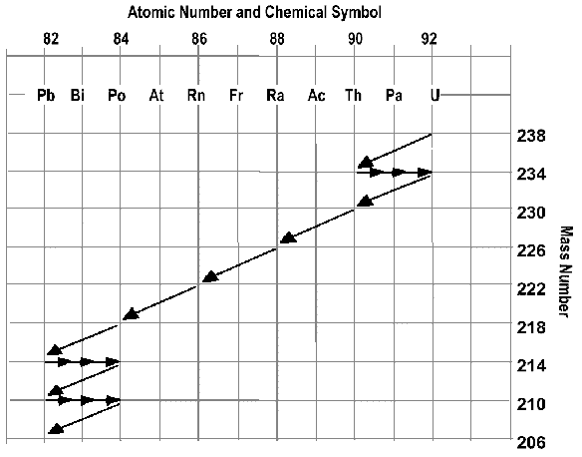
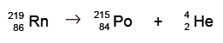
2) The beta decay of uranium-233

3) Use the disintegration series to write a decay equation for:
a) Ra-226
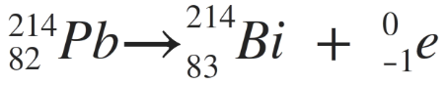
b) Pb-214

4) What is the difference between nuclear fusion and nuclear fission? Fission is the SPLITTING of atoms. Fusion is the COMBINING of atoms.
5) Name three uses for nuclear reactions. Atomic Bombs, medical treatments (i.e. radiation), smoke detectors, dating fossils

Radioactivity and half-life questions
1. What is a radioactive isotope__An isotope of an atom that is unstable and will emit energy in the form of alpha, beta, and/or gammy rays.
2. What is radioactive decay? _The process an atom undergoes as it loses energy. As it is undergoing decay, the atom is considered radioactive.
3. What is half-life? The amount of time it takes for half of the atoms in a given sample to undergo decay.
4. If we start with 400 atoms of a radioactive substance, how many would remain after one half life?___200______
after two half-lives? __100_______ after three half-lives? __50_______ after four half lives? ____25____

5. If we start with 48 atoms of a radioactive substance, how many would remain after one half life?___24______
after two half-lives? __12_______ after three half-lives? ____6_______ after four half lives?___3____

6. If we start with 16 grams of a radioactive substance, how much will remain after three half-lives?___2 g_____

7. If we start with 120 atoms of a radioactive substance, how many will remain after three half-lives?__15 g______
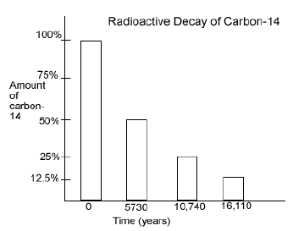

Use the following graph to answer questions 8-11…
8. How long is a half-life for C-14?___5730 yrs_________

9. If only 25% of the carbon-14 remains, how old is the material containing the carbon-14? __10,740 yrs______

10. If a sample originally had 120 atoms of C-14, how many atoms will remain after 16,110 years? __15 atoms_____
11. If a sample known to be about 10,740 years old has 400 carbon-14 atoms, how many atoms were in the sample when the organism died? __1600 atoms_______
12. Which type of nuclear radiation (beta particles, gamma rays, or alpha particles) can be blocked by…
a) a piece of paper __alpha__________ b) a sheet of aluminum ____beta_____ c) a piece of lead __gamma__________
Use the following chart to answer questions 13-16…
Radioactive Substance | Approximate half-life
Radon-222 | 4 days
Iodine-131 | 8 days
Radium-226 | 1600 years
Carbon-14 | 5730 years
Plutonium-239 | 24,120 years
Uranium-238 | 4,470,000,000

13. If we start with 8000 atoms of radium-226, how much would remain after 3,200 years? ___2000 atoms_______
14. If we start with 20 atoms of plutonium-239, how many would remain after 48,240 years? __5 atoms________
15. If we start with 60 atoms of uranium-238, how many remain after 4,470,000,000 years? __30 atoms_______

16. If we start with 24 atoms of iodine-131, how many remain after 32 days? _1.5 atoms__________

