Unit 2 Atomic Theory Remediation
- Fill in the following chart, noting if the description is describing nuclear fission or fusion.
Fission or Fusion? | Description
 | Occurs on the sun
 | Type of energy created by nuclear power plants
 | Involves the splitting of two atoms
 | Two small atoms are combined into one larger atom
 | Atomic bombs dropped on Japan in WWII were products of this energy

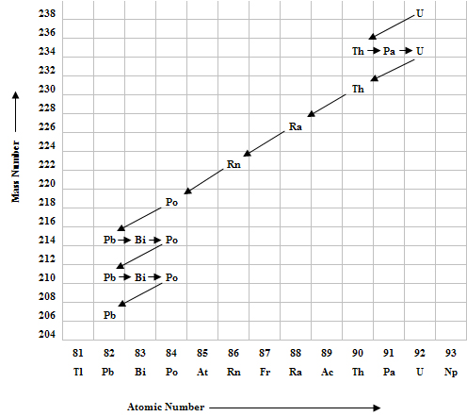
- Using the disintegration series given, write the decay equation for the following:
  - ²³⁰Th

  - ²¹⁴Pb

- a. If Gallium-68 has a half-life of 68.3 minutes, how much of a 10 g sample is left after two half-lives?

- How much total time has passed?

- If an electron moves from n = 4 to n = 2, what wavelength of light will be emitted?
  - _____________________ nm b. ___________________________ m
c. What color of light is emitted? _______________________________
5. Complete the chart below by filling in the blanks.
Nuclear Notation | Number of Protons | Number of Neutrons | Number of Electrons
¹⁴C
⁵⁶Fe²⁺
 | 34 | 45 | 36

6. Find the average atomic mass of an element X given the information below:
Isotope | Mass(amu) | % Abundance
1 | 36.765 | 10.67
2 | 38.056 | 77.68
3 | 40.003 | 10.34
4 | 41.060 | 3.31

