Unit 8 – Ecology Guided Notes
- Ecology - _________________________________________________________________________
- Environment - _____________________________________________________________________
- What is the difference between biotic and abiotic?______________________________________________________
- DRAW THE HEIRARCHY OF ECOLOGY. Beside each label, write in the definition.

- Birth Rate - _____________________________________________________________________________________
- Death Rate - ____________________________________________________________________________________
- Carrying Capacity - _______________________________________________________________________________
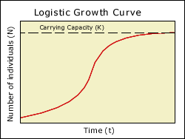
            - Population vs Carrying Capacity _____________________________ _______________________________________________________ _______________________________________________________

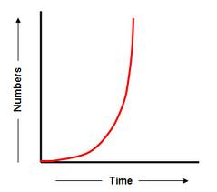
- Birthrate vs Death Rate ______________________________
__________________________________________________
__________________________________________________

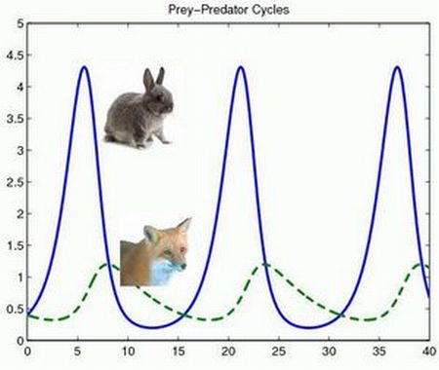

- Predator-Prey Relationship _____________________________
____________________________________________________
____________________________________________________

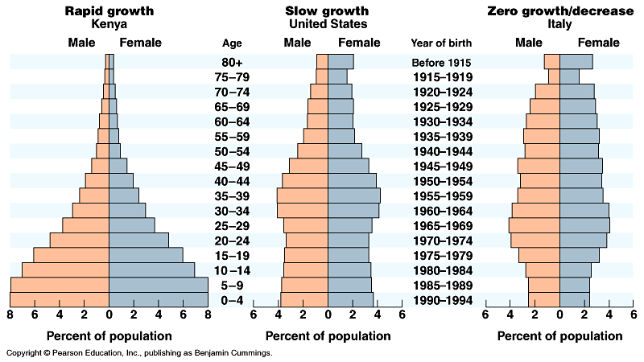

Limiting Factors - ________________________________________________________________________________
_______________________________________________________________________________________________

