UNIT 8 IMMUNITY AND MICROORGANISMS TEST
Prokaryote
Eukaryote
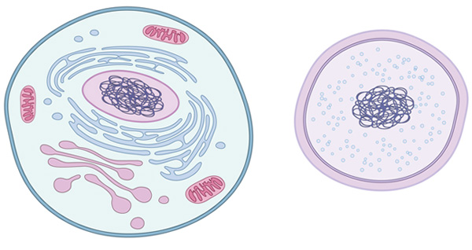
- Prokaryotes vs. Eukaryotes
  - _________________ – NO membrane-bound organelles), Eukaryotes – have membrane-bound organelles
    - Membrane organelles include nucleus, chloroplast, mitochondria
  - Prokaryotes evolved _____________ Eukaryotes

- 6 Kingdoms – Archaebacteria, Eubacteria, Protista, Fungi, Plants, Animals
  - ____________________ – unicellular, live in extreme environments
  - Eubacteria – true bacteria (some cause diseases such as _______________ and _________________________________)
  - Protista – are eukaryotes so they have membrane-bound organelles, are many different sizes and shapes, can be one-celled or many cells, can be autotrophic or heterotrophic
    - ______________ – protists that can perform photosynthesis
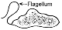
- _______________ – Whiplike tails that some protozoans use to move
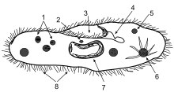
- ________________ – little hairs around outside of organism used for movement (movement also called locomotion)
  - Paramecium – example of protozoan that has cilia

Paramecium with Cilia

- Bacteria
  - Called “nature’s recyclers” because they _____________________ dead organisms
  - They are prokaryotic – meaning NO membrane-bound organelles (no nucleus, no mitochondria, no chloroplasts, etc.)
  - They are ____________________
  - Used in food production, help us to _____________ foods, help plants to get nitrogen from the air

- Viruses
  - Have many different size and structures
  - _________________ – not made of cells, cannot make proteins, cannot use energy (but study in Biology since they are active inside living cells)
  - Viruses are made of proteins and nucleic acids
  - ________________ infection- ends when new viruses burst out of the infected cell (also called “host cell”), this destroys the host cell right away
  - __________________ viruses – embed DNA into host cell’s DNA, do NOT kill cell right away

- Immunity
  - Pathogens are foreign things that are bad for the body – bacteria, virus
  - Body responds to infections first with extra mucus, sweat, tears
  - ______________ immunity – a person is exposed to antigens (antigens are anything that causes your body to make antibodies, such as bacteria and viruses) and then makes memory B cells and __________________ against that antigen
    - When already have memory B cells against a certain pathogen, then you are less likely to get the disease a second time
  - ______________ immunity – when antibodies in breast milk are passed from mother to baby and help protect nursing babies from many illnesses
  - ________________ – made from killed or weakened pathogens
    - When a person receives a vaccine, they make antibodies to fight that pathogen

- __________________ – only kill bacteria NOT viruses
  - Antibiotics work by interfering with cell processes that are only in bacteria, not in viruses
- Malaria – uses a ____________ (mosquito) to transmit disease to humans

Review
- ________________ Transport – when need energy to move molecules across a cell membrane (such as the sodium-potassium pump)
- ________________ Transport – molecules do NOT need energy to move across cell membrane (ex. diffusion, osmosis, facilitated diffusion)
- Liquid fats contain mostly __________________ fatty acids (solid fats have mostly saturated fatty acids)

