UNIT 9 Macroorganisms (Plants and Animals) Study Guide
FUNGI
- Fungi are decomposers (bread down organic material) – this is a type of heterotroph since fungi get their food from another organism
PLANTS
- Plants - multicellular eukaryotes
- Vascular tissue – veins used to move water and sap (sugar) through plant
- Ancestors of plants were most like green algae

- Types of plants:
  - Moss (also called bryophytes)– Non-seed, non-vascular plant (which means they do not have vascular tissue); no seeds – only spores
  - Fern – Non-seed, vascular plant; no seeds – only spores
  - Gymnosperms – produce cones (ex. pine trees)
  - Angiosperms – produce flowers (any tree or plant that produces flowers/fruit)

- Order plants appeared on earth: 1. Algae, 2. Moss, 3. Fern, 4. Gymnosperm, 5. Angiosperm

- To increase their chances that the offspring will survive, seeds…
  - Have hooks on them to stick to animal’s fur
  - Are enclosed in something edible (fruit)
  - Enter dormancy until conditions are suitable

- Angiosperms – have fruit (the ovary of the flower becomes the fruit and surrounds the seeds)
  - The fruit – provides food for humans and other animals, protects the seeds, and helps to disperse the seeds (ex. animals eat it and poop out the seeds somewhere else)
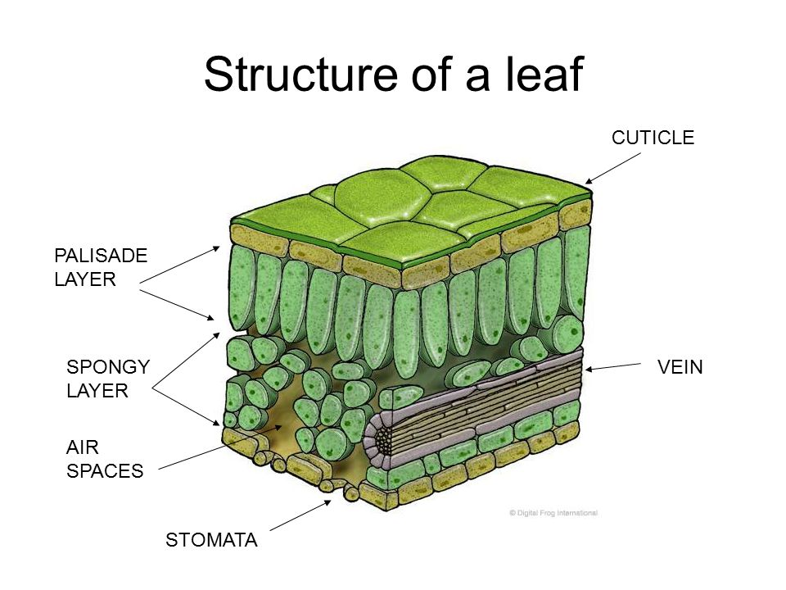

    - Photosynthesis takes place in the Palisade Mesophyll Layer
    - Water is transported in the Vein (same as Xylem)
    - The Stomata are holes that regulate the movement of gases (oxygen and carbon dioxide) in and out of the cell to help the plant maintain homeostasis

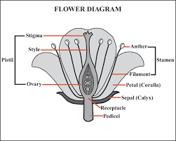

- StaMEN = male parts
- Pistil = female parts
- The ovary will become the fruit
- Since this plant has a flower, it is an Angiosperm

ANIMALS
- All animals are eukaryotic, multicellular, and heterotrophic
- Animal cells do not have cell walls (only plant cells do)
- Amphibians – animals including frogs that live in moist environments and must return to the water to reproduce (tadpoles, which are baby frogs, live in water)
- Metamorphosis – Caterpillar and butterfly are different life stages of the same organism

- Systems of the body
  - Circulatory System – moves materials throughout organism (blood vessels, heart)
  - Digestive System – breaks down nutrients into soluble pieces (mouth, gizzard, stomach, intestines)
  - Respiratory System – exchange of gases oxygen and carbon dioxide (skin, tracheal tubes, lungs)
  - Excretory System – removal of metabolic wastes (bladder, kidneys)

REVIEW
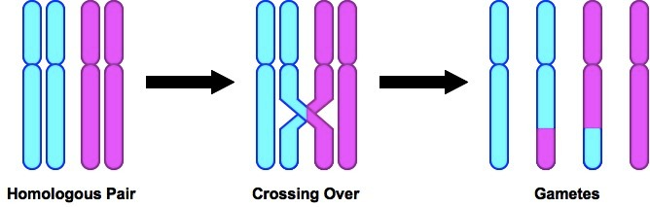
- Crossing over – when homologous chromosomes exchange pieces of chromosome to mix up the genes

- DNA – remember that Adenine (A) bonds with Thymine (T) and Cytosine (C) binds with Guanine (G)
- DNA molecule – shaped like ladder - backbone is made of deoxyribose sugar and phosphate molecules
- If a person gets a mutation in their egg or sperm, it CAN be passed onto their offspring; if a person gets a mutation in a body cell (such as a skin cell), it CANNOT be passed onto offspring
- If a child is born with a rare genetic disease, but neither parent had the disease, then the parents must have been carriers for the trait
- Gel electrophoresis – a technique used to separate DNA fragments by charge and length
- If insects are treated with an insecticide (kills insects) and their offspring are immune to the insecticide, it means that the insects developed adaptations to the insecticide
- Camouflage – when an organism develops adaptations that cause it to blend into their environment (ex. insects that look like sticks)

