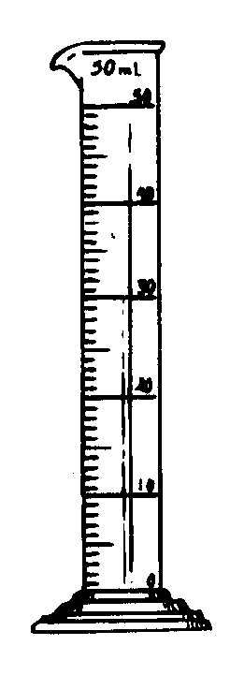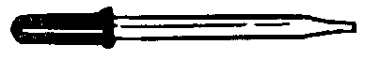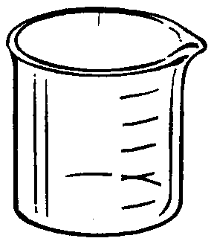In this activity you will match each piece of laboratory equipment with the proper term found below. At the end of this unit you will also be expected to know the function of each piece of laboratory equipment.

**2**

**3**

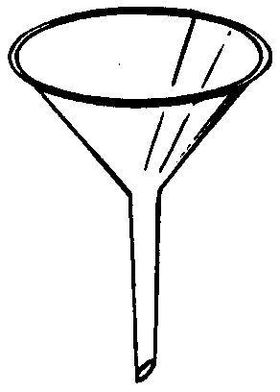slide

**1**

**4**

**6**

**7**

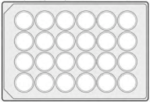

**5**

**8**

Thermometer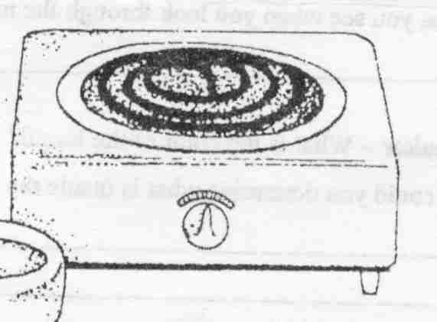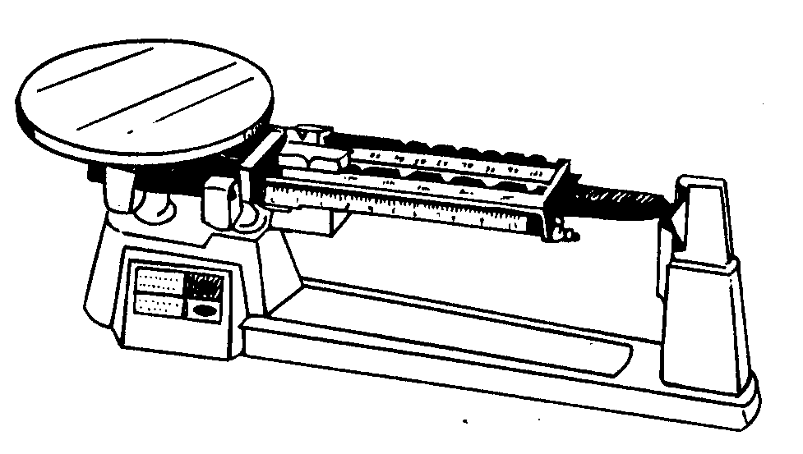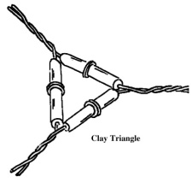

**11**

**10**

**9**

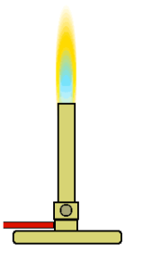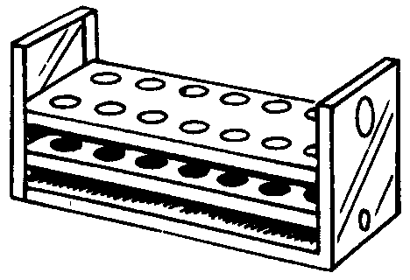

**12**

**14**

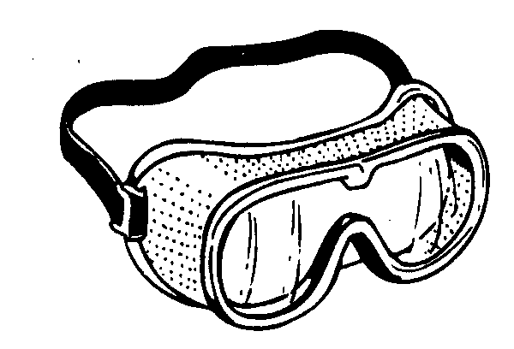

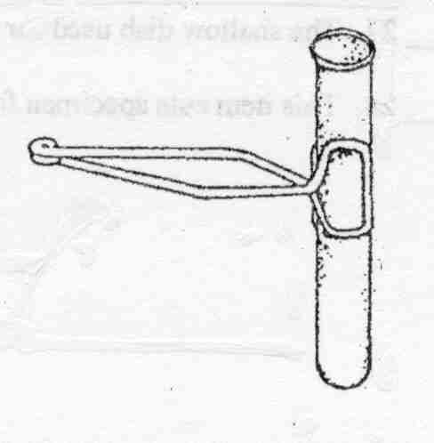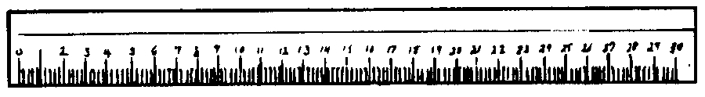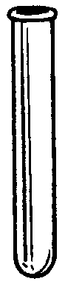MCj01992320000[1]

**18**

**15**

**19**

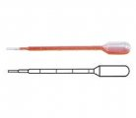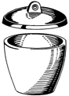

**13**

**17**

**20**

**16**

Beaker Funnel Test tube brush Erlenmeyer Flask

Bunsen burner Goggle Test tube clamp Pipette (disposable)

Clay Triangle Graduated Cylinder Test tube rack Well Plate

Crucible Hot plate Thermometer Evaporating dish

Dropper Metric Ruler Triple Beam Balance Test Tube

|  |  |  |
| --- | --- | --- |
| 1. _________Beaker_____ 2. ______Test Tube Brush 3. ___Dropper______ 4. ____Funnel________ 5. ____Well Plate_________ 6. _Graduated Cylinder___ 7. __Evaporating Dish____ 8. __Clay Triangle______ 9. ___Hot Plate________ 10. Triple Beam Balance___ | 1. _Test Tube Rack____ 2. _Bunsen Burner_____ 3. __Clamp_____________ 4. ___Thermometer_____ 5. __Ruler_____________ 6. __Pipette_____________ 7. ___Test Tube__________ 8. __Crucible____________ 9. __Goggles________ 10. _Erlenmeyer Flask___ | 1. Circle 3 things that measure the volume of a liquid. 2. What unit would you use to measure the volume of liquids?__Liters___________ 3. What unit would you use to measure the length of a piece of paper? ____Meters_(or cm)_________ 4. What unit would you use to measure the temperature of a liquid?___Celsius___ 5. What unit would you use to measure the mass of a rock? _gram________ |

**Scientific Measurement Worksheet**

**Put the following in scientific notation:**

1. 0.000003 = ____3 x 10-6__________________

2. 822000000 = ____8.22 x 108____________

3. (9.3 x 1013) x (1.23 x 1010) = ____1.1 x 1024______________

4. (6.53 x 10-16) x (2.93 x 10-4) = ____7.97 x 10-3_________

(2.4 x 10-17)

**The following measurements were made. Express using scientific notation for one response.**

1. 0.000006 m ___6 x 10-6 m___________________

2. 19000000 g ___1.9 x 107 g___________________

3. 0.000000000006 m ___6 x 10-12 m___________________

4. 0.0004 mol ___4 x 10-4 mol___________________

**Make the following conversions: (SHOW YOUR WORK!!)**

1. 2.33 dm = __2.33 x 10-1m____________ “d” is deci = 10-1 (NOT one I am making you memorize)

2. 1.4 kg = ___1400 g___________

3. 44.5 m = _____4450 cm or 4.45 x 103 cm______

4. 145 g = __145,000 mg or 1.45 x 106 mg________

5. 229 K = _____-44oC

6. 20.5 K = ______-252.5 oC

**Metric Conversions**

|  |  |
| --- | --- |
| Convert 86 g to mg  86 g x 1 mg = 86,0000 mg  1 x 10-3g | Convert 64 mL to L  64 mL x 1 x 10-3 L = 0.064 L  1 mL |
| Convert 86.7 cm to mm  86.7 cm x 1 x 10-2 m x 1 mm = 867 mm  1 cm 1 x 10-3m | Convert 24.2 ML to KL  24.2 ML x 1 x 106 L x 1 KL = 24,200 KL  1 ML 1 x 103 L |
| Convert 2.3 m to mm  2.3 m x 1 mm = 2300 mm  1 x 10-3 m | Convert 567 cm to m  567 cm x 1 x 10-2 m = 5.67 m  1 cm |
| Convert 6.75 pg to ng  6.75 pg x 1 x 10-12 g x 1 ng = .00675 ng  1 pg 1 x 10-9 g | Convert 68.7 l to ml  68.7 l x 1 x 10-6 l x 1 ml = .0687 ml  1 l 1 x 10-3 l |
| 1.8 m to dm  1.8 m x 1 dm = 18 dm  1 x 10-1 m | 0.05 kg to g  0.05 kg x 1 x 103 g = 50 g  1 kg |
| 931.87 mg to cg  931.87 mg x 1 x 10-3g x 1 cg = 93.187 cg  1 mg 1 x 10-2 g | 562 mg to g  562 mg x 1 x 10-3 g = 0.562 g  1 mg |
| 9.60 m to km  9.60 m x 1 km = .0096 km  1 x 103 m | * 1. cg to mg   25.6 cg x 1 x 10-2 g x 1 mg = 256 mg  1 cg 1 x 10-3g |
| 20.5 K to oC  20.5 = C + 273  -252.5 oC | 3 days to seconds  3 days x 24 hrs x 60 min x 60 sec = 259,200sec  1 day 1 hr 1 min |
| 69 234 861 cm to km  69234861 cm x 1x10-2 m x 1 km = 692.234861km  1 cm 1 x 103m | 6920 hours to days  6920 hrs x 1 day = 288.33 days  24 hrs |



5 4 1

6 3 6

4 5 5

3 1 6

169.0 582.8 2026.8

90. 4.0

11 7.58

.81 4252

417 200.6

2.80 x 103 1100

160

**Introduction to Chemistry Review**

**Density Practice**

d = .196/100 d = 1.96 x 10-3 g/mL

d = 89.6/10 d = 8.96 g/cm3

10.5 = m/5 m = 52.5 g

V = 3 x 3 x 3 = 27 cm3 d = 27/27 = 1 g/cm3

.88 = 4.4/v v = 5 mL

19.3 = m/5 m = 96.6 g

GOLD: 19.3 = m/10 SILVER: 10.5 = m/10

193 g = m HEAVIER 105 g = m

**Introduction to Chemistry Review**

1. **Match the following terms with their definition.**

3 A. Constants 1. using data to reach a conclusion

5 B. Hypothesis 2. an explanation tested over a long period of time

2 C. Theory 3. factors in an experiment that stay the same for all groups.

7 D. Observation 4. a system of guidelines for problem solving

6 E. Variables 5. an educated guess

4 F. Scientific Method 6. the factor in an experiment that is tested

1 G. Analysis 7. using the senses to gain information about the world

1. **Complete the following conversions.**

1. 123 mL = 0.123 L

2. 789 km = 7.89 x 107 cm

3. 34 kg = 34,000 g

4. Which is larger? (Circle one) 55 cm or 5.5 m

5. Which SI unit is used to measure mass? kg .

6. Which unit would you use to measure a football field? Km (or meter) .

1. **Determine the percent error in the following problems:**

1. Experimental value: 1.24 kg

Accepted value: 1.30 kg Ans. 4.6% .

1.30-1.24 x 100

1.30

1. Observed value: 252 mL

True value: 225 mL Ans. 12%

252-225 x 100

225

1. Observed value: 1.24 x 10-3 g

True value: 9.98 x 10-3g Ans. 88% .

1.24 x 10-3 - 9.98 x 10-3 x 100

9.98 x 10-3

1. Experimental value: 5.2 x 105 g

Accepted value: 1.2 x 105 g Ans. 333% .

5.2 x 105 – 1.2 x 105 x 100

1.2 x 105

1. **Using the density formula find the unknown.**
2. A block of aluminum occupies a volume of 15.0 mL and weighs 40.5 g. What is its density?

D = 40.5/15 d = 2.7 g/mL

1. What is the weight of the ethyl alcohol that exactly fills a 200.0 mL container? The density of ethyl alcohol is 0.789 g/mL.

.789 = m/200 m = 157.8 g

1. A rectangular block of copper metal weighs 1896 g. The dimensions of the block are 8.4 cm by 5.5 cm by 4.6 cm. From this data, what is the density of copper?

V = 8.4 x 5.5 x 4.6 d = 1896/212.52

V = 212.52 cm3 d = 8.9 g/cm3

1. 28.5 g of iron shot is added to a graduated cylinder containing 45.50 mL of water. The water level rises to the 49.10 mL mark, from this information, calculate the density of iron. V = 49.10-45.5 d = 28.5/3.6

V = 3.6 mL d = 7/9 g/mL

1. What volume of silver metal will weigh exactly 2500.0 g. The density of silver is 10.5 g/cm3. 10.5 = 2500.0/v

238 g/cm3 = v

1. **Convert the following to scientific/standard notation:**

1) 0.0005 = 5 x 10-4 6) 0.25 = 2.5 x 10-1

2) 5,050 = 5.05 x 103 7) 1.5 x 103 = 1500

3) 0.0008 = 8 x 10-4 8) 0.0025 = 2.5 x 10-3

4) 4 x 100 4 9) 3.75 x 10-2 = 0.0375

5) 1,000,000 = 1 x 106 10) 5,000 = 5 x 103

1. **Determine the number of significant figures:**

a) ___4_______ 75.02mm

b) ____2_______ 0.0049 g

c) ____4______ 18.90 mL

d) _____2______ 150 cm

e) _3_(0.135)__ 0.0222 x 0.7000 x

8.702

f.) _3__(77.5)___ 3.42+74.1

g.) _4_(725.7)_ 745.1-12.234-7.2

h.) _1__(5000)_____ 150.4÷0.03