**Name ______________________________________________________________**

**UNIT 1 HOMEWORK PACKET**

**HW#1**

slide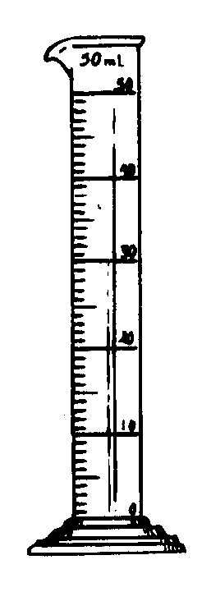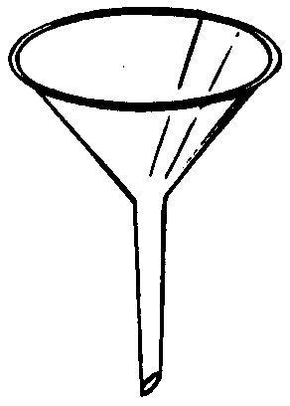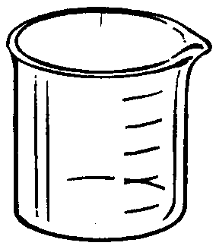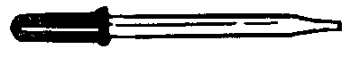In this activity you will match each piece of laboratory equipment with the proper term found below. At the end of this unit you will also be expected to know the function of each piece of laboratory equipment.

**2**

**3**

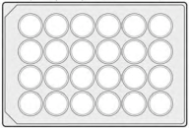

**7**

**6**

**1**

**4**

Thermometer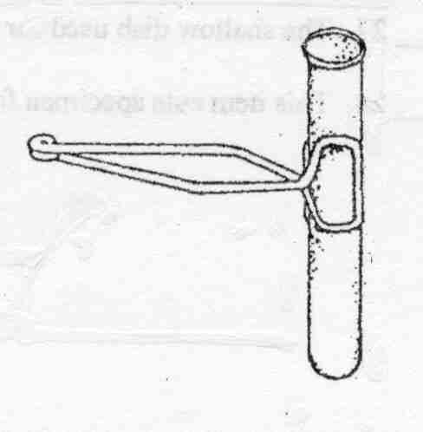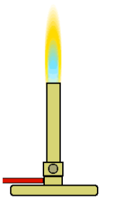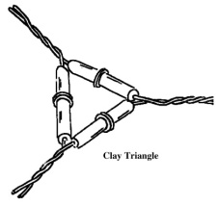

**8**

**5**

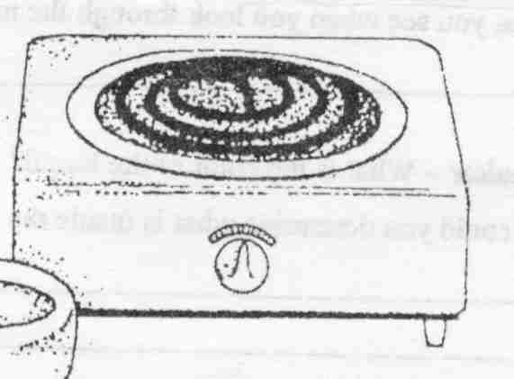

**13**

**9**

**11**

**10**

**9**

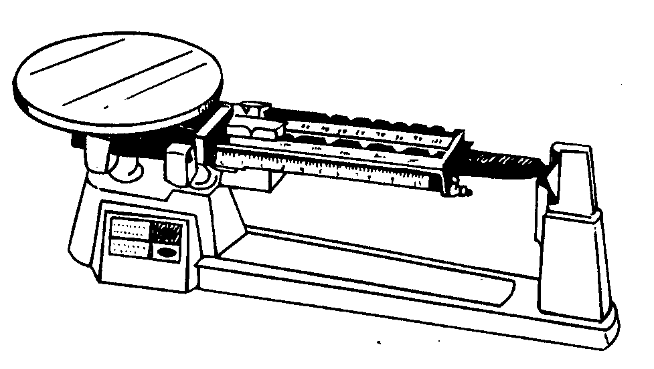

**14**

**10**

**12**

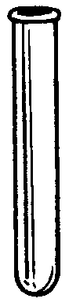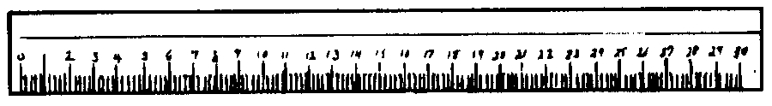

**11**

**15**

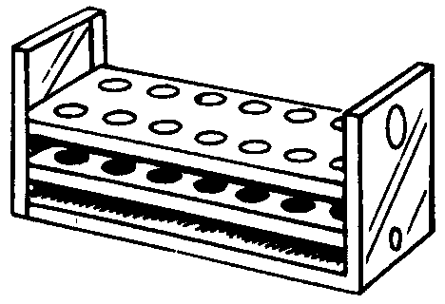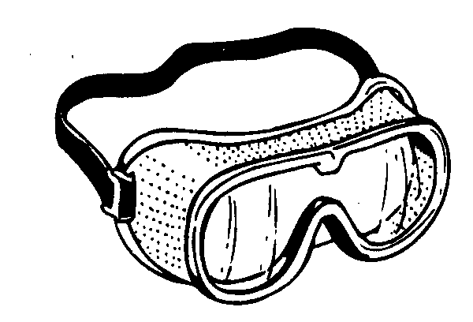MCj01992320000[1]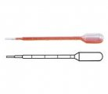

**17**

**19**

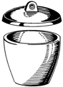

**20**

**16**

**18**

Beaker Funnel Test tube brush Erlenmeyer Flask

Bunsen burner Goggle Test tube clamp Pipette (disposable)

Clay Triangle Graduated Cylinder Test tube rack Well Plate

Crucible Hot plate Thermometer Evaporating dish

Dropper Metric Ruler Triple Beam Balance Test Tube

|  |  |  |
| --- | --- | --- |
| 1. ____________________ 2. ____________________ 3. ____________________ 4. ____________________ 5. ____________________ 6. ____________________ 7. ____________________ 8. ____________________ 9. ____________________ 10. ____________________ | 1. ____________________ 2. ____________________ 3. ____________________ 4. ____________________ 5. ____________________ 6. ____________________ 7. ____________________ 8. ____________________ 9. ____________________ 10. ____________________ | 1. Circle 3 things that measure the volume of a liquid. 2. What unit would you use to measure the volume of liquids?_____________ 3. What unit would you use to measure the length of a piece of paper? ______________ 4. What unit would you use to measure the temperature of a liquid?_____________ 5. What unit would you use to measure the mass of a rock? _________ |

**HW #2**

1. **Scientific Notation - Put the following in scientific notation:**

1. 0.000003 = ______________________

2. 822000000 = ______________________

3. (9.3 x 1013) x (1.23 x 1010) = ______________________

4. (6.53 x 10-16) x (2.93 x 10-4) = ______________________

(2.4 x 10-17)

1. **The following measurements were made. Express using scientific notation.**

1. 0.000006 m ______________________

2. 19000000 g ______________________

3. 0.000000000006 m ______________________

4. 0.0004 mol ______________________

1. **Convert the following to scientific/standard notation:**

1) 0.0005 = 6) 0.25 = _______

2) 5,050 = 7) 1.5 x 103 =

3) 0.0008 = 8) 0.0025 = ________

4) 4 x 100 9) 3.75 x 10-2 =

5) 1,000,000 = 10) 5,000 = _______

1.  **Density Problems**

**HW #3**

1. **Make the following conversions: (SHOW YOUR WORK!!)**

1. 2.33 dm = ______________________ m

2. 1.4 kg = ______________________ g

3. 44.5 m = ______________________ cm

4. 145 g = ______________________ mg

5. 229 K = ______________________ oC

6. 20.5 K = ______________________ oC

1. **Metric Conversions**

|  |  |
| --- | --- |
| Convert 86 g to mg | Convert 64 mL to L |
| Convert 86.7 cm to mm | Convert 24.2 ML to KL |
| Convert 2.3 m to mm | Convert 567 cm to m |
| Convert 6.75 pg to ng | Convert 68.7 l to ml |
| 1.8 m to dm | 0.05 kg to g |
| 931.87 mg to cg | 562 mg to g |
| 9.60 m to km | 25.6 cg to mg |
| 20.5 K to oC | 3 days to seconds |
| 69 234 861 cm to km | 6920 hours to days |

**Review**

1. **Determine the percent error in the following problems:**

1. Experimental value: 1.24 kg

Accepted value: 1.30 kg Ans. .

1. Observed value: 252 mL

True value: 225 mL Ans. __________________ .

1. Observed value: 1.24 x 10-3 g

True value: 9.98 x 10-3g Ans. .

1. Experimental value: 5.2 x 105 g

Accepted value: 1.2 x 105 g Ans. .

1. **Accuracy vs Precision**

What is the DIFFERENCE between accuracy and precision? _____________________________

_____________________________________________________________________________

A measurement was taken three times. The correct measurement was 68.1 mL. Circle whether the set of measurements is accurate, precise, both, or neither.

a) 78.1 mL, 43.9 mL, 2 mL accurate precise both neither

b) 68.1 mL, 68.2 mL, 68.0 mL accurate precise both neither

c) 98.0 mL, 98.2 mL, 97.9 mL accurate precise both neither

d) 72.0 mL, 60.3 mL, 68.1 mL accurate precise both neithe

